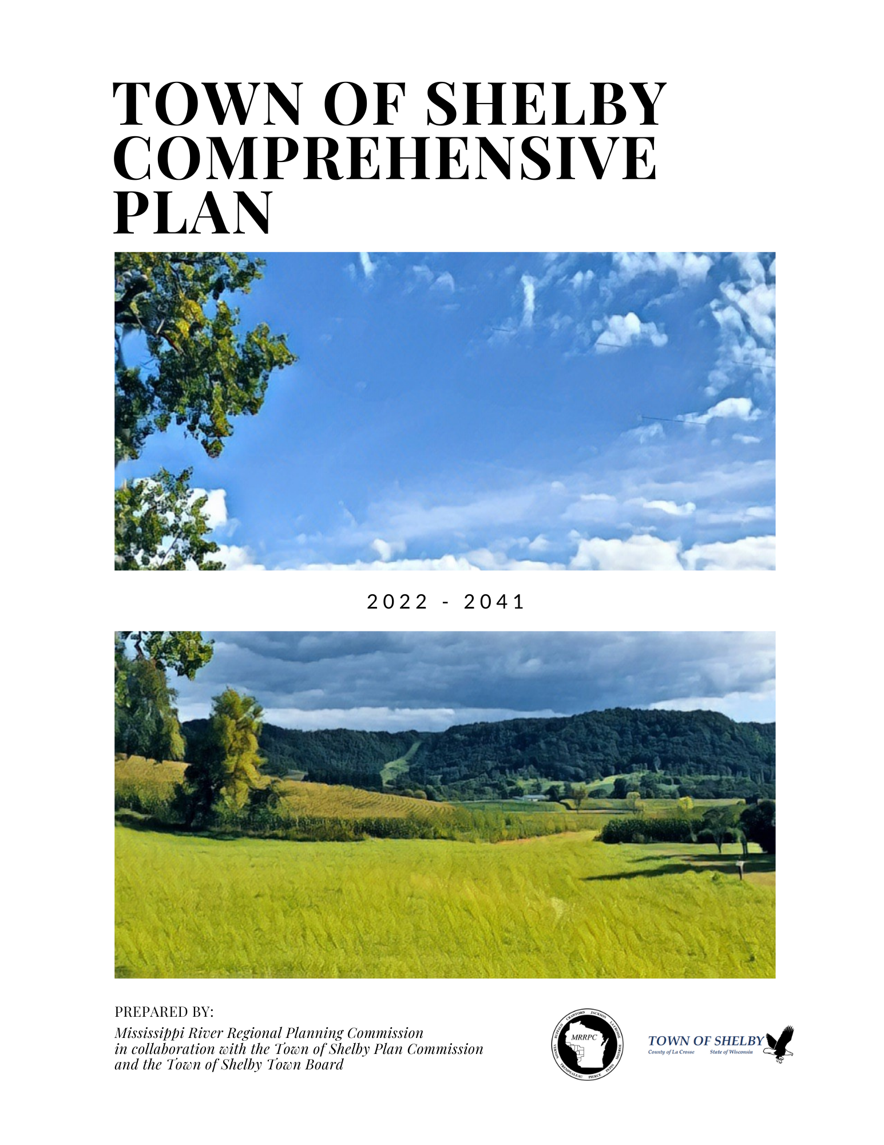

Town of Shelby Comprehensive Plan 2022-2041

The Town of Shelby Comprehensive Plan 2022-2041 responds to and is consistent with the State of Wisconsin Comprehensive Planning Law as defined in Sections 66.1001(1)a and 66.1001(2) of the Wisconsin Statutes. The comprehensive plan is made with the general purpose of guiding and accomplishing a coordinated, adjusted, and harmonious development of the Town that will in accordance with existing and future needs, best promote public health, safety, morals, order, convenience, prosperity, or the general welfare, as well as efficiency and economy in the process of development.

Prepared by:
Mississippi River Regional Planning Commission
1707 Main Street, Suite 435
La Crosse, WI 54601
608.785.9396
plan@mrrpc.com

in collaboration with:

Town of Shelby Planning Commission
Town of Shelby Town Board

A special thanks to members of the public who took the time to fill out the survey, offer online feedback on the goals and objectives, and/or attended a public meeting. Thank you to the stakeholder groups who took the time to speak with Town staff members and share their interests, concern, and ideas for the Plan.

RECOMMENDED TO ADOPT BY RESOLUTION 2022-01 on September 20, 2022
By the Town of Shelby Planning Commission

ADOPTED BY ORDINANCE 5.04 on September 20, 2022
By the Town of Shelby Town Board

Contents
1. Issues and Opportunities 7
About this Plan 7
History and Setting 7
Summary of Key Findings from Survey 2
Demographic Analyses 3
Demographic Trends and Forecasts 3
Age and Gender 3
Race 4
Income Levels 4
2. Housing Element 7
Housing Units 9
Housing Characteristics 9
Type of Housing Unit 10
Age of Housing Structures 10
Housing Values 10
Housing Affordability 11
Housing Projections 12
Housing Sales 12
Special Needs Housing 14
3. Transportation Element 15
Existing Road Network 16
Transportation of Goods and Freight 23
Analysis on Regional Movement of People 24
Analysis on the Local Movement of People 25
Transportation Plans 28
Programs for Local Government 29
Figure 3.1 Town of Shelby Commute Profile 30
4. Utilities and Community Facilities Element 30
Water Supply 32
Sanitary Sewer 32
On-Site Wastewater Treatment Technology 33
Solid Waste Disposal and Recycling Facilities 33
Stormwater Management 34
Telecommunication Facilities 35
Power Plants, Electricity, and Transmission Lines 35
Libraries 35
Schools 35
Town Buildings 36
Police, Fire, and Rescue 36
Health Care Facilities 37
Child Care Facilities 37
Cemeteries 37
Timetable for the Expansion of Utilities and Community Facilities 38
5. Open Space and Outdoor Recreation 39
Developed Parks, Undeveloped Lands, and Vacant Parcels 41
Shelters & Rentals 43
Vacant Parcels 43
Trail Systems 44
Waterways & Trout Streams 44
Pammel Creek 44
Mormon Coulee Creek 45
Mississippi River 45
Shelby Youth Ball 45
Recreational Land Located in the Town of Shelby 45
Goose Island Campground 45
Mount La Crosse Ski Area 45
Stry Foundation Nature Center 46
Upper Mississippi River Fish and Wildlife Refuge 46
Definitions 46
6. Agriculture, Natural, and Cultural Resources Element 47
Agricultural Lands 48
Agricultural Statistics 48
Agricultural Dependency 48
Soil Types and Capability 49
Groundwater 50
Wetlands 50
Floodplains 51
Surface Water 51
Woodlands 52
Topography 53
Steep Slopes 53
Wildlife, Rare, Threatened, and Endangered 54
Open Spaces, Environmental Corridors, and Environmentally Significant Areas 54
Mining and Non-Metallic Mineral Resources 55
Historical Structures and Places 55
Archeological Resources 55
Cultural Agencies and Programs 56
7. Economic Development 57
Education of Labor Force 57
Participation in Labor Force 57
Employment Statistics 58
Economic Base 60
Commercial and Industrial Building Trends 61
Environmentally Contaminated Sites 62
Employment Projections 63
Coronavirus Impact Planning 63
County, Regional, and State Economic Development Programs 65
8. Intergovernmental Cooperation 67
La Crosse County 69
Surrounding Municipalities 69
Regional Planning Jurisdiction 69
Important State and Federal Agency Jurisdiction 70
School Districts 71
Existing or Potential Conflicts and Processes to Resolve Conflicts 71
9. Land Use 73
Land Assessment 75
Development Density 76
Intensity of Commercial and Light Industrial Districts 76
Land Use Supply 76
Land Use Demand 77
Land Prices 78
Future Land Use Projections 79
Opportunities for Redevelopment 80
Redevelopment opportunities exist in portions of the Town located along 14/61 & 35 and in areas of “town islands.” 80
Future Land Use Policies 80
10. Implementation 83
10.1 Regulatory Measures 83
10.2 Non-regulatory Measures 86
10.3 Consistency Among Plan Elements 87
10.4 Plan Adoption, Monitoring, Amendments and Update 87
10.5 5-Year Action Plan 88
Appendix A: Public Participation Plan 91
Appendix B: Land Use Considerations and Plans 93
Appendix C: Maps 95
Map 1.1 Regional Context 96
Map 3.1 Average Daily Traffic 97
Map 3.2 Trails and Bike Lanes 98
Map 3.3 Transportation 99
Map 4.1 Utilities 100
Map 4.2 Transmission Lines 101
Map 4.3 Schools 102
Map 5.1 Shelby Owned Parcels 103
Map 5.2 Trail Systems 104
Map 5.3 Waterways 105
Map 6.1 Agricultural Land Use 106
Map 6.2 Soil Classification 107
Map 6.3 Slope 108
Map 6.4 Archeological Sites 109
Map 9.1 Existing Land Use 111
Map 9.2 Zoning 112
Map 9.3 Future Land Use 113
11. Appendix D 115
Survey Responses 115
12. Appendix E 120
Public Hearing Affidavit 121
Resolution to Adopt Plan 122
Ordinance to Adopt Plan 123

Issues and Opportunities

About this Plan
The Town of Shelby Comprehensive Plan has been developed to provide background and direction for a variety of land use decisions. Included in this plan are a variety of chapters, or elements, which provide baseline information and goals, objectives, and recommendations specific to each element. This plan should be used by the Planning Commission to make decisions about growth and development over the next 20-year period. Periodic updates are required to ensure this plan remains current over time. Specific requirements and procedures for use and maintenance of this plan are provided in the Implementation Element.
Elements in this plan include:

- Issues and Opportunities
- Housing
- Transportation
- Utilities and Community Facilities
- Open Spaces and Outdoor Recreation
- Agricultural, Natural, and Cultural Resources
- Economic Development
- Intergovernmental Cooperation
- Land Use
- Implementation

This section of the plan will provide information on the demographic trends and projections that are taking place in the Town of Shelby. The information has been gathered from various sources, including township level data when possible.

History and Setting
The Town of Shelby is an unincorporated municipality located in the southwest corner of La Crosse County, just south and east of the City of La Crosse along the banks of the Mississippi River. The Town of Shelby is bordered to the south by Vernon County, to the east by the Town of Greenfield, to the north by the Towns of Medary and Barre and to the north and west by the City of La Crosse (See Map 1.1 Regional Context Map Appendix C). The Town is a mix of urban and rural residences, farmsteads, commercial and institutional facilities, about 45 miles of roads, wetlands, parkland and recreation land, agricultural lands, and wooded areas. In total, the Town has an area of approximately 28.60 square miles. Of this, approximately 6.70 square miles are water and approximately 21.90 square miles are land.
The area’s original inhabitants were Native Americans. It is documented that Mormons settled in the 1800’s on what is now called Mormon Coulee and Mormon Creek. German and Swiss immigrants followed in the 1850’s and 1860’s bringing with them their knowledge and skills in agriculture. Until shortly before its establishment, the Town of Shelby was part of the Town of Greenfield, after the division of the Town of Greenfield, the Town of Shelby was established on April 2, 1867. Phillip Young, a German settler, is credited with giving the Town of Shelby its name after his former home of Shelby, Ohio.
The Town of Shelby was a growing area from the late 1950’s to 1980 with a population ranging from 7,000 to 8,000 during this period. More recently, annexation has reduced the Town’s population to 4,770 in 2020. Overall, the southern portion of La Crosse County slowed in population growth due to large-scale infrastructure improvements (primarily highways) in northern areas over the past two decades.
Agriculture has a long-standing history in Shelby, particularly along Mormon Coulee where oats, hay, potatoes and even fruit trees have been grown in the past 100 years. Agricultural land still exists within Shelby, however, is utilized less for farming than what has been seen in previous years. More areas in Shelby are being sought out for development or residential properties and more urban areas are becoming prevalent throughout the Town.
Today, Shelby can be described as an urbanized town with distinct urban, suburban, and rural areas. Rural and agricultural areas remain in the eastern portion of the Town near and adjacent to extreme topographical areas. The western portion of the Town contains a more urbanized landscape, especially in areas where it borders the City of La Crosse.

Summary of Key Findings from Survey
The Town of Shelby assembled questions about a variety of topics that exist within the community including housing, transportation, and land use. These questions were then incorporated into a Town Survey for two reasons: 1) to facilitate a community discussion about long-term issues related to these topics; and 2) to collect community sentiment concerning these topics. The survey was performed as part of the Town of Shelby Comprehensive Plan. Results of the survey were incorporated into this Plan and used to help generate goals and objectives to determine actions for implementation. A summary of the key findings are below and complete survey results with comments can be found in Appendix D.
312 survey responses were received by the Town. There was an even distribution of respondents from each Ward represented. Most respondents had lived in the Town over 10 years, worked outside the Town, or were retired (63 years old or older).
Perception of Town
Overall survey respondents are satisfied with the overall quality of the Town and Town Hall facilities. Many choose to live in the Town because of the natural beauty, reasonable tax rate, rural character, and proximity to natural resources. The amenities provided such as parks and recreation, snow removal, police protection, and emergency services are to the standards most residents prefer. An area residents feel needs improvement is road maintenance.
Transportation
As stated above, road maintenance was an area of concern for respondents. It was rated a low priority to increase public transportation with a high priority of providing safer walking and biking along roadways. It was also a medium priority to provide multi-use trails.
Agriculture and Natural Resources
Respondents included many high priority items they felt the Town should address concerning agriculture and natural resources. The top response was protecting groundwater followed by protecting scenic views and undeveloped hills. They also felt the Town should participate in environmental projects to manage storm water, protect air quality, and support solar energy opportunities. The lower priority items were to promote waterway and fishing opportunities. The Town also felt strongly about encouraging farmland preservation.
Growth Projections and Management
As the Town grows, survey respondents stated they were open to regionally sharing services such as public transportation, regional law enforcement, and regionally supplied fire and first responders. It was rated a high to medium priority to expand community partnerships and intergovernmental cooperation.
When looking at new development in the Town, respondents are hoping for more single-family units on rural lots and lots smaller than 1 acre. They are also interested in mixed use areas for business, industry, and residential units. 13% of respondents did not want more development promoted.
39% of respondents do not currently have municipal sewer or water. The majority of respondents felt no sewer and water should be extended to new developments and if they were, the cost should be incurred to the developer or the Town of Shelby. The Town wanted to know if they should work to provide these services to already developed areas. Respondents had mixed responses with about half saying yes, with the cost shared with property owners and the Town, while half were not interested in extending services.

Demographic Analyses
This section includes comparisons to other local and regional governments. They are included to provide a better understanding of the trends emerging locally and within the County or State. Comparable data includes:
- Town of Medary: also borders the City of La Crosse, is subject to same development pressures;
- City of La Crosse: borders the Town, provides the local basis for “urban” characteristics on growth and service provision;
- La Crosse County: regional governmental jurisdiction, contains uniform topographical characteristics and a variety of local governmental entities for comparison.

Demographic Trends and Forecasts
The population of Shelby has fluctuated over the years. During the 1960’s, the population decreased by 16%, likely due to an annexation by the City of La Crosse. The population then rose again, only to experience an 11% drop during the 1980’s for the same reason. The most recent population estimates show that Shelby’s population decreased by 1.17% from 2010 to 2020. Projections from the Wisconsin DOA indicate that the population will remain stable. The DOA considers and monitors changes and patterns in fertility, mortality, and migration. DOA’s projections indicate modest growth from 2020 to 2030 in Town of Medary (+60 people) and City of La Crosse (+150 people).

Table 1.1 Population Estimates
 | Census
 | 1990 | 2000 | 2010 | 2020 | 2025 | 2030 | 2035 | 2040 | 2020-2030 Predicted Change
Town of Shelby | 5,002 | 4,687 | 4,715 | 4,770 | 4,775 | 4,765 | 4,710 | 4,665 | -0.10%
Town of Medary | 1,539 | 1,463 | 1,461 | 1,545 | 1,575 | 1,605 | 1,615 | 1,630 | 3.88%
City of La Crosse | 51,140 | 51,818 | 51,320 | 52,550 | 52,750 | 52,700 | 52,300 | 51,850 | 0.28%
La Crosse County | 97,904 | 107,120 | 114,638 | 120,447 | 123,404 | 128,120 | 129,830 | 131,500 | 0.6%
Source: US Census Bureau 2010, 2020-2040 estimates Demographic Service Center, Wisconsin DOA

Age and Gender
The median age for the Town is 51.1 years old, which is significantly higher than the County median age of 35.9 years old and the City of La Crosse’s median age of 29.3. Table 1.2 outlines the age distribution for the population of Town of Shelby residents. Just over 60% of residents in the Town are 40 years old and over. 19.4% of Town of Shelby residents are under 20 years old or older, which is lower than the County total of 24.3% residents under 20. When considering gender, 51.1% of the residents are male. For La Crosse County, only 48.8% of residents are male.

Table 1.2 Population by Age, 2019
 |  | Percent (%)
 | Median Age | 0-9 | 10-19 | 20-29 | 30-39 | 40-49 | 50-59 | 60-69 | 70-79 | 80+
Town of Shelby | 51.1 | 11.3 | 8.1 | 7.5 | 10.3 | 12.5 | 15.9 | 21.2 | 10.0 | 3.1
Town of Medary | 42.3 | 14.1 | 13.9 | 9.4 | 11.4 | 12.0 | 15.6 | 15.3 | 6.6 | 1.6
City of La Crosse | 29.3 | 8.4 | 14.2 | 28.5 | 11.8 | 8.3 | 10.0 | 9.3 | 5.5 | 4.1
La Crosse County | 35.9 | 10.6 | 13.7 | 18.4 | 12.0 | 10.7 | 12.6 | 11.3 | 6.6 | 4.1
Source: American Community Survey (ACS) 2019 5-Year Estimates

Race
A majority of Shelby residents are white. Residents of Asian descent comprise 3 percent (3%) of the Town’s population, which makes them the second largest race population in the Town. The racial composition is similar to that of the County.

Table 1.3 Population by Race, 2019
 | White (%) | Black (%) | American Indian and Alaska Native (%) | Native Hawaiian and Other Pacific Islander (%) | Asian (%) | Hispanic (%) | Some Other Race (%) | Two or More Races (%)
Town of Shelby | 97.1 | 1.1 | 1.0 | 0.0 | 3.0 | 0.6 | 0.0 | 2.3
Town of Medary | 95.1 | 0.4 | 0.0 | 0.0 | 2.3 | 3.1 | 2.3 | 0.0
City of La Crosse | 92.1 | 3.8 | 0.9 | 0.1 | 4.7 | 2.2 | 0.8 | 2.3
La Crosse County | 90.9 | 1.6 | 0.4 | 0.0 | 4.4 | 1.9 | 0.2 | 2.0
Source: American Community Survey (ACS) 2019 5-Year Estimates

Income Levels
Table 1.4 depicts three measures of income for the Town and surrounding communities.
- Per Capita Income is the total income of the area divided by the total population.
- Median Household Income considers income for all people who occupy a housing unit- related or not.
- Scaled income levels based on per household income
Per capita income in the Town of Shelby is higher than the County and Village of Holmen. Median household income is significantly higher in the Town at $83,056 compared to the County at $57,882.

Table 1.4 Income Analysis
 | Per Capita Income | Median Household Income | Under $50k | $50k-$100k | $100k-$200k | Over $200k
Town of Shelby | $52,448 | $83,056 | 24% | 35.8% | 26.2% | 14.1%
Town of Medary | $36,829 | $79,306 | 23.7% | 36.2% | 32.2% | 8.0%
City of La Crosse | $26,827 | $45,233 | 55.2% | 30.9% | 11.2% | 2.7%
La Crosse County | $32,565 | $57,882 | 42.7% | 33.2% | 19.2% | 4.8%
Source: American Community Survey (ACS) 2019 5-Year Estimates

Housing
This element provides a baseline assessment of the Town of Shelby’s current housing stock including analyses of current conditions. The following is a series of goals, objectives, and recommendations which have been developed to increase, enhance, or sustain the housing stock in the town.
GOAL 1
Allow for diversity of housing choices and lot sizes that are consistent with the character and services available.
Objective 1-1: Determine where high, medium, and low density is found within the town and update plans, ordinances, and policies to allow for continued consistency in those areas.
Objective 1-2: Consider local and regional strategies for housing the aging population, including facilities that would provide a continuum of care.
Objective 1-3: Ensure that there is a variety of housing types within the Town that will appeal to residents of all income and age levels.
GOAL 2
Protect integrity of current housing stock by encouraging redevelopment that is consistent with the density and character in existing neighborhood.
Objective 2-1: Support redevelopment of vacant, blighted, or underused lands.
GOAL 3
Do not allow the town to be financially burdened by new residential development.
Objective 3-1: Work with appropriate entities to ensure sufficient existing and future capacities for needed infrastructure (schools, etc.).
GOAL 4
Pursue and promote environmentally friendly, sustainable, development and redevelopment.
Objective 4-1: Work with public and private entities (i.e., La Crosse County, Focus on Energy, etc.) to provide education and general information to residents on sustainability and environmental impacts of development.

ACTIONS
Action 1: Require use of conservation design principles. Conservation neighborhoods should meet the following guidelines:
- Shield development from the main roads through natural vegetation and topography.
- Provide vegetative buffers between building sites and sensitive environmental areas.
- Preserve mature trees, vegetation, and other attributes that relate to the site’s history or natural character.
- Prohibit or limit the placement of homes and buildings on exposed bluffs or ridgelines.
- Create an interconnected network of streets and trails with connections to the larger community.
- Integrate natural resources into the subdivision design as aesthetic and conservation landscape elements.
- Restore degraded environmental areas within the subdivisions, such as streams and wetlands.
- Encourage Best Management Practices (BMPs) for storm water management as opposed to conventional engineering strategies. Typical BMPs include overland transfer, natural landscaping to increase infiltration and reduce runoff, bio-infiltration systems, and residential roof runoff directed to pervious yard areas and minimized impervious surface ratios for development sites.
- Provide wide area for public access to parks and common open spaces.
- Maximize areas of common open space in the neighborhood through public dedication and/or private management of open space.
Action 2: Require the use of bluff design guidelines for all development within Shelby’s bluffs (as defined by the Shelby Planning Commission). Bluff design guidelines as follows:
- Land use patterns and site designs shall preserve the hillsides, scenic vistas, woodlands, wildlife habitat, and associated rare features found in the Coulee Region.
- Minimize exotic landscaping including the size of building footprints, and the amount of impervious surface devoted to roadways to the extent feasible. Allow the natural landscape to dominate.
- Nestle structures in valleys or below ridgelines and within the folds of the hills.
- Prohibit ridge top “Sky lining” that alters the natural land profiles with built structures. Limit the visual impact of any new development that can legally be constructed. Discourage clear cutting or extensive removal of trees.
- Cluster development in a manner so as to maximize visually significant, unfragmented woodlands and open spaces.
- Design buildings on hillsides to follow the natural terrain in a manner that minimizes earth disturbance.
- Construct fences that are wildlife-friendly including efforts to minimize the areas fenced and the length of fences, using fence designs which exclude or discourage only certain types of wildlife, and providing exits and corridors for wildlife.
- Place all utilities underground.
- Restrict or shield lighting so as to restrict horizontal and vertical light spillover, thereby preserving the dark night sky.
Action 3: Disallow any development on a slope of greater than 30%. Review development on slopes of 20% or greater on a case-by-case basis. Require that construction on slopes 20% or greater be accompanied by site plans that provide drainage on and off the site to protect all surrounding areas.
Action 4: Restrict development in floodplains.
Action 5: Create a site development process that requires a public hearing pertaining to development of bluffs, conservation neighborhoods, and traditional neighborhood developments.
Action 6: Reject expansion of existing mobile home courts and require new mobile homes to have permanent foundations and pitched roofs except for instances of multi-story development.
Action 7: Determine the adequacy of the impact fees currently in place in the Town’s subdivision ordinance.
Action 8: Work with school districts and other entities to determine population thresholds for necessary expansion and in planning for appropriate increases to infrastructure incrementally over time.
Action 9: Require a developer bond to be paid before the start of a project that will cover all infrastructure costs if a developer runs into financial trouble.
Action 10: Provide information about sustainability and environmentally friendly development with building permits.
Action 11: Update town website with information on sustainability, environmentally friendly building practices, and local resources for additional assistance and information.

Housing Units
Table 2.1 depicts the number of housing units within the Town of Shelby as determined by the American Community Survey (ACS) in 2019. The table also outlines the percentage of housing units that are occupied by the homeowner, the percentage of units that are rented, and the percentage of units that are vacant. In the Town, there are 1,963 housing units that are owner occupied, 191 units that are rental occupied, and 197 that are vacant.

Table 2.1 Housing Occupancy, 2019
 | Total Housing Units | Owner Occupied |  | Renter Occupied |  | Vacant Units
 |  | Number | Percent | Number | Percent | Number | Percent
Town of Shelby | 2,351 | 1,963 | 91.1% | 191 | 8.9% | 197 | 8.4%
Town of Medary | 714 | 611 | 88.7% | 78 | 11.3% | 25 | 3.5%
City of La Crosse | 22,800 | 9,772 | 46.1% | 11,414 | 53.9% | 1,614 | 7.1%
La Crosse County | 50,304 | 29,949 | 63.0% | 17,569 | 37.0% | 2,786 | 5.5%
Source: American Community Survey 2019 5-Year Estimates

Housing Characteristics
A “household” is an occupied housing unit. Table 2.2, below, outlines the average size of both households and families within the Town. It also identifies the percentage of households that consist of family versus non-family households. The average household in the Town of Shelby consists of 2.26 people, while the average family in the Town consists of 2.69 people. The majority, 69.8%, of households in the Town consist of related families.
The Town has the smallest average family size compared to the City of La Crosse and La Crosse County. The Town also has the second highest percent of family households (69.8%) behind the Town of Medary (77.5%) shown in Table 2.2.

Table 2.2 Household Characteristics, 2019
 | Average Household Size | Average Family Size | Family Households (2+ people)* | Non-family Households* | Households with 1 person*
Town of Shelby | 2.26 | 2.69 | 69.8% | 30.2% | 26.3%
Town of Medary | 2.69 | 3.04 | 77.5% | 22.5% | 16.5%
City of La Crosse | 2.22 | 2.87 | 43.8% | 56.2% | 37.2%
La Crosse County | 2.37 | 2.95 | 57.9% | 42.1% | 30.2%
Source: American Community Survey 2019 5-Year Estimates, *percent of occupied housing units

Type of Housing Unit
Table 2.3 outlines the composition of housing unit type, by number of units. In the Town of Shelby, single family detached homes are the most common type of housing. Mobile homes are the second highest type of unit with 10.1% of all units falling into this category.

Table 2.3 Type of Unit in Structure by Percentage, 2019
 | Total Occupied Units | 1-Unit Detached | 1-Unit Attached | 2 Units | 3 or 4 Units | 5 to 9 Units | 10 or More Units | Mobile Home
Town of Shelby | 2,351 | 2,033 | 24 | 45 | 12 | 0 | 0 | 237
Town of Medary | 714 | 588 | 53 | 35 | 0 | 0 | 0 | 38
City of La Crosse | 22,800 | 11,404 | 1,257 | 1,831 | 1,724 | 1,253 | 5,025 | 306
La Crosse County | 50,304 | 30,788 | 3,336 | 2,847 | 2,162 | 2,152 | 6,844 | 2,170
Source: American Community Survey 2019 5-Year Estimates

Age of Housing Structures
Table 2.4, below, represents the percentage of homes that were constructed within each decade over the past eighty years. Over 70% of the homes in the Town of Shelby have been constructed prior to 1980. To compare, just over 55% of homes throughout the County were constructed prior to 1980.

Table 2.4 Age of Housing Structures, 2019
 | Total Housing Units | 1939 or earlier | 1940-1949 | 1950-1959 | 1960-1969 | 1970-1979 | 1980-1989 | 1990-1999 | 2000-2009 | 2010-2013 | 2014 or later
Town of Shelby | 2,351 | 8.5% | 5.8% | 16.5% | 17.3% | 25.8% | 12.5% | 6.3% | 5.4% | 0.6% | 1.4%
Town of Medary | 714 | 6.9% | 6.9% | 8.7% | 8.0% | 19.3% | 11.9% | 15.0% | 18.1% | 5.3% | 0.0%
City of La Crosse | 22,800 | 25.9% | 8.6% | 12.2% | 10.2% | 12.2% | 9.0% | 10.9% | 6.9% | 2.1% | 2.0%
La Crosse County | 50,304 | 17.2% | 5.3% | 8.9% | 8.6% | 16.3% | 10.7% | 15.2% | 12.4% | 3.0% | 2.5%
Source: American Community Survey 2019 5-Year Estimates

Housing Values
Table 2.5 (below) outlines the values of owner-occupied housing units within the Town of Shelby. In 2019, the estimated median home value in the Town was $208,800. Esri is a leading company working with geographic information system (GIS) software. Specifically, this element focuses on Esri forecasts that predict an increase in Town median home values to be $302,660 in 2026, a 45% increase in 5 years if current market conditions continue. The Town’s housing unit median value is $35,500 higher than the County’s. One can surmise that as County values increase so too will the value for the Town of Shelby’s housing stock. Town residents spend on average 15% on their mortgage (based on the US Census 2010), lower than the 16% national average.

Table 2.5 Value of Owner-Occupied Housing Units, 2019
 | Total Owner-Occupied Units | Median ($) | Less than $50,000 | $50,000 to $99,000 | $100,000 to $149,999 | $150,000 to $199,999 | $200,000 to $299,999 | $300,000 to $499,999 | $500,000 or more
Town of Shelby | 1,963 | $208,800 | 8.9% | 3.6% | 13.7% | 19.8% | 31.2% | 17.1% | 5.8%
Town of Medary | 611 | $240,500 | 7.7% | 2.5% | 9.2% | 17.8% | 35.2% | 22.7% | 4.9%
City of La Crosse | 9,772 | $142,500 | 3.8% | 15.4% | 37.2% | 23.9% | 12.4% | 4.8% | 2.5%
La Crosse County | 29,949 | $173,300 | 5.7% | 8.0% | 22.6% | 23.9% | 24.3% | 11.9% | 3.1%
Source: American Community Survey 2019 5-Year Estimates

Housing Affordability
The following tables depict how much residents in Shelby spend on housing. The Department of Housing and Urban Development (HUD) generally recommends that a person/family spend no more than 30% of their income on housing costs, such as a mortgage or rent. 65% of Shelby homeowners spend less than 20% of their income on home related expenses. Approximately 14% of homeowners pay 30% or more of their income towards housing expenses. Shelby homeowners pay the lowest percent of their income towards housing expenses compared to the Town of Medary, City of La Crosse, and La Crosse County as a whole. Renters in the Town of Shelby tend to pay a higher percentage of their income on housing as 45.6% of renters pay 30% or more of their income towards their housing costs.

Table 2.6 Percent of Income Spent on Owner Occupied Units, 2019
 |  | Less than 20% |  | 20% to 30% |  | 30% or more |  | Not Computed
 | Total Owner-Occupied Units | Number | Percent | Number | Percent | Number | Percent | Number | Percent
Town of Shelby | 1,963 | 1,276 | 65.0% | 406 | 20.7% | 281 | 14.3% | 0 | 0.0%
Town of Medary | 600 | 362 | 60.3% | 106 | 17.7% | 132 | 22.0% | 11 | 1.8%
City of La Crosse | 9,749 | 5,556 | 57.0% | 2,358 | 24.2% | 1,835 | 18.8% | 23 | 0.2%
La Crosse County | 29,886 | 18,239 | 61.0% | 6,535 | 21.9% | 5,112 | 17.1% | 63 | 0.2%
Source: American Community Survey 2019 5-Year Estimates

Table 2.7 Percent of Income Spent on Renter-Occupied Units, 2019
 |  | Less than 20% |  | 20% to 30% |  | 30% or more |  | Not Computed
 | Total Renter-Occupied Units | Number | Percent | Number | Percent | Number | Percent | Number | Percent
Town of Shelby | 160 | 60 | 37.5% | 27 | 16.9% | 73 | 45.6% | 31 | 19.4%
Town of Medary | 75 | 49 | 65.3% | 22 | 29.3% | 4 | 5.3% | 3 | 4.0%
City of La Crosse | 10,928 | 2,987 | 27.3% | 2,440 | 22.3% | 5,501 | 50.3% | 486 | 4.4%
La Crosse County | 16,667 | 4,910 | 29.5% | 4,363 | 26.2% | 7,394 | 44.4% | 902 | 5.4%
Source: American Community Survey 2019 5-Year Estimates
*Renter-Occupied Housing Unit – All occupied units which are not owner occupied, whether they are rented for cash rent or occupied without payment of cash rent, are classified as renter-occupied.

Housing Projections
The Town of Shelby is projected to need approximately 28 housing units between 2015 and 2040. This will increase the current supply 1.4% between 2015 and 2040. To compare, the Town of Medary will see a 11.6% increase in households, the City of La Crosse will see a 0.14% increase, and La Crosse County will see an increase of 12.9%.
The table below outlines the number of households currently in the County as well as the projected growth in households that is expected from 2015 to 2040. The projections provided for the next twenty years have been provided by the State of Wisconsin Department of Administration (DOA). The projections have been reached by closely monitoring past growth trends within the Town, County, and surrounding areas.

Table 2.8 Projected Housing Units 2015 to 2040
 | 2015 | 2020 | 2025 | 2030 | 2035 | 2040
Town of Shelby | 1,973 | 1,993 | 2,011 | 2,020 | 2,011 | 2,001
Town of Medary | 587 | 605 | 622 | 638 | 646 | 655
City of La Crosse | 22,265 | 22,538 | 22,683 | 22,676 | 22,519 | 22,298
La Crosse County | 48,658 | 50,388 | 51,968 | 53,262 | 54,159 | 54,929
Source: DOA 2013, US Census Bureau 2010

Housing Sales
The average sale price of housing in the Town of Shelby has increased from 2011 to 2020. In 2020 the average sale price was $281,643 with a median price of $276,000. This was 18.2% higher than the 2020 La Crosse County average sales price of $230,538 and median sales price of $204,000.

Figure 2.1 Town of Shelby Housing Sale Prices
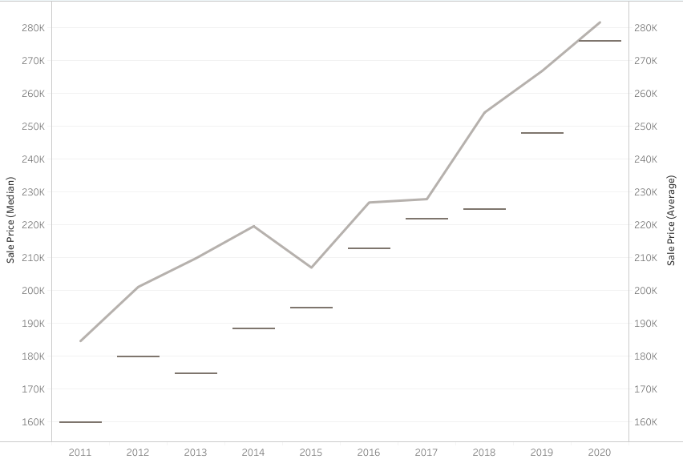
Source: DOA 2020
Table 2.9 shows the type of housing purchased in the Town of Shelby from 2016 to 2020. Ranch style homes have been the most popular home to purchase from 2016 to 2020. Contemporary homes and bi-level homes have also been bought more than other styles of homes in the area. This data shows either residents favor living in ranch style homes verses other styles of homes and/or this is the most predominant type of home available in the Town.

Table 2.9 Type of Housing Sales
Housing | 2016 | 2017 | 2018 | 2019 | 2020
Ranch | 27 | 23 | 30 | 27 | 38
Bungalow | 3 | 2 | 0 | 0 | 0
Bi-Level | 4 | 6 | 9 | 7 | 9
Duplex | 10 | 6 | 0 | 0 | 0
Apartment 4-23 Units | 0 | 1 | 0 | 0 | 0
Cape Cod | 1 | 5 | 3 | 3 | 3
Modern Single Story | 1 | 0 | 0 | 0 | 1
Modern Multi-Story | 0 | 0 | 2 | 4 | 4
Colonial | 0 | 0 | 1 | 2 | 4
Contemporary | 5 | 1 | 4 | 8 | 3
Farmhouse | 0 | 0 | 1 | 0 | 0
Prairie | 1 | 1 | 0 | 0 | 0
Condo | 0 | 0 | 4 | 3 | 4
Victorian | 0 | 1 | 0 | 0 | 0
Mini Warehouse/Storage Units | 0 | 0 | 0 | 0 | 8
Warehouse | 1 | 0 | 0 | 0 | 0
Office Other | 0 | 0 | 1 | 0 | 0
Office Medical | 0 | 1 | 0 | 0 | 0
Retail/Shopping | 0 | 1 | 0 | 0 | 0
Other | 0 | 0 | 5 | 6 | 10
Source: DOA 2016-2020

Special Needs Housing
The State of Wisconsin’s Department of Health and Family Services keeps an inventory of assisted living facilities. While there are none listed for the Town of Shelby, nearby facilities in the City of La Crosse are numerous. In the La Crosse-Onalaska area there are:
- 4 Adult Day Care Facilities
- 14 Adult Family Home
- 17 Community Based Residential Facilities
- 16 Residential Care Apartment Complex
- 2 Home Health Agencies
- 8 Licensed Nursing Homes

Transportation
This element includes a compilation of background information, goals, objectives, and recommendations to guide the future development of Shelby’s transportation system.
GOAL 1
Maintain a safe, efficient, and economical transportation system by proactively addressing the varied vehicle, bicycle, pedestrian, and transit needs.
Objective 1-1: Assess impact of future development on the Town and region’s transportation infrastructure.
Objective 1-2: Better connect the region’s walking and biking infrastructure through trails, paths, and on-street routes.
Objective 1-3: Monitor the feasibility of participating in public transit programs.
Objective 1-4: New streets and reconditioning of existing streets will seek to implement the provisions of the adopted "Bicycle & Pedestrian Plan Element" of the "La Crosse Area Long-Range Transportation Plan.”

ACTIONS
Action 1: Support and assist the work of the La Crosse Area Planning Commission (LAPC) in developing regional cooperation to provide the most cost-effective public transportation countrywide.
Action 2: Encourage cooperative transportation efforts.
Action 3: On an annual basis, continue to review and upgrade the roads under Shelby’s jurisdiction based on safety, level of service and pavement condition criteria.
Action 4: Improve development review to ensure that all private and public development is undertaken in a manner which minimizes increased traffic congestion and land use conflicts.
Action 5: Traffic calming techniques should be included in all new developments where appropriate.
Action 6: When new roads are required, minimize the use of dead-end roads and cul-de-sacs whenever possible. New driveways shall continue to be regulated to ensure sufficient emergency vehicle access and to maintain safe driveway spacing standards.
Action 7: Require developments to provide appropriate areas for future transit and transportation facilities.
Action 8: Work with the Wisconsin Department of Transportation as they develop and make modifications to State and Federal Highways to create “limited access highways” so that their actions to promote safer travel do not mean increased speed limits on local highways.

Existing Road Network
U.S. Highway (USH) 14 & 16
Highways 14 and 61 share a common roadway from their entry point into Wisconsin from Minnesota via La Crosse's Cass Street and Cameron Avenue Bridges, to Vernon County. Within the City of La Crosse, as well as a small segment of the Town of Shelby, the urban street carrying these two highway designations, as well as STH 35, is Mormon Coulee Road. At a location which longtime residents of La Crosse still refer to as the "Ten Mile Hill", USH 14/61 splits off to the east while STH 35 continues south designated as "The Great River Road.” This intersection is now entirely within the City of La Crosse. At the Ten Mile Hill, USH 14/61 has a four-lane, 52-foot-wide pavement, with curbed urban cross section. East of Ten Mile Hill grade, USH 14/61 has a two-lane, 24-foot-wide pavement with an eight-foot shoulder on each side and three feet of which is paved. Every parcel of land that has a property line common to the state right of way for USH 14/61 has an access control restriction entered onto the property description at the La Crosse County Recorder's records. This severely restricts the placement of additional access points onto highway right-of-way, and also places similar restriction on town road access within 300 feet of the USH 14/61 centerline. While not totally prohibited, any additional access requests will be closely scrutinized by the Wisconsin Department of Transportation (DOT) and internal road connections to an existing access point on the state road or a local road will be the preferred solution. This access control project reaches from Brickyard Road eastward to the La Crosse – Vernon County line.
State Trunk Highway (STH) 33
This highway, known as State Road in the City of La Crosse and a portion of Shelby, enters the Town of Shelby at 32nd Street, with the south side of the street being in the Town, although the city limits extend another 1,000 feet or so along the north side of the road. The Highway has high traffic volumes which reflect the heavy local service use this part of State Road receives by serving the Wedgewood Terraces, Wedgewood Valley, and Greenwald Coulee subdivisions, as well as the Towns of Greenfield and Barre, and the Village of West Salem.
From the city limit eastward to Wedgewood Drive, State Road is 48 feet wide, four lanes, with an urban curb cross section. A paved pedestrian walkway is located on the north side of the road, separated by the curb. This pathway also serves as a bicycle path, although there are no restrictions against a bicycle exercising its legal right to ride in the roadway at this point. East of Boma Road STH 33 pavement narrows to 36 feet, and an east bound climbing lane continues to the top of Irish Hill. The paved pedestrian way ends, but a 10-foot-wide paved shoulder continues on the north side of the roadway to within 150 feet of Forest Ridge Drive. At the top of the hill the roadway continues as a two-lane, 24-foot-wide pavement with each shoulder ranging from three to five feet to the Town of Greenfield Town line.
STH 35-Great River Road
This highway is concurrent with USHs 14 and 61 from the Five Mile Hill junction, whereupon STH 35 continues south for about 1.8 miles to the Vernon County line. This pavement and shoulder width has been determined adequate for the existing traffic volumes, but the constraining feature is the access points from public streets and private drives.
The Great River Road in Wisconsin is designated and administered by the Wisconsin Mississippi River Parkway Commission. This Commission is part of the international commission composed of delegates from the ten Mississippi River states plus the province of Ontario in Canada. The purpose of the Parkway is to develop a travel route dedicated to leisurely travel with an emphasis on the scenic and historical qualities of the Mississippi River, which acts as the common thread binding the road together. This must occur on a public roadway which, in the case of STH 35 south of La Crosse, is also the principal link between La Crosse and Prairie Du Chien. These two goals are sometimes at cross purposes as the desire of one group is to maintain a scenic roadway for leisure travelers and the other group wants a direct truck and auto route for commercial purposes. This road is scheduled to be improved to a four-lane cross section starting in the next ten years.
CTH F
This 2.18-mile segment of Rural Major Collector begins/ends at STH 33 near the top of Irish Hill. Within the Town of Shelby, it provides access to a condominium project, eight Town roads, CTH FO, four residential subdivisions, and a multi-family residence. At the road’s northern end there is approximately one mile of length in the Town of Medary where access is made to CTH FA, then it enters the City of La Crosse and is known as Bliss Road, which is the city street providing access to Granddad Bluff Park up the bluff from Main Street.
CTH FO
This Rural Minor Collector begins at CTH F and extends 1.07 miles to the east Town line. After entering the Town of Greenfield, it connects to CTH OA, and provides access to Barre Mills and West Salem.
CTH GI
This Rural Minor Collector of 2.74 miles serves the Goose Island County Park, and it includes spurs and its own dead-end, all within the park. It has a 22-foot pavement except for one segment of 20 feet, and 2-foot shoulders either side. The average daily traffic varies by season, with the heaviest volume being in the summer and fall. There are a large number of bicyclists on the road; however, the slow speed of motor vehicles and the general recreational character of the road does reduce the potential motor vehicle/bicycle conflict. A proposal to widen the shoulders to better accommodate bicycles has been discussed, but the roadbed is located mostly in marsh. Adding the additional fill required for widening the roadway would be both very expensive and environmentally challenging.
CTH K
Located at the extreme southern border of the Town, and La Crosse County, CTH K, a Rural Major Collector, enters the Town for 0.78 miles while primarily serving Vernon County as a link between USH 14 and STH 35. The surface width of the pavement is 20 feet, with 2 feet of shoulder on both sides.
CTH MM
This 4.22-mile road is classified as a Rural Minor Collector and has also been designated a Rustic Road by the Wisconsin DOT. This designation results from a petition from the local unit of government having jurisdiction of the road, and an evaluation by DOT to determine if it meets program standards. The Rustic Road encourages the use of the road for leisure travel by motorists, bicyclists, and hikers. The jurisdiction having responsibility for the road maintains it for safe public travel but is encouraged to preserve the unique scenic qualities through appropriate design standards and maintenance practices, and the encouragement of appropriate zoning to protect compatible adjacent land use. The roadway is currently 20 to 24 feet wide, with a pavement width of one 0.47-mile segment of 18 feet, to 20 feet for the major length of the road. CTH MM connects at each of its ends to USH 14/61 and travels along Brinkman Ridge more or less parallel to the major highway in Mormon Coulee. The area served is a mixture of agricultural fields and woods with little development.
CTH YY
A 0.19-mile segment of this Rural Minor Collector extends north from USH 14/61 right on the Shelby/Greenfield Town line. CTH YY extends through Greenfield to connect with STH 33 about two miles west of the unincorporated village of St. Joseph. There are no buildings in the Town of Shelby on this road.
Town Roads
Shelby has over 45 miles of local roads which are credited to the Town’s mileage base by DOT for mileage payments. These roads range all the way from 0.11 miles of Losey Boulevard, a four lane, 52-foot-wide urban street with an average daily traffic (ADT) of 22,000 to 0.94 miles of crushed rock surfaced rural roads, spread among four separate dead-end lanes, each serving one or two houses, or out-buildings. Maintenance on urban streets, especially snowplowing or sanding, is coordinated with the City of La Crosse, and on occasion a snowplow from one or the other jurisdiction may handle the neighboring jurisdiction’s street for a short distance. Some other Town roads, such as North Chipmunk Road, also pass in and out of neighboring jurisdictions, and require maintenance coordination. North Chipmunk is the longest stretch of Town road, with 1.83 miles before passing into Vernon County, to reenter into Shelby farther west. Four other roads, Bloomer Mill, Skyline, Breidel Coulee, and Hagen Road are all over a mile long; all other Town roads are less than a mile long, with about 15½ miles of “final segments” being dead ends or cul-de-sacs (see Map 3.1 Average Daily Traffic Appendix C).
Road Name | Length | Width | Notes
14th Street South
15th Street South
26th Street South | 634 | 28 | Resurfaced in 1972
27th Street South | 1151 | 32 | Resurfaced in 1974
28th Street South | 264 | 36 | Resurfaced in 2013
32nd Street South
Apple Orchard Lane | 264 | 22 | Resurfaced 1974
Bank Drive | 1056 | 34 | Resurfaced 1968
Bank Drive West | 476 | 32
Battlestone Station Road | 1426 | 24
Birchview Road | 1056 | 20
Birchwood Lane | 1584 | 20
Bliss Road
Bloomer Mill Road | 8712 | 20
Boma Court | 151 | 23
Boma Road | 5591 | 22
Boschert Street | 792 | 34
Boulder Court | 422 | 25
Breidel Coulee Road | 6811 | 16
Briarwood Avenue | 5545 | 24-26
Brickyard Lane | 317 | 36
Brookside Drive | 1374 | 22
Brookside Lane | 422 | 24
Burr Oak Street East | 475 | 34
Burr Oak Street West | 528 | 34
Carla Court | 898 | 26
Cedar Hills Lane |  |  | Private Road
Cedar Road | 2112 | 20
Center Street | 1003 | 24
Cherrywood Drive | 686 | 22
Chipmunk Road N
Circle Place | 211 | 20
City View Lane
Cliffside Drive | 1162 | 26-30
Continental Lane | 1795 | 24
Cottonwood Drive | 581 | 18
Coulee Avenue | 475 | 20-26
Coulee Springs Lane | 950 | 20
Crestview Place | 317 | 20
Crown Boulevard | 1410 | 22
Crystal Drive | 581 | 22
Deerview Drive | 1003 | 28
Dengel Road | 792 | 16
Diagonal Road | 422 | 30-32
E Helke Road | 2112 | 18
Eagle Point Drive |  |  | Private Road
Easter Heights Road | 370 | 14
Easter Road | 3432 | 16-18
Ebner Coulee Road | 3746 | 18
Eddie Avenue | 739 | 24
Elm Drive
Emerald Court | 475 | 20
Evergreen Lane | 1320 | 24
Farnam Street | 1004 | 22
Fen Lockney Drive | 1109 | 22
Ferndale Lane | 634 | 28
Floral Lane | 246 | 28
Forest Ridge Drive | 2956 | 24
Frank Court | 475 | 36
Glenhaven Drive | 845 | 30
Green Street | 581 | 22
Greenbriar Court | 845 | 22-26
Gronemus Road | 2376 | 14
H Helke Road | 3168 | 16
H Werner Road | 2851 | 14
Hagen Road | 6353 | 26-36
Hanifl Road | 1373 | 18
Harvest Lane | 3168 | 24
Heatherwood Place | 528 | 24
Hiawatha Avenue | 898 | 30
Hickory Lane | 1636 | 18-22
Highland Place | 1268 | 24
Hillcrest Drive | 2060 | 24-28
Hoeschler Court | 211 | 10
Hoeth Street | 1425 | 22-24
Horseshoe Place | 3908 | 28-30
Hypoint Drive | 1320 | 32
Irish Court | 1056 | 20
Janisch Road | 898 | 18
Johnson Road | 2587 | 20
Joy Lane | 1848 | 36
Justin Road | 2584 | 16
Kammel Road | 897 | 18
Kearns Court | 1320 | 28
Knobloch Road | 7392 | 24-25
Kreutz Lane | 1373 | 24
Lauterbach Road | 4594 | 20
LeJeune Road | 2270 | 14
Leske Road | 2247 | 16
Lisa Lane | 1109 | 24
Little Avenue | 370 | 16
Lochnairn Court | 686 | 22
Losey Boulevard South | 581 | 48
Mark Place | 475 | 18
Markle Road | 784 | 30-34
Mc Laren Road | 1109 | 22
Mesa Road | 581 | 20
Meyers Road | 1320 | 24
Mickel Road | 1742 | 26-28
Mill Street | 2164 | 25-30
Mormon Drive | 1215 | 22
Mormon Place | 211 | 20
Nolop Road | 528 | 20
Norseman Drive | 1056 | 20
North Chipmunk Rd | 10138 | 20-22
Oak Drive | 951 | 34
Old Highway 35 | 1162 | 18
Old Town Hall Road | 1690 | 22
Old Vineyard Road | 1954 | 20
Orchard Valley Drive | 2615 | 28-36
Pammel Pass East | 1267 | 22-24
Pammel Pass West | 1109 | 20-22
Paris Angel Drive | 845 | 22
Park Drive | 3221 | 18-28
Pine Bluff Road | 1109 | 20
Pinecrest Court | 475 | 32
Pineview Drive | 792 | 66
Queen Avenue | 423 | 22
R Herold Road | 264 | 14
Raatz Road | 422 | 26
Red Oaks Drive | 1901 | 24
Redwood Court | 1003 | 26
Ridgewood Lane | 1003 | 22
Ristow Court | 158 | 22
Rochelt Road
Rosewood Lane | 317 | 16
Schlicht Lane
Schroeder Road | 475 | 16
Scott Drive | 369 | 24
Shelby Road | 336 | 32
Sherwood Drive | 898 | 32
Shorewood Drive | 2270 | 22-26
Skemp Road | 3643 | 10-14
Skyline Boulevard | 8448 | 18-32
Southdale Drive | 2112 | 32-35
Sprig Street | 739 | 22
Springbrook Way
Starlite Drive | 845 | 28
Stonecrest Road | 1267 | 24
Summit Drive | 634 | 32
Terrace Drive | 845 | 28
Terry Court | 845 | 24
Thistledown Drive | 1373 | 24
Three Town Road | 1583 | 66
Timber Lane | 211 | 22
Timber Valley Road | 2112 | 22
Troy Road | 475 | 24
Valley Parkway | 370 | 18
Valley Road | 3485 | 92
Vanity Drive | 2060 | 60
Velmar Court | 528 | 32
Vista Drive | 423 | 24
W Werner Road | 1742 | 16
Ward Avenue | 634 | 42-44
Wedgewood Drive East | 3221 | 20-22
Wedgewood Drive West
Wedgewood Drive | 476 | 30
Williams Place | 422 | 30
Willow Trail | 3227 | 22
Willow Way East | 2112 | 102
Willow Way West | 2218 | 26-32
Woodhaven Drive | 1742 | 24
Woodland Drive | 792 | 36

Table 3.1 Town of Shelby Average Daily Traffic
 | 1996 | 1999 | 2002 | 2011 | 2017
STH 35/USH 61/14 | 9,600 | 10,400 | 10,600 | - | 10,400
STH 35/CHY K | 9,500 | 10,400 | 9,900 | - | 10,400
USH 61/14/CTH YY | 7,600 | 6,300 | 5,800 | - | 6,100
STH 33/CTH F | 3,900 | 3,900 | 4,300 | 3,400 | -
Source: WisDOT 2018

Transportation of Goods and Freight
According to the 2018 State Freight Plan, six freight-dependent sectors and their composite industries comprised almost 40 percent of Wisconsin’s employment and 44 percent of the state’s GDP. The six sectors are 1) wholesale and retail, 2) manufacturing, 3) agriculture and forestry, 4) construction, 5) transportation, information, and utilities/energy, and 6) mining. The convergence of highway, rail, and water cargo facilities in La Crosse County provides the opportunity for a fully intermodal terminal for freight distribution. The County’s closest intermodal terminals are in Minneapolis/St. Paul and Chicago.

Truck Routes
The officially designated state or federal trucks routes within the Town of Shelby are USH 14/61, STH 35, and STH 33. A discussion of these routes can be found at the beginning of this chapter.
Water
Direct water access for waterborne freight is available through both public and private terminals in the City of La Crosse and the Town of Campbell. The Port of La Crosse serves incoming and outgoing barge traffic on the Mississippi River. The port handles nearly 1.3 million metric tons of commodities annually and offers connections to the Upper Midwest and the world, including China, Russia, Spain, South America, Mexico, and other countries. For information regarding the future of Wisconsin Commercial Ports Association (WCPA), refer to the WCPA strategic plan.
Rail Freight
La Crosse County has rail cargo service through three Class I railroad companies, all of which provide direct access to Chicago and connections to eastern points. The Canadian Pacific Railway connects La Crosse to Milwaukee and Minneapolis/St. Paul. This company provides service, or potentially could provide service, to Rockland, Bangor, West Salem, and the north side of La Crosse. The Union Pacific Railroad operates with trackage rights on the Canadian Pacific between Tomah and Winona. The Burlington Northern & Santa Fe operates in the far western part of the County in a north-south orientation and provides service to industries on the south side of La Crosse and Onalaska. The Wisconsin State Rail Plan 2030 indicates shipments by rail and trucking freight are anticipated to grow through year 2030. Forecasts from the Wisconsin State Rail Plan 2030 are listed below:
- Increase in weight of freight rail commodities by over 16 percent
- Increase in value of freight rail traveling in Wisconsin by 18 percent
- Decrease in value of freight rail traveling from Wisconsin
Air Cargo
The La Crosse Municipal Airport serves as an air cargo facility. The airport is not one of the state’s six primary air cargo airports, but it does function as a feeder air service. Rather than maintain and operate a fleet of small aircraft, the integrated express carriers’ contract for on-demand service with a variety of aircraft operators. The Wisconsin State Airport System Plan 2030 forecasts for all-cargo aircraft operations at La Crosse Municipal Airport to continue to grow. In 2020, state forecasts predicted that the La Crosse Municipal Airport will have the second highest aircraft operations by commercial air cargo carriers, second to General Mitchell International in Milwaukee, but that the La Crosse Municipal Airport’s share of the state’s air cargo operations will be less than 12 percent. This prediction held true and is anticipated to grow in the following years.

Analysis on Regional Movement of People
Highway Network
The following street types move people throughout the region:
- Principal Arterials – Serve longer intra-urban trips and traffic traveling through urban areas. They carry high traffic volumes and provide links to major activity centers.
- Minor Arterials – Provide intra-community continuity and service to trips of moderate length, with more emphasis on land access than principal arterials. The minor arterial system interconnects with the urban arterial system and provides system connections to the rural collectors.
Air Transportation
The La Crosse Regional Airport, located northwest of the Town, is one of nine Wisconsin airports that have commercial air passenger service on a year-round basis. The airport is located on “French Island” as it is known to locals, and it serves passenger air travel through connections to regional hubs. The La Crosse Regional Airport is served by American Airlines and Delta Air Lines with three daily non-stop hubs. These include Minneapolis-St. Paul, Chicago, and Detroit. The airlines process nearly 90,000 enplanements and 180,000 total passengers annually. At the airport, the multimodal connection opportunities are to rent a vehicle from four national car rental companies (Avis/Budget, Enterprise, Hertz, and National/Alamo), or to use local city bus Route 4 (French Island/Industrial Parks).
The Wisconsin State Airport System Plan 2030 forecasts an increasing number of enplanements. The plan forecasted 109,960 thousand enplanements in 2010 and 122,570 enplanements in 2030. This is a 0.5% increase from 2010 to 2030, the same as the state average over this time period.
Passenger Rail
Intercity passenger rail is available through Amtrak service in the City of La Crosse. The Amtrak Empire Builder serves La Crosse, with regional connection to Chicago, Milwaukee, Columbus, Portage, Wisconsin Dells, Tomah, Winona, Red Wing, and St. Paul. The Empire Builder also connects to the West Coast (Seattle, WA and Portland, OR). Through a connection in Chicago, the national Amtrak network is available. The passenger rail station is located at St. Andrew and Caledonia Streets (601 St. Andrew Street in the City of La Crosse).
WisDOT has been studying ways in which Wisconsin’s intercity passenger rail system could be expanded and developed into a more robust component of the state’s overall transportation system. WisDOT, along with Amtrak and eight other Midwestern state DOTs, is currently evaluating the Midwest Regional Rail System, a proposed 3,000-mile, Chicago-based passenger rail network in the Midwest. The regional rail system would provide 6 round trips at peak times between Chicago, Milwaukee, Madison, La Crosse, and St. Paul. Modern trains operating at peak speeds of up to 110-mph could produce travel times competitive with driving or flying.
Intercity Bus
Intercity passenger bus service in the La Crosse area was provided by Greyhound Lines; however, in August 2004, Greyhound discontinued service to the La Crosse area as part of its route restructuring. Intercity bus transportation is now provided by Jefferson Lines, a connecting carrier to Greyhound Bus Lines. Jefferson Lines runs daily scheduled bus service that connects to Greyhound’s national service in Madison and Minneapolis/St. Paul. The intercity bus terminal is located at 601 St. Andrew Street in the City of La Crosse.

Analysis on the Local Movement of People
Local Roadway Network
The street network shapes access and circulation through the Town. Public streets in the area are classified by their primary function, as described below:
- Principal Arterials – Serve longer intra-urban trips and traffic traveling through urban areas. They carry high traffic volumes and provide links to major activity centers.
- Minor Arterials – Provide intra-community continuity and service to trips of moderate length, with more emphasis on land access than principal arterials. The minor arterial system interconnects with the urban arterial system and provides system connections to the rural collectors.
- Collectors – Provide both land access and traffic circulation within residential neighborhoods, commercial areas, and industrial areas. These facilities collect traffic from local streets in residential neighborhoods and channel it onto the arterial system. In the central business district, and in other areas of like development and traffic density, the collector system may include the street grid which forms the basic unit of traffic circulation.
- Local Streets – Local streets primarily provide direct access to adjacent land and access to higher order systems. Local streets offer the lowest level of mobility and through traffic movement on this system is usually discouraged.
Public Transportation and Transit
The Town currently does not participate financially in supporting mass transit service but two La Crosse Municipal Transit Utility (MTU) routes pass through the edges of the Town, and one other route passes close enough to parts of the Town to provide reasonable service to at least some Town residents. The Town briefly subsidized an extension of MTU Route 3 but ended the subsidy because of low fares and ridership.
Paratransit
Paratransit, in its broadest sense, includes all modes of “public” or “mass” passenger transportation systems other than privately driven automobiles or regularly scheduled bus/train service. La Crosse County Department of Aging contracts with a private operator to provide “mini-bus” service to all residents of La Crosse County age 60 or over, or 18 and over who are self-defined disabled, or otherwise unable to use conventional mass transit if it is available. In the Town of Shelby this service is available certain days of the week on a demand response door-to-door, with a hierarchy of trip purposes determining the priority for space and time.
To meet the special needs of persons with disabilities and to comply with the Americans with Disabilities Act, MTU operates lift-equipped buses on its regular fixed route system. MTU also provides complementary Paratransit Service. Disabled persons who, by reason of their disability cannot get to a bus stop from their home, from the bus stop to their destination, or who require more assistance in using transit service than that provided by a driver operating a lift equipped MTU bus, may qualify for ADA Paratransit Service.
Taxis
There are three taxicab companies operating in the La Crosse area that will provide chauffeured taxi service from or to anywhere in the County, or to or from other destinations, with a La Crosse County starting or ending point, at market rates. Rideshare options are also available such as Uber and Lyft.
Biking
The La Crosse area has an extensive system of both on-road bicycle and off-road multipurpose facilities, especially in the more urbanized areas. The Beyond Coulee Vision 2040 describes in detail each of the off-road and on-road bicycling facilities. On-road bicycle routes include both intracity and intercity routes, with intercity routes achieving state and national significance. On-road intracity routes tend to align with minor arterial streets in order to take advantage of signalization and connectivity. Greater directness could be achieved by following major arterials; however, those alignments are more heavily trafficked and pose a greater danger to bicyclists. Map 3.2 Trails and Bike Lanes in Appendix C shows bike lanes, sharrolws (shared lane marking on street), shoulders, and trails developed in the Town of Shelby.
The La Crosse Area Planning Committee (LAPC), the designated Metropolitan Planning Organization (MPO) in La Crosse created a plan called the Beyond Coulee Vision 2040. Table 3.2 is from the Beyond Coulee Vision 2040 showing a comparison of bike lane miles from 2015 and 2018.

Table 3.2: Comparison of Bike Lane Miles, 2015 and 2018
Community | Lane Miles 2015 | Lane Miles 2018 | Percent Change
La Crosse | 12.3 | 17.6 | 43.1
Onalaska (C) | 6.7 | 10.6 | 58.2
La Crescent | 4.5 | 4.5 | 0.0
Shelby | 3.2 | 3.2 | 0.0
Onalaska (T) | 2.3 | 2.3 | 0.0
Holmen | 0.6 | 0.6 | 0.0
Campbell | 0.0 | 0.6 | 100.0
West Salem | 0.6 | 0.6 | 0.0
Total | 30.2 | 40.0 | 32.5
Source: LAPC GIS
Walking
Pedestrian facilities are not mapped by most local governments in La Crosse County, including the Town of Shelby. The Beyond Coulee Vision 2040 summarizes information on sidewalks as follows:
Sidewalks offer the most efficient and effective means for making short trips in urban areas and for safely accessing transit stops. They run parallel to roadways, providing equivalent connections between origins and destinations as the roadways themselves. The development of sidewalks is addressed by municipalities in their municipal codes, identifying where and how wide sidewalks must be if required at all. Table 13 summarizes the sidewalk requirements for communities with provisions in their municipal codes. All but the town of Campbell require sidewalks or trails on at least one side of arterial and collector streets.
Only 29 percent of the centerline miles in the urbanized area have sidewalks on both sides of the street. An additional 9 percent of the centerline miles have sidewalk on one side and 4 percent have trail on one side, totaling 13 percent of the centerline miles with accommodations on only one side. More than 57 percent of the centerline miles in the urbanized area have no sidewalks or trail. Figure 35 shows how roads with sidewalks on both sides are concentrated in the core areas of the cities and villages.
Trails
The LAPC planning area has over 87 miles of trails—of which about 12 miles are for walking only. The nearly 76 miles of shared trails include about 22 miles of the unpaved Great River State Trail and La Crosse River State Trail. These trails are managed by the Wisconsin Department of Natural Resources and require a state trail pass for bicyclists 16 and older. Walkers, cross-country skiers, and snowshoers do not need to purchase a trail pass. Funds from snowmobile registration fees allow snowmobilers to use the trails without purchasing a trail pass.
The remaining 54 miles of shared trails only allow bicyclists and pedestrians. Table 3.3 summarizes the trail miles of shared-use and walking trails for the planning area communities with trails. Trail miles increased about 13 percent since 2015 (Coulee Vision 2040), with 57% of the trail development occurring in the cities of Onalaska and La Crosse. The Town of Shelby has 3.30 miles of shared-use trails and 1.02 miles of walking trails.

Table 3.3 Trail Miles in the LAPC Planning Area
Community | Shared-Use Trails (miles) | Walking Trails (miles)
Dresbach | 2.41 | -
La Crescent | 1.99 | 1.22
Hamilton | 8.06 | -
Holland | 5.67 | -
Holmen | 2.77 | -
La Crosse | 23.46 | 2.97
Medary | 6.22 | -
Onalaska (C) | 10.56 | 5.35
Onalaska (T) | 9.99 | 1.07
Shelby | 3.30 | 1.02
West Salem | 1.42 | -
Planning Area | 78.85 | 11.63
Source: LAPC GIS 2021

Transportation Plans
As the Metropolitan Planning Organization (MPO) for the La Crosse, WI-MN urbanized area, the La Crosse Area Planning Committee (LAPC) is required to develop a transportation plan with a 20-year-or-more planning horizon that includes “both long-range and short-range strategies/actions that lead to the development of an integrated intermodal transportation system that facilitates the efficient movement of people and goods.” The MPO has addressed land use and transportation goals for the area that can be found in the Beyond Coulee Vision 2040 Plan. The LAPC goal analysis of long-range transportation planning with the Town of Shelby can be found in Appendix B. An overview of local traffic in the Town of Shelby can be found on Map 3.3 Transportation in Appendix C.
In 2015 the Coulee Region Transportation Study looked at various strategies to expand on and improve current facilities in the La Crosse Area. The purpose of the study is to identify strategies that address safety, infrastructure deterioration, congestion, multimodal deficiencies, environment and support economic development and livability in the Coulee Region. The goal of the study was to:
“Improve the long-term movement of people and goods, safely and efficiently, in a manner that accommodates economic development, incorporates community plans, and limits adverse environmental impacts and social effects, in ways that support the regions natural beauty and livability and contribute positively to the region's quality of life.”
Updates to this study will are scheduled from summer of 2022.

Programs for Local Government
WisDOT administers a variety of state and federal programs, including:

- Airport Improvement Program (AIP)
- Connecting Highway Aids
- County Elderly and Disabled Transportation Assistance
- Federal Discretionary Capital Assistance
- Freight Rail Infrastructure Improvement Program (FRIIP)
- Freight Rail Preservation Program (FRPP)
- General Transportation Aids (GTA)
- Highways and Bridges Assistance
- Local Bridge Improvement Assistance
- Local Roads Improvement Program (LRIP)
- Local Transportation Enhancements (TE)
- Railroad Crossing Improvements
- Rural and Small Urban Public Transportation Assistance
- Rural Transportation Assistance Program (RTAP) Rustic Roads Program
- Surface Transportation Discretionary Program (STP-D)
- Surface Transportation Program – Rural (STP-R) & Urban (STP-U)
- Traffic Signing and Marking Enhancement Grants Program
- Transportation Economic Assistance (TEA)

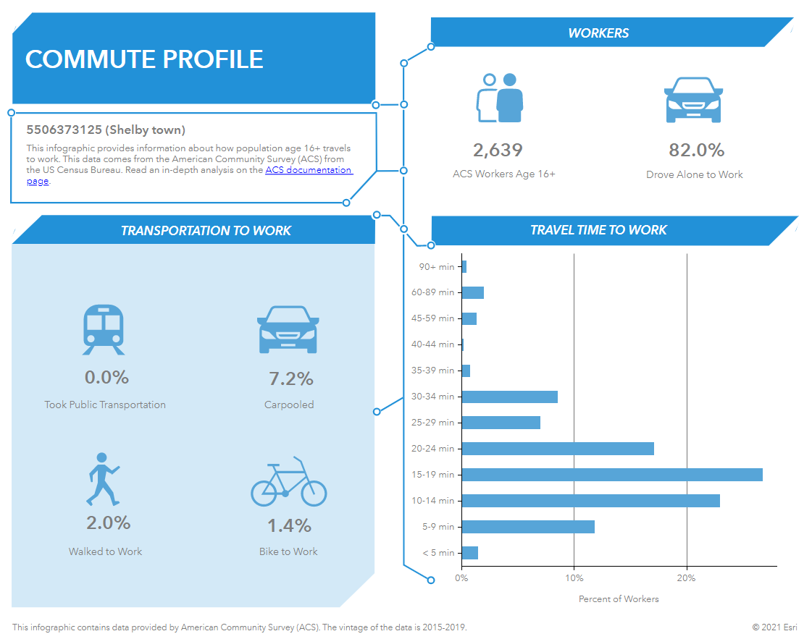

Figure 3.1 Town of Shelby Commute Profile

Utilities and Community Facilities
This element includes background information, goals, objectives, and recommendations to guide the future development of utilities and community facilities in the Town of Shelby. It describes current facilities and includes recommendations for future utilities’ needs, upgrades, and considerations. The Town of Shelby survey indicated:
- The majority of respondents have neither municipal sewer nor water services
- Residents are satisfied with municipal sewer and water services (where available)
- If the Town expands municipal sewer and water services to new developments, they should share the cost with the developer or the Town
- If the Town expands municipal sewer and water in developed areas the cost should be shared with property owners and the Town

GOAL 1
Maintain quality public services that provide for increased public safety, a low crime rate, a strong rural and urban economy, a clean environment, and reasonable and equitable taxes.
Objective 1-1: Recognize that new occupied structures within the Town will be serviced by the Shelby Sanitary District, private individual systems, or some other form of “off-site” wastewater disposal.
Objective 1-2: Explore urban “off-site” waste treatment systems. Other new technologies need to be explored for areas not served by sanitary sewer.
GOAL 2
Avoid environmentally sensitive areas when extending and constructing new utilities and community facilities.
Objective 2-1: Consult the community facilities maps before making decisions regarding location of new utilities or community facilities and encourage development and redevelopment practices that will maintain or improve the natural environment.

ACTIONS
Action 1: Identify preferred “off-site” waste treatment systems for use in urban developments. Ensure these facilities are owned and maintained by a consortium of property owners.
Action 2: Continue to upgrade and maintain the Shelby Sanitary District as required to meet or exceed DNR standards.
Action 3: Explore the development of a stormwater plan in areas known to be flood prone, or where community infrastructure encounters damage in flood events. Follow-up planning efforts with stormwater management ordinances and require costs for stormwater infrastructure be borne upon developers for each project.
Action 4: Limit expansion or development of infrastructure in areas where such development would cause subsurface contamination or result in increases in surface runoff.
Action 5: Encourage (or require by ordinance) design and landscaping patterns in new development that encourage retention of natural vegetation to control erosion and runoff.
Action 6: Work in partnership with local and regional entities (La Crosse County Planning & Zoning, the DNR, LAPC, Mississippi Valley Conservancy, etc.) to develop and disseminate education materials and model ordinance language for erosion control and site planning for all new development.

Water Supply
Four residential areas of the Town are served by a regulated public water system. Shelby Sanitary District Two serves 277 customers in Arbor Hills, most of Wedgewood Valley, and the Skyline Addition, which includes all of the Hagen Road accessed properties from Sherwood Drive to the south. The two Wedgewood Terraces are served by a 181-customer cooperative water system, which purchases wholesale water from the Sanitary District. There are 10 to 15 instances of two to six homes sharing a single well, and a few lots in the “Urban Island” portion that are served and billed by the City of La Crosse. The rest of the Town residents obtain their water from their own private well.

Table 4.1 Town of Shelby Municipal Water Supply, 2020
Name | City | Storage Capacity
La Crosse Waterworks | La Crosse | 5,000,000
Shelby Arbor Hills | La Crosse | 44,000
Shelby Skyline Addition | La Crosse | 47,000
Shelby Wedgewood Terrace | La Crosse | 152,000
Source: Town of Shelby, WI DNR, SHE Report 2018

While the Town’s precipitation and soil geology allow for rapid groundwater recharge, they also allow for groundwater contamination from surface activities. There are many contaminated groundwater sites within La Crosse County and with continued growth in population and economic activity, the demand on groundwater supplies will continue to increase. To assist in preventing further groundwater contamination, a groundwater modeling study of La Crosse County was completed in 2003. This study assessed the effects of recent and potential future groundwater withdrawals and provides a suitable tool to evaluate the effects of proposed water management programs. The plan identifies the extent of contamination on existing sites and the direction in which these contaminated sites are flowing.

Sanitary Sewer
Several residential subdivisions and commercial and industrial properties in Shelby are served by two different sanitary districts, while the remainder of properties within the Town have their own septic system. Shelby Sanitary District One has been taken over by the City of La Crosse, and much of the area served by it has been annexed; the town island and properties on the southeastern fringe of the City of La Crosse along Cliffside Drive remain in the unincorporated portion served by Sanitary District One. Administration and maintenance of this district including the billing of Shelby property owners served, is done by the City of La Crosse. Sanitary District Two is administered and maintained by the Town of Shelby. Approximately 14 miles of sanitary sewer mains serve Arbor Hills, the Wedgewood Terraces, Wedgewood Valley, the Hagen Road -Greenwald Coulee Subdivisions, Creekside Meadows, and Breidel Coulee; along the HWY 33 corridor between Norseman Drive and the City of La Crosse limits. Most town areas adjacent to the City, such as Ebner Coulee, Floral Lane, and Old Vineyard Addition are also served by Sanitary District Two. All wastewater from both sanitary districts is treated at the La Crosse municipal wastewater plant on Isle La Plume. There are 819 single family homes, 1 multi-family unit site, 6 commercial sites, 1 industrial site, and 4 lift stations within this district. A Sanitary Collection Facilities Plan was created in 2019. This Sanitary Collections Systems Facilities Plan provides the Town of Shelby Sanitary District #2 a summary of its existing sanitary sewer collection system along with a preliminary assessment of future system needs based on existing comprehensive plan boundaries and the City of La Crosse and Town of Shelby Boundary Agreement. An overview of the Town of Shelby utilities and sanitary district boundaries can be found on Map 4.1 Utilities in Appendix C.
The Isle La Plume facility was originally constructed in 1936, but has been modified and upgraded many times, with the last major upgrade occurring in 2021. The Sanitary District is supported by user service fees paid by its customers.

On-Site Wastewater Treatment Technology
The disposal of wastewater in the remainder of the Town is handled through the use of individual on-site wastewater disposal systems, often referred to as septic system. Septic systems discharge wastewater to underground drainage fields or septic tanks. There are currently six types of on-site disposal system designs authorized for use in the state: conventional (underground), mound, pressure distribution, at grade, holding tank, and sand filter systems. The Wisconsin Department of Commerce (COMM) regulates the siting, design, installation, and inspection of most private on-site sewage systems. Recent changes to the State’s Plumbing Code (COMM 83) allow for both conventional and advanced pre-treatment systems for residential development. The changes allow properties that have soil depths or soil types that were once unsuitable for conventional septic systems to now be developed and serviced by advanced pre-treatment sewage systems. If not properly located or maintained, on-site sewage disposal systems can significantly pollute groundwater.

Solid Waste Disposal and Recycling Facilities
The Town of Shelby offers refuse, on a weekly basis, and recycling collection, on a biweekly basis, to residents within the Town. The Town Hall also has a location for residents to dispose of leaves and grass clippings. Solid waste from the Town is disposed of at the La Crosse County Landfill, which is located east of I-90 and south of Highway 16.
La Crosse County provides public management of an integrated solid waste disposal system that is provided through public/private partnerships. This system is utilized by several counties in Wisconsin and Minnesota. The system accepts residential, commercial, industrial, and institutional wastes. The disposal system processes solid waste into refuse derived fuel which is then utilized in generating electricity. The county provides oversight of a landfill complex which includes sanitary landfill, ash monofil, construction and demolition landfill, clean wood waste processing, and yard waste disposal. La Crosse County provides these services to manage the environmental liability for disposal of these wastes for the protection of La Crosse County.
Solid waste managed by La Crosse County enters one of three waste streams: deposition in the La Crosse County Landfill, incineration at Xcel Energy’s Waste-to-Energy facility on French Island, or recycling. Recycled quantities include materials diverted for recycling at the landfill -- shingles, concrete, tires, scrap metal, yard waste and wood waste.
In total, La Crosse County handled 138,133 tons of solid waste in 2020 – up from 123,274 tons in 2007 (+12.1%), and up from 129,673 tons in 2019 (+6.5%; see Figure 16). The COVID pandemic caused substantially higher citizen usage of the County solid waste system, which explains the increased amount of solid waste generated in 2020. Economic recession may explain the relatively low quantity of solid waste generated in 2009 and the subsequent increasing trend.
Of the total solid waste handled in 2020, 63.0% was deposited into the landfill, 20.8% was incinerated to produce electricity, and 16.2% was recycled. Roof damage caused by storms resulted in large quantities of shingles being received by the County solid waste system in 2020, which explains the increased quantity of recycled material. The 2020 total diversion rate (i.e., the sum of the percent incinerated, and the percent recycled) was 37.0%, down from 41.4% in 2007, but up from 33.5% in 2019. Waste from La Crosse County incinerated at French Island was used to produce an estimated 19.6 million kWh of electricity in 2020, enough to supply approximately 2,153 households.
La Crosse County adopted a Master Land Use Plan (MLUP) for the landfill to guide land use decisions for the site. The most recent plan was created in 2015 and includes short-, medium-, and long-term goals to achieve a balance of economic, social, and environmental land use objectives. For more information on this plan, refer to the Master Land Use Plan for the La Crosse County Landfill.
The Household Hazardous Materials (HHM) Program located at 6502 State Road 16 in La Crosse opened its doors in October 2001. The HHM facility collects hazardous household materials from La Crosse County residents free of charge and for a minimal fee for individuals who reside outside of La Crosse County.

Stormwater Management
Stormwater management has gained attention in recent years as an environmental concern because of its impacts on flooding, property damage, and surface water quality issues. Similar to water supply and wastewater treatment, stormwater management is an important part of municipal infrastructure. The Town of Shelby, pursuant to La Crosse County Code is responsible for collecting, storing, and conveying rainfall and snowmelt runoff in a manner that is safe for the public and does not harm the environment.
In addition, the Wisconsin Department of Natural Resources (DNR) requires an erosion control plan and permit for all projects that disturb one or more acres of land. The landowner is required to ensure that a site-specific erosion control plan and stormwater management plan are developed and implemented at the construction site. Also, the La Crosse County Subdivision and Platting Ordinance requires subdividers to provide a soil erosion plan subject to Chapter 21 of the La Crosse County Code of Ordinances and a stormwater management plan that meets the appropriate post-construction water quality requirements of NR151 of the Wisconsin Administrative Code and the water quantity requirements set forth in the La Crosse County Code of Ordinances.
The La Crosse Stormwater Group is taking on the goal to slow down the rush of rain and snowmelt that pollutes rivers. The Town of Shelby is working with the Group to educate residents and small business owners, about what runoff is, why it is bad, and how to fix it. The Town’s goal is to protect water resources and prevent erosion. The Soak It Up Project Award is given to community members who have finished a stormwater management project on their property and their projects are then shared so others can be inspired to do the same on their properties.
Stormwater runoff in La Crosse County and the Town of Shelby was in part addressed in 2008 when La Crosse County adopted Chapter 29 of the La Crosse County Code of Ordinances “Post Construction Storm Water Management.” The ordinance delegates authority to the La Crosse County Department of Land Conservation to enforce the ordinance. The ordinance includes technical standards, storm water management performance standards, permit requirements, and storm water management plan requirements for new or expanding developed areas.

Telecommunication Facilities
CenturyLink Inc. (Lumen Technologies) provides the County with local telephone service; long distance service is available through several providers. Cellular telephone services are available in Town through a variety of providers. High speed Internet access and fiber optic connections are available in the Town of Shelby through Charter Communications. The region is connected to the Midwestern fiber optic network via CenturyTel. However, this technology is not available throughout the entire Town and certain residents in rural areas within the Town have limited capabilities for high-speed Internet services.

Power Plants, Electricity, and Transmission Lines
Most of the geographic area of the Town of Shelby is served by Vernon Electric Co-op, a local retail distributor of the Dairyland Power Cooperative system. The portions of Shelby most immediately adjacent to, or surrounded by, the City of La Crosse such as Ebner Coulee, La Crosse Floral, Wedgewood Terrace, Wedgewood Valley, Greenwald Coulee, Skyline Addition, and Cliffside Drive/ Crown Boulevard are served by Xcel Energy, and also have piped natural gas service. Arbor Hills, CTHs F and FO, the Coachlite and Pleasant Valley mobile home parks, and everything east of Wedgewood Valley and Greenwald Coulee on STH 33 to the Town line and almost everything east of USH 14/61 and STH 35 intersection, Chipmunk Coulee, and most of the River Hills area is served by Vernon Electric. Goose Island Campground, the HWY 14/61 corridor, and part of the River Hills area is served by Xcel Gas. Map 4.2 Transmission Lines in Appendix C shows the location of local transmission lines.

Libraries
The Town of Shelby is serviced by Winding Rivers Library System in conjunction with the La Crosse County Public Library System. These libraries serve residents throughout the County. A main branch is located in the City of La Crosse and five other branches are located throughout the County. Each of the five communities has designated a Library Commission or Committee to handle the annual expenses and budget concerns of the library facility they provide. These are often elected officials, but they are also Village, Town or City government appointments with little or nothing to gain by the significant contribution they make with their time and talents. All of the La Crosse Libraries belong to the Winding Rivers Library System which gives residents access to a seven-county interlibrary loan system including: Buffalo; Jackson; Juneau; La Crosse; Monroe; Trempealeau; and Vernon Counties.

Schools
The Town of Shelby is served by the School District of La Crosse. The far northeastern corner of the Town is part of the West Salem School District. The School District of La Crosse operates eleven elementary schools, six middle schools, and four high schools. These schools are located throughout the district and include a wide variety of options for students, including charters, magnet, and alternative programs. No schools are located in the Town. Map 4.3 Schools showing local school locations and districts can be found in Appendix C.
In addition, the County has 16 private schools that provide additional educational choices for residents. Within the County, town residents also have access to several post-secondary education schools, including the following:
University of Wisconsin-La Crosse was founded in 1909 and is now one of the 13 four-year campuses in the University of Wisconsin System with enrollment of around 10,000 students. UW-L has joined the City’s other two institutions of higher education and the region’s medical facilities to form a consortium to bring cutting-edge health care to the region, along with a state-of-the-art health research and education facility for professionals and students.
Western Technical College is a public two-year college with a focus on technical education. The college has an annual enrollment of approximately 9,400 credit students and 12,900 non-credit students. The average age of WTC’s credit and non-credit student is 33.
Viterbo University established in 1890, is a co-educational Catholic University founded in the Franciscan tradition. Viterbo offers undergraduate and graduate degrees and has an enrollment of approximately 2,700 students. It offers over 40 academic programs at the associate’s, bachelor’s, master’s, and doctoral level.

Town Buildings
Town Buildings The two principal Town buildings are located across Ward Avenue from each other at 2800 and 2801 Ward Avenue, within a town island surrounded by the incorporated City of La Crosse. The original Town Hall, 2801, was built in 1956-57 and the Town shop was built adjacent. In 1992 the Town bought the building at 2800 Ward Avenue that had been occupied by a tool rental and remodeled it into their Town Hall.

Police, Fire, and Rescue
The Town of Shelby has one full-time police officer that serve the Town. The Police Department is based out of the Town Annex at 2801 Ward Avenue. In addition to the Town police officer, the La Crosse County Sheriff’s Department is located in the City of La Crosse and serves the entire County.
The Town of Shelby has its own fire department that also serves parts of the Town of Greenfield. The department consists of around 40 volunteer fire fighters. The Chief, Assistant Chief, Captains, Lieutenants, EMS Officer and Health and Safety Officer are paid a stipend quarterly for their work as officers. Fire protection and first responder services, fire safety inspection and education are all services provided by the department.
The La Crosse County 911 Emergency Dispatch Center is located in the La Crosse County Law Enforcement Center in La Crosse. Dispatch provides 24-hour emergency telephone service to everyone in La Crosse County. Using a state-of-the-art enhanced 911 system (E-911), the 911 telecommunicator is able to send emergency and non-emergency assistance quickly and accurately. In addition to providing emergency telephone answering service, the La Crosse County 911 Emergency Dispatch Center telecommunicators are the radio and multiple computer system operators. This fully integrated system allows the department to provide full emergency and non-emergency service to each of the eight Law Enforcement Departments, the eight Fire Departments, the nine First Responder organizations, Emergency Government, and Search and Rescue throughout the entire Community.

Health Care Facilities
No health care facilities are located in the Town of Shelby. The nearest health care facilities to the Town are located in the City of La Crosse. Gundersen Health System and Mayo Clinic Health System are two (2) large medical centers that operate in the region, each with a hospital and large clinic in the City of La Crosse. In addition, both Gundersen Health System and Mayo Clinic Health System operate health care facilities (i.e., Express Care, Clinics) in the City of La Crosse, the City of Onalaska and the Village of Holmen.
Gundersen-Lutheran Medical Center is the area’s recognized leader in heart, trauma and cancer care, births, business services, research and health education, with over one million clinic, hospital, and emergency room visits each year. Gundersen Lutheran operates a 325-bed teaching hospital with a Level II Trauma and Emergency Center in La Crosse. Franciscan Skemp, MHS La Crosse Campus operates a 250-bed hospital with a 24-hour Emergency Trauma Center. Franciscan Skemp Healthcare, partnered with world-renowned Mayo Clinic, offers excellent specialty services including cardiology, neurology, nephrology, oncology, orthopedics and many others, as well as comprehensive, compassionate primary care throughout an 11-county region in Wisconsin, Minnesota, and Iowa. Franciscan Skemp is a leader in women’s health, having established the area’s first Women’s Health Center in 1983.
A health care education consortium that includes Viterbo University, Western Technical College and the University of Wisconsin at La Crosse exists in the region.

Child Care Facilities
The childcare options within the Town of Shelby are limited to private home-based childcare facilities. Additionally, the La Crosse County Family Resource Center helps to connect parents and children to childcare providers. La Crosse County has 26 regulated full day family childcare centers and 59 regulated full day group childcare homes. 55 childcare facilities offer infant care.

Cemeteries
There are eight cemeteries located within the Town. They are:
Active
- Chipmunk Coulee/Salzar Methodist Cemetery (N. Chipmunk Rd. near CHY K)
- Kienholz Family Cemetery/ Old Settler's Mormon Coulee Cemetery (Hwy 14/61 at Breidel Coulee Rd)
- Mormon Coulee Memorial Park Cemetery (N1137 Bloomer Mill Rd.)
- Trinity United Church of Christ Cemetery/ Swiss Reformed Cemetery (Hwy 14-61 at Breidel Coulee Rd)

Inactive
- Hass Family Cemetery (Helke Road)
- Justin Family Cemetery (Hwy. 14 at Justin Rd)
- Markle Family Cemetery/ Salzer Methodist - Mormon Coulee Cemetery (W4607 Hwy.14/61)
- Pruett Family Cemetery (Hwy 14-61, east of Bloomer Mill Rd.)

Timetable for the Expansion of Utilities and Community Facilities
Population is expected to increase over the next twenty years, as such, many services and facilities are likely to be upgraded over time with increases in development. See Table 4.3.

Table 4.3 Forecasted Utilities and Community Facilities Needs
Department | Need | Approximate Timeframe | Comments
Sources:
- La Crosse County, Wisconsin Farmland Preservation Plan, 1980 –Amended in 2014
- La Crosse County Comprehensive Outdoor Recreation Plan, 1998 – Amended in 2020
- La Crosse County Land & Water Resource Management Plan, 1999 – Amended in 2020
- Storm Water Management Review Plan for Drainage Issues 2019
- Zoning Ordinance – Comprehensive Revision in 2012
- Land Division Ordinance

Open Space and outdoor recreation
This element includes background information, goals, objectives, and actions to guide the future development of the parks and vacant lands in the Town of Shelby. This element provides an overview of outdoor recreation opportunities that exist in the Town of Shelby, detailing current facilities while addressing potential needs for utilities, facilities, upgrades, and considerations in the years to come.
Within the Town of Shelby there is approximately 3,532 acres of developed parks, trails, and recreation facilities and approximately 62 acres of undeveloped or vacant parcels.
GOAL 1
Create consistency in Town of Shelby Parks, Trails, and Vacant Parcels.
Objective 1-1: Explore options for consistency in signage, park facilities and fixtures.
GOAL 2
Prioritize regular maintenance of Town of Shelby Parks and Trails.
Objective 2-1: Schedule regular maintenance for all existing trails, green space, equipment, and facilities.
GOAL 3
Update Town of Shelby Parks and Trails to meet needs for accessibility and safety updates.
Objective 3-1: Investigate grants and alternate sources of funding to provide accessibility and safety updates to the Town Parks and Trails.
GOAL 4
Coordinate public and private sector efforts such as Mississippi Valley Conservancy, Blufflands Coalition and City of La Crosse to protect and preserve green space and waterways.
Objective 4-1: Encourage development of Town of Shelby Parks, Trails and Vacant Parcels that will conserve and enhance natural beauty.
Objective 4-2: Identify locations and implementation tools needed to better connect the recreational path and greenway system.
GOAL 5
Provide opportunities for community involvement and community education.
Objective 5-1: Educate residents on trail usage, locations, and etiquette and recreation opportunities using the Facebook page, town website and newsletters.
Objective 5-2: Encourage community involvement with parks and trails.
GOAL 6
Plan for reasonable and responsible expansion and redevelopment/ development of Town of Shelby Parks, Trails, and Vacant Lands.
Objective 6-1: Discuss methods to ensure expansion, development and/ or redevelopment does not negatively impact natural resources and reduces the impacts of floods, erosion, pollution, and stormwater run-off.

ACTIONS
Action 1: Create a plan to make necessary updates to Town of Shelby Parks, Trails, and Vacant Parcels.
Action 2: Redesign logos for parks and trails that complement the Town of Shelby and Sanitary District No. 2 logos as well as logos for local trail organizations.
Action 3: Work with Public Works to create a manageable maintenance plan for existing parks and trails.
Action 4: Create a plan to make necessary updates to Town of Shelby Parks, Trails and Vacant Parcels for accessibility and safety.
Action 5: Limit bluff top development by enforcing existing ordinances and continuing with voluntary easement acquisition programs and other tools.
Action 6: Explore development of a Comprehensive Outdoor Recreation Plan in accordance with DNR standards to forecast park needs and create eligibility for grant funding through the state.
Action 7: Update Town of Shelby website and Facebook page to provide information and education.
Action 8: Obtain maps and historic information about the trails and parks and make those available to the public.
Action 9: Seek out funding sources and grants for larger projects that the annual budget cannot cover. Fundraising options should also be investigated.
Action 10: Work with developers to dedicate desirable lots or linear spaces to greenspace and parkland.
Action 11: Identify “no build” preservation areas and develop ways to encourage owners to participate, i.e., conservation easement; purchase of development rights; outright donation of land or tax incentives.
Action 12: Set a preferred ratio of open space to developed space (i.e., 10/20/30 acres between any developments).
Action 13: Encourage development of a Mormon Coulee Creek Greenway from Goose Island to County Highway YY, along both sides of the creek, where possible. Require a 150-foot setback for new development along this section of Mormon Coulee Creek.
Action 14: Encourage development of a Pammel Creek Greenway from Drive In Road easterly to the bottom of Irish Hill, along both sides of the creek, where possible.
Action 15: Budget for regular maintenance, smaller updates, planning efforts, and community education and involvement opportunities.
Action 16: Maintain an up-to-date inventory of all parks, trails, vacant lands and determine goals for each individual parcel.
Action 17: Draft and maintain a list prioritizing necessary projects for parks, trails, and vacant parcels.

Developed Parks, Undeveloped Lands, and Vacant Parcels
The Town of Shelby has an extensive system of parks and play areas. The major subdivisions have parks due to the Town’s subdivision ordinance requirements. Within the Town, there are 16 developed parks and 8 undeveloped parcels of land, and several vacant parcels. These parks and parcels retain green space and preserve safe, beautiful areas that are desirable for public use. Map 5.1 of Town of Shelby owned parcels can be found in Appendix C. The Developed and Undeveloped Parcels are as follows:

Table 5.1 Park Inventory
Developed Park Name | Acres | Parcel No. | Amenities
Arbor Hills Park | 3.77 | 11-313-1 | Grass Parking, ¼ Basketball Court, Swings (1 Infant and 3 Standard), Large Play Equipment, 1 Bench, Tennis Courts, Greenspace
Battlestone Station Road Park | 1.35 | 11-1048-510 | Off Street Parking, Walking Trail, Berms, Greenspace
Boulder Ridge Park | 1.06 | 11-2558-0 | Grass/Street Parking, Swings (1 Infant and 3 Standard), Large Play Equipment, Greenspace
Breidel Coulee Park | 9.29 | 11-77-4 | Grass Parking, Swings (1 Infant and 3 Standard), Slide, Step Climber Gym, Picnic Table, Greenspace
Brookwood Park | 1.00 | 11-140-0 | Grass/Street Parking, Swings (1 Infant and 3 Standard), Play Equipment, 2 Spring Riders, 1 Bench, Picnic Table, Greenspace
Gazebo Park | .37 | 11-639-0 | Street Parking, Gazebo, Game Bench, Greenspace, Bike Rack, Bubbler, 2 Benches, Free Library
Hills of Home Park | 0.15 | 11-208-3 | Grass/Street Parking, Swings (1 Infant and 3 Standard), Slide, Greenspace.
Mormon Coulee Park | 20.5 | 11-1815-0 &  11-1864-0 | 3 Paved Parking Lots, 3 Open Shelters, 1 Closed Shelter with Bathrooms, Swings (2 Infant and 2 Standard), Twin Slides, 3 Large Play Equipment Sets, 2 Teeter Totters, 1 Spring Rider, Basketball Court with 2 Hoops, Disc Golf Course, Ball Field with Bleachers, 4 Stationary Grills, 2 Free Standing Bathrooms, Walking Path, Bridge, Creek, Greenspace, 5 Benches. 2 Little Free Libraries.
Nolop Estates Park | 0.28 | 11-287-0 | Grass/Street Parking, Swings (1 Infant and 1 Standard), ¼ Basketball Court, Play Equipment
Pammel Creek Park | 18.0 | 11-1008-0,  11-2522-0 &  11-994-0 | Off Street Parking, Swings (2 Infant and 2 Standard), Play Equipment, 4-Sided Basketball Hoop, Soccer Nets, 2 Ball Fields with Bleachers and a Batting Cage, Gravel Walking Path, 2 Wooden Bridges, Open Shelter, Small Storage Shed, Port-a-Potty, Free Library, Greenspace
River Hills Park | 0.42 | 11-2291-0 | Grass/Street Parking, Swings (1 Infant and 1 Standard), Slide, 2 Spring Riders, ½ Basketball Court, Greenspace
Skyline Park | 7.90 | 11-1250-0 | Street Parking, Swings (1 Infant and 3 Standard), 1 Spring Rider, Tunnel Slide, Climber, ½ Basketball Court, Bench, Free Little Library, Walking Trail, Greenspace
Smyth Park | 1.77 | 11-324-2 | Grass Parking, Swings (4 Standard), Slide, Step Climber Gym, ½ Basketball Court, Backstop with 2 Wooden Benches, Covered Shelter, Greenspace.
Wedgewood Terrace Lower Park | 0.70 | 11-956-0 | Street Parking, Slide, Swings (1 Infant and 3 Standard), 2 Teeter Totters, 2 Spring Riders, Monkey Bars, 1 Bench, Volleyball Net (seasonally) Greenspace.
Wedgewood Terrace Upper Park | 0.77 | 11-846-0 | Street Parking, Slide, Swings (1 Infant and 3 Standard), 2 Teeter Totters, Basketball Court, 1 Bench, Play Equipment, Walking Path, Tennis Court, Greenspace.
Wedgewood Valley Park | 1.30 | 11-760-0 | Grass/Street Parking, Swings (1 Infant and 3 Standard), 1 Teeter Totter, 1 Freestanding Metal Slide, Play Equipment, 1 Bench, Little Free Library, Wooden Bridge, Creek, Paved Pathway, Walking Trail, Greenspace.
Total Acres | 68.75

Table 5.2 Undeveloped Land
Undeveloped Land Location | Acres | Parcel No. | Amenities
Arbor Hills | 17.46 | 11-480-0,  11-484-0,  11-325-3 | Gravel Road Access, Greenspace, Shelby Wellhouse and Reservoir
Brookwood | 1.00 | 11-131-0 | Vacant Lot
Hickory Lane | .29 | 11-698-1 | Planted Boulevard (No Need for Mowing)
Hillcrest- Greenwald Coulee | .99 | 11-1231-0 | Open Wooded Area
Sunset Slope | .20 | 11-1039-0 | Vacant Lot
Terrace Wellhouse/ Drive-In Road | 2.21 | 11-772-0, 11-674-101 | Greenspace and a Wellhouse with minimal storage
Valley Reservoir | 10.88 | 11-566-0, 11-568-1 | Wooded Trail that allows access to Shelby’s Valley Reservoir
Total | 33.03

Shelters & Rentals

The Town of Shelby has many shelters that are available for public use on a first come, first served basis. There are only two shelters that the Town of Shelby rents, both are in Mormon Coulee Park located just off Highway 14/61. The Enclosed Shelter “Shelter 1” can be accessed via Bloomer Mill Road and Open Shelter “Shelter 2” can be accessed via Park Drive. Shelters may be reserved for events between April 15th and October 15th each year. Reservations are taken at Town Hall after the 1st of January. A full payment of the rental fee and a signed contract are due when making the reservation, the deposit is meant to be paid when the key is picked up at Town Hall the Friday before the scheduled event.

Vacant Parcels
The parcels listed below are vacant parcels that are owned and maintained by the Town of Shelby that are partially vacant or could be utilized for trails or additional greenspace. Parcels that are owned and maintained by the Town of Shelby that are designated as right-of-way or drainage easements have not been included. This list is meant to assist with the planning of future trails, parks, walkways, and other uses for the vacant land owned by the town. The parcel number and general location has been provided to help identify the parcels. The vacant parcels are as follows:

Table 5.3 Vacant Parcels
Parcel No. | Acres | Potential Use | Description
11-1276-4* | .41 |  | Vacant Parcel Strip, Hypoint Drive/Hagen Road
11-2021-0 | 10.07 | Hiking Trail | Old Landfill, Old Town Hall Road, controlled by DNR, cannot break ground, or put a building on the parcel.
11-1321-2 | 2.15 | Hiking Trails | Valley Reservoir, Woodlands, Easter Road
11-994-0 | 5.26 |  | Vacant Lot, State Road 33/ Horseshoe Place
11-2522-0 | 1.74 |  | Vacant Lot, State Road 33/ Horseshoe Place
11-614-1 | 1.53 |  | Pammel Creek Land, Hagen Road
11-2688-0 | 1.26 |  | Vacant Parcel, Knobloch Road
11-2689-0 | 1.36 |  | Vacant Wooded Parcel, Willow Trail

Trail Systems
The table below details the trail systems located in the Town of Shelby and near the Town of Shelby. Not all the trails listed are controlled, owned or maintained by the Town, but are frequently utilized by Town residents. Map 5.2 Trail Systems can be found in Appendix C.

Table 5.4 Trail Systems
Trail Name | Acres | Parcel No. | Amenities
Old Vineyard Bluffland (Includes Butterfly Trails) | 37.79 | 11-363-0, 11-363-1, 11-363-2, 11-377-0, 11-569-0, 11-566-0, 11-568-1, 11-575-0, 11-586-4, 11-586-6, 11-587-0 | Trails and Trail Heads, Garbage Receptacle at the Upper Trailhead. Parking for the Upper Butterfly Trailhead in a Cul-de-Sac. Parking for the Lower Butterfly Trailhead on the Side Street. In Shelby.
Pammel Creek Walkway | 10.01 | 11-588-0, 11-614-1, &  17-50310-36 (City) | Wooden Bench, Metal Bench, Trail map sign, greenspace. In Shelby.
Clara’s Climb | 25.30 | 17-50246-40 | Access on Ebner Coulee Road – No Street Parking, Hiking access to La Crosse Gateway Trails System
Dobson Tract | 53.53 | 17-20270-50 | Access at the end of Thistledown Drive- Parking Available
Easter Road Trailhead – Hass Trails | 119.74 | 17-50310-300 | Trailhead and Parking on Easter Road, No biking, camping or motorized vehicles
Crown Blvd Trailhead | 19.12 | 17-50325-82 & 11-1723-12 | Trailhead on Crown Boulevard, One mile out and back
Chad Erickson Trail | 77.75 | 17-50310-36, 17-50310-30, 17-50310-40 | Paved walking trail- primary trailhead/ parking lot off Park Lane Drive. (South end of the trail). Additional access along Pammel creek road or via state road school.
Total | 343.24

Waterways & Trout Streams
This section will provide an overview of waterways that exist within the Town of Shelby and the recreational activities they provide for residents and visitors. These waterways range from the Mississippi River which flows along the southwestern border of the town near Stoddard and Goose Island Park, to the smaller creeks that flow within the town such as Pammel Creek and Mormon Coulee Creek. Map 5.3 Waterways can be found in Appendix C.

Pammel Creek
This creek originates in Pammel Creek park flowing along Highway 33, Pammel Creek Road, following 33rd St and emptying into the Mississippi River just beyond Sherwood Park in the City of La Crosse. This waterway has a large concrete casing in some areas, allowing for additional water flow when large rainfalls occur in this area. This helps to alleviate the flooding and overrun of water from the creek into nearby homes and across the road. This creek is very shallow a majority of the time and its water levels do not allow for swimming, canoeing or kayaking. This creek is considered a protected trout stream by the Department of Natural Resources.

Mormon Coulee Creek
Mormon Coulee Creek is located further south in the Town of Shelby. It originates past the eastern border of the Town, and the creek flows into the Town of Shelby from the Town of Greenfield. This creek flows just off Highway 14/61 for the most part, directly through its namesake, Mormon Coulee Park. It adds a beautiful water feature to Mormon Coulee Park, splitting the park in two. It provides added recreation opportunities for fishing. After the park the stream leads more towards the southern border of town, spilling into the Mississippi River just before Goose Island and County Road K. The water levels in this creek do not allow for swimming or canoeing/ kayaking. This creek is considered a protected trout stream by the Department of Natural Resources.

Mississippi River
The Mississippi river flows along the southwestern border of the town through Goose Island and along the Boschert Addition (located behind the Shelby Mall). The Mississippi flows along the City of La Crosse and Town of Shelby borders as well as many other municipalities in La Crosse County. This waterway is used nearly year-round. In the warmer months for swimming, fishing, boating, jet skiing, canoeing, paddle boarding, kayaking, waterskiing, and tubing. In the colder months, once the river has frozen enough, the river is utilized by many for ice fishing.

Shelby Youth Ball
Shelby Youth Ball is the youth baseball and softball program run by the town. The Shelby Youth Ball program utilizes multiple ball fields throughout the town. The main fields associated with Shelby Youth Ball are located on 33rd Street which is in the City of La Crosse. The fields are owned by La Crosse County but are leased and maintained by the Town of Shelby. These fields are located on an 8-acre parcel that includes the following amenities:
3 Ball Fields, 2 sets of 2 Batting Cages, 3 Base Boxes, 2 Swing Away Poles, 3 Scoreboards, 2 Bubblers, 6 Bleachers, 4 Swings, 3 Outfield Fences, 3 Warning Tracks, 6 Dugouts, Hitting Pad, Greenspace, Concession Stand with Open Shelter Attached with 2 Restrooms (Handicap Accessible), Storage Shed (Icehouse), Parking lot across from the fields (off 33rd Street).

Recreational Land Located in the Town of Shelby
There are many outdoor recreational facilities located within the Town of Shelby that are not owned or operated by the Town, totaling 3,415.18 acres.

Goose Island Campground
This campground is owned and operated by La Crosse County. Spanning 710 acres along the banks of the Mississippi River, this campground offers boating, canoeing, hiking, camping, fishing, and many other recreational opportunities. This Campground includes picnic shelters and playgrounds that can be used by campers and the public.

Mount La Crosse Ski Area
Mount La Crosse Ski Area established in 1959, more commonly known to locals as Mt. La Crosse, is a 200-acre, privately owned ski hill in the Town of Shelby. Mt. La Crosse maintains 18 slopes and trails for skiing and snowboarding all serviced by 3 chair lifts and one rope tow. The Mt. La Crosse Chalet contains a bar and restaurant, complete ski shop, and a rental and repair shop. Mt. La Crosse hosts races and other sporting events throughout the winter season.

Stry Foundation Nature Center
The Stry Foundation Nature Center is a 5.18-acre passive recreation facility owned by a non-profit foundation. This Nature Center is located just off Highway 33 in the Town of Shelby. This natural wildlife habitat consists of a pond and walking trails that can be accessed by the public.

Upper Mississippi River Fish and Wildlife Refuge
The Upper Mississippi River Fish and Wildlife Refuge is a nature preserve available for passive recreation. This vast refuge consisting of 2,500 acres spanning along the Mississippi River is owned by the federal government.

Definitions
Passive Recreation refers to recreation that does not require prepared facilities like sports fields or pavilions. This includes wildlife observation, walking, biking, picnicking, canoeing.
Greenspace/ Greenways shared use pathway or area of grass, trees and other vegetation to encourage and connect people to nature, other areas of the community and is set apart for recreational and aesthetic purposes in an otherwise urban or developed environment.
Developed Park means land that is used for recreation and assembly that has amenities such as a playground, tennis court, basketball court, baseball diamond, gazebo, soccer field, shelter or other building that is maintained and owned by the Town of Shelby.
Undeveloped Lands means parcels that are owned and maintained by the Town of Shelby that are currently vacant. Planning for future use of these parcels is not limited or restricted by easements
Vacant Parcels means parcels that are owned and maintained by the Town of Shelby that are partially vacant or could be utilized for trails or additional greenspace. Parcels that are owned and maintained by the Town of Shelby that are designated as right-of-way or drainage easements will not be included. Planning for future use of these parcels is likely limited to an existing utility or easement on the parcel.

Agriculture, Natural, and Cultural Resources
This element includes an analysis of existing agricultural, natural, and cultural resources in and around the Town of Shelby. The chapter includes existing conditions, goals, and objectives for the effective management of resources in the Town. The Town of Shelby Comprehensive Plan survey showed residents considered it a high priority to:
- Protect groundwater
- Protect scenic views and undeveloped hills
- Participate in environmental projects to manage stormwater
- Protect air quality
- Support solar energy opportunities
GOAL 1
Coordinate public and private sector actions and efforts to protect bluffs, floodplains, wetlands, groundwater, woodlands, prime agricultural soils, and the habitats of threatened and endangered species.
Objective 1-1: Protect various environmental resources that help define the Shelby area.
Objective 1-2: Ensure valuable resources, such as groundwater, are protected from the effects of stormwater runoff that may occur with new development.
Objective 1-3: Protect the aesthetic nature of rural Shelby as distinct from the more urbanized areas
GOAL 2
Preserve cultural, historic, and archeological resources within the town.
Objective 2-1: To preserve historic places and structures within the community.
Objective 2-2: To maintain the ongoing historical context of Shelby.

ACTIONS
Action 1: Review existing ordinances to determine their effectiveness.
Action 2: Promote awareness of voluntary easement programs and direct willing landowners to existing resources.
Action 3: Promote best management practices (BMPs) and sustainable development that does not substantially alter the character of Shelby.
Action 4: Encourage active agriculture in select areas throughout the town.
Action 5: Encourage preservation of natural and historic areas. Work with the La Crosse County Historical Society to identify and record historically significant properties.
Action 6: Disseminate information on historical preservation tax credits and other programs designed to help property owners maintain their historic property.
Action 7: Encourage local historic societies, Chambers of Commerce, and agencies such as UW-Extension to create a map and database of historical sites.
Action 8: Identify archaeological sites and require deed restrictions and disturbance limitations to protect the archaeological significance of the site.

Agricultural Lands
There are 3,532 acres of agricultural land within the Town of Shelby. This accounts for nearly 20% of all the land within the Town. Farming is part of the local economy and is also a way of life for some residents. Map 6.1 in Appendix C depicts where these land uses are located and how these agricultural lands are utilized.

Agricultural Statistics
Average prices for rent of non-irrigated cropland in La Crosse County in 2020 were $139.00 per acre, $1 above the State average of $138.00 per acre. Average cash rent paid for pasture in La Crosse County in 2020 was $28.50 per acre, below the State average of $35.00 per acre.
In 2019, the overall cost agricultural land averaged $5,253 per acre in the Town. Based on Table 5.1, the number of farms in La Crosse County has decreased by 9.13%. This is more than the State average decline in farms of 7.11%. Though the number of farms has decreased, the overall market value of agricultural land has drastically increased in the County by 52.05%. This is far above the State average increase of 32.22%. The largest changes are in sizes of farms from larger farms (in acreage) to smaller farms.

Table 6.1 La Crosse County Agriculture Summary
 | 2012 | 2017 | % Change 2012-2017
Farms (#) | 734 | 667 | -9.13
Land in farms (acres) | 158,718 | 144,334 | -9.06
Estimated market value of land and buildings ($) | 709,760 | 1,079,187 | 52.05
Estimated market value of all machinery and equipment ($) | 88,617 | 83,104 | -6.22
Farms by size
1 to 9 acres | 30 | 49 | 63.33
10 to 49 acres | 147 | 150 | 2.04
50 to 179 acres | 300 | 218 | -27.33
180 to 499 acres | 196 | 185 | -5.61
500 to 999 acres | 63 | 51 | -19.05
1,000 acres or more | 17 | 14 | -17.65
Total cropland | 671 | 575 | -14.31
Irrigated land (# of farms) | 20 | 26 | 30.00
Source: USDA Ag. Census 2012, 2017

Agricultural Dependency
There is an estimated 16 people, or less than 1% of the Town population, living on farms, and 15 people, or less than 1% of employed adults within the Town working in agriculture, forestry, fishing, and hunting occupations. This is less than La Crosse County as a whole and the neighboring Town of Medary but more than Towns of Campbell.
According to the Wisconsin Agricultural Statistics Service, between 2012 and 2017 the following agricultural land trends occurred in La Crosse County:
- Land in farms decreased 9 percent from 158, 718 to 144,334 acres
- Average size of farms decreased 3 percent from 231 to 223 acres
- Full-time farms decreased 21 percent from 507 farms to 403 farms
- Market value of agricultural products sold decreased 5 percent to $45,758,000 (crop sales accounted for 20 percent of the market value and livestock sales accounted for 80 percent of the market value)
- Average market value of agricultural products sold per farm decreased slightly from $60,843 to $60,287
The State of Wisconsin showed similar agricultural trends during this time period. However, market value of agricultural products sold statewide increased by six percent and average market value of agricultural products sold per farm statewide increased by 10 percent.

Soil Types and Capability
The Town’s ridges and bluff tops are predominately overlain by Fayette and Dubuque Silt Loams. Fayette is considered to be a productive agricultural soil, and Dubuque is almost its equal, except in steeper settings. In addition to Fayette Silt Loam, the slopes have soils of the Gale-Hixton Complex, which is a somewhat less productive agricultural soil, but with modern soil management techniques is still capable of producing annual crops. The only other significant soil complex on the buildable slopes is the Gale-Hixton Complex, a sandstone derived soil occurring on well drained nearly flat ridge tops to steep slopes.
On the less steep valley sides, in the coulees, and other low areas, the soil mixture becomes more complex. In the valleys, Arenzville Silt Loam and Plainfield Loamy Fine Sand are common. Arenzville is by far the better agricultural soil, being about the quality of Fayette, while the Plainfield series is too prone to wind erosion to produce good yields of row crops. It is better suited for vine-type crops or forage cover crops. The river terrace silt loam soils, Toddville, Richwood, and Judson, are all very productive agricultural soils. These productive agricultural soils are more common in the eastern part of the Town, where erosion has not yet cut down through as many strata. The Fayette and Bertrand soil associations, in the western area of the Town do not quite equal the more naturally productive silt loams in the east. They, however, are certainly quite capable of producing fine crops.
More detailed information on these soil types can be found in the La Crosse County Farmland Preservation Plan 1980. Soil suitability is depicted on Map 6.2 in Appendix C. Soil suitability classes for agriculture range from Class I to Class VIII, with I being most suitable and VIII being the least suitable soils for agriculture.

Table 6.2 Soil Suitability La Crosse County
Soil Classification | Acres | Description
Class 1 | 7,697 | Soils have slight limitations that restrict their use.
Class 2 | 35,921 | Soils have moderate limitations that restrict the choice of plants or require moderate conservation practices.
Class 3 | 49,246 | Soils have severe limitations that restrict the choice of plants or that require special conservation practices, or both.
Class 4 | 43,389 | Soils have very severe limitations that restrict the choice of plants or that require very careful management, or both.
Class 5 | 0 | Soils are subject to little or no erosion but have other limitations, impractical to remove, that restrict their use mainly to pasture, rangeland, forestland, or wildlife habitat.
Class 6 | 60,189 | Soils have severe limitations that make them generally unsuitable for cultivation and that restrict their use mainly to pasture, rangeland, forestland, or wildlife habitat.
Class 7 | 74,261 | Soils have very severe limitations that make them unsuitable for cultivation and that restrict their use mainly to grazing, forestland, or wildlife habitat.
Class 8 | 38 | Soils and miscellaneous areas have limitations that preclude commercial plant production and that restrict their use to recreational purposes, wildlife habitat, watershed, or esthetic purposes.
Water | 17,920
Source: USDA Soil Survey 2017

Groundwater
The region’s surface waters are among the most popular environmental resources from a recreational and aesthetic perspective. There are few natural inland lakes in La Crosse County, but the adjoining surface waters of the Mississippi River, Black River, Lake Onalaska, and Lake Neshonoc are the biggest contributors to surface water recreation. Collectively, there is 17,920 acres of surface water in the County.

Wetlands
A majority of Town’s wetlands are found surrounding the Mississippi River, Pammel Creek, and Mormon Creek.
Wetlands are defined in Wisconsin Statutes 23.32 as areas where water is at, near, or above the land surface long enough to be capable of supporting aquatic or hydrophytic vegetation and which has soils indicative of wet conditions. Wetlands are environmentally sensitive due to the many values and functions they provide, including:
- Filtering and replenishing groundwater.
- Flood protection – wetlands act like sponges by storing and slowly releasing rainfall and runoff, which reduces flood peaks and flood recovery costs.
- Filters for certain kinds of wastes and soluble contaminants generated from runoff, which protects water quality.
- Food and habitat for many plants and animals, which benefits hunting, fishing, sightseeing, and other recreational or tourism interests.
- Shoreline protection – wetlands protect shorelines from erosive wave action and enhance the quality of life by providing spacious and scenic open spaces.

Floodplains
Floodplains in the Town of Shelby are located adjacent to the Mississippi River, Pammel Creek, Mormon Creek and Chipmunk Coulee Creek. The western edge of the Town falls within a 100-year floodplain depicts this area. Floodplains are land areas that have been or may be covered by floodwater during the "regional flood." The regional flood is a flood determined to be representative of large floods known to have occurred in Wisconsin or which may be expected to occur on a particular lake, river or stream. Floodplains are identified and mapped by the Federal Emergency Management Agency (FEMA). The Nation's annual flood recovery costs are high and the human hardship beyond this is immeasurable. It is for this reason that the federal, state, and local governments encourage hazard mitigation planning that discourages floodplain development. Counties, cities, and villages are responsible for administering floodplain zoning in accordance with regulatory standards of Chapter NR 116 of the Wisconsin Administrative Code and the standards of the National Flood Insurance Program.

Surface Water
The Town of Shelby is located within the La Crosse-Bad Axe River Basin. The Mississippi River comprises a major portion of the western border of the Town. Mormon Creek, Pammel Creek and Chipmunk Creek are the major surface water resources within the Town. Mormon Creek has been designated as a Class II Trout Stream. The La Crosse River and 34 other creeks account for the remaining surface waters in the County. In total, the County has 273 miles of stream, or 983 surface acres, excluding any portion of the Mississippi River. The region’s surface waters are among the most popular environmental resources from a recreational and aesthetic perspective. There are few natural inland lakes in La Crosse County, but the adjoining surface waters of the Mississippi River, Black River, Lake Onalaska, and Lake Neshonoc are the biggest contributors to surface water recreation. Collectively these waterways cover over 16,460 acres of surface water in the County.

Table 6.3 Features within the La Crosse-Bad Axe Basin
Basin | Watershed | Water Body
Water within the La Crosse-Bad Axe River Basin
 | Little La Crosse River Watershed
 | La Crosse River | Dutch Creek
 | Big Creek | Burns Creek
 | Fish Creek | Adams Creek
 | Prairie Creek | Lake Neshonoc
 | Lower La Crosse River Watershed
 | La Crosse River | Pleasant Valley Creek
 | Neshonoc Creek | Botswick Creek
 | Larson Coulee Creek | Smith Valley Creek
 | Gills Coulee Creek | Pammel Creek
 | Coon Creek Watershed
 | Berge Coulee Creek | Mormon Creek
 | Coon Creek | Chipmunk Coulee Creek

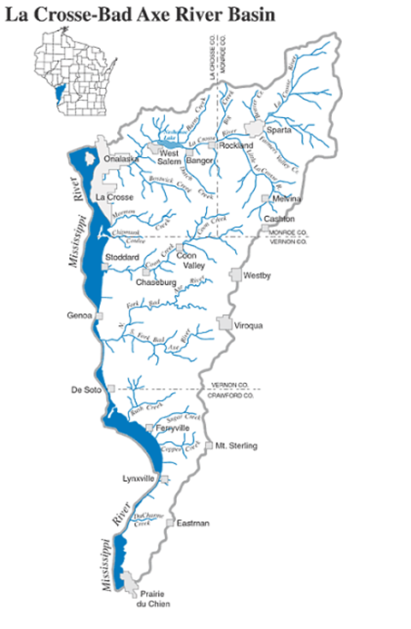

Woodlands
There are over 10,400 acres of woodlands within the Town of Shelby according to the most recent La Crosse County land use records available (2014). Approximate Woodland boundaries can be found on Map 8.1 in Appendix C. The Town and County are located in a region of the country known as the Prairie-Forest Border, which forms the transition zone between the plains to the south and west and the forests to the north and east. Before European settlement and the resulting fire suppression, the vegetation in this region consisted of oak savanna and southern oak forest. The remaining forest cover is generally broad-leaved deciduous forest. Oak is the predominant hardwood with maple replacing some of the oak stands following logging. Extensive stands of bottomland hardwoods such as elm and cottonwood are found in the vicinity of the Black and Mississippi Rivers. The State’s Managed Forest Law (MFL) program is available to landowners with 10 or more contiguous acres of forestland. Participating landowners must agree to a forest management plan that includes harvesting at least 80 percent of their forest area. In exchange, their land is taxed at a rate below the state average. There are 2,089 private acres within Shelby enrolled in the program.
Woodlands perform important aesthetic, environmental, and ecological functions. The Town and County's scenic wooded covered hills and coulees are one of the most attractive features of the landscape and have a major impact on residents and tourists alike. Woodlands also provide important settings, backdrops, and screens for homes, businesses, farms, roads, and shorelines. This creates an attractive landscape that benefits the economy and aesthetics of the County. In addition, woodlands generate or contribute to energy, oxygen, nitrogen, and carbon cycles. They also provide essential habitats for numerous varieties of plants and animals and can mitigate the destructive effects of erosion, pollution, and severe weather.

Topography
The Town and County lie in the heart of the driftless area, which covers southwestern Wisconsin, southeastern Minnesota, and northeast Iowa. This area was missed by the most recent glacial advance but was highly dissected by the glacial melt water created 11,000 years ago by the retreating glacier. The scenic ridges and valleys created by this melt water were named coulees by early French settlers resulting in this area becoming known as the "Coulee Region." Many of the ridges have bluffs of exposed dolomite limestone and sandstone outcroppings.

Steep Slopes
Map 6.3 Slope in Appendix C illustrates areas with slopes of 20 percent or greater. Topography in the Town of Shelby is characterized by steep slopes throughout the Town that range from 20 to 90%, and narrow valleys and ridge tops.
Steep slopes are environmentally sensitive from a water quality perspective because increased erosion potential and stormwater runoff occur when these slopes are developed. The detrimental effect of stormwater runoff from impervious surfaces such as rooftops and driveways increases greatly when such surfaces are constructed on steep slopes. Disturbed vegetation and poorly designed implemented landscape cause profoundly increased erosion and dramatically degrade the water quality of run off. La Crosse County has many creeks, some of which support trout fisheries. All these creeks, as well as the larger rivers and lakes, are potential receptors of runoff from development on steep slopes. The water quality of these rivers and creeks provides biologic, recreational, and aesthetic benefits. The creeks classified as trout streams, in particular, make handling of runoff from development on steep slopes especially critical if these sensitive aquatic environments are to be maintained or enhanced.
To protect the area's rivers, lakes, and streams from excessive stormwater runoff, the County Land Conservation Department enforces a construction site erosion control ordinance that requires approval of an erosion control plan prior to construction activity taking place. This ordinance also prohibits construction activity from occurring on slopes of 30 percent or greater. Increased erosion control measures are required in this ordinance when slopes of 20 percent or greater are to be disturbed. In addition to erosion, sedimentation, and water quality problems, development on steep slopes can impair the natural beauty and viewsheds in the area. When development occurs on steep slopes, or on ridge tops, the aesthetic or visual character of the area is degraded because the development tends to dominate the viewshed.

Wildlife, Rare, Threatened, and Endangered
There are 6 species in La Crosse County that are currently endangered or threatened. These species include mammals, birds, reptiles, mussels, and insects. Over the last few decades, the communities within the County have experienced changes in the composition of their animal and plant life. Historically most changes occurred through human encroachment and consequent disturbance to the wildlife and its habitat. Land uses that have drastically altered the natural environment such as the cutting of forests, wetland drainage, agriculture, and increased urbanization have resulted in the reduction of the quantity and quality of habitat for many species. This reduction in habitat has also resulted in the near extirpation of some species.
The U.S. government, to protect biological resources, enacted the Endangered Species Act (ESA) of 1973. The Act essentially prohibits the taking of a threatened or endangered species or its habitat. Wisconsin, in accordance with the ESA, has developed the Wisconsin Natural Heritage Working Lists. The Wisconsin Natural Heritage Working Lists contains species known or suspected to be rare in the state. The list and a map depicting the general location of these rare species can be viewed on the DNR website.

Table 6.4 Threatened and Endangered Species – La Crosse County
Scientific Name | Common Name | Status
Mammals
Myotis septentrionalis | Northern long-eared bat | Threatened
Birds
Grus americanus | Whooping crane | Experimental population
Reptile
Sistrurus catenatus | Eastern massasauga | Threatened
Mussels
Lampsilis higginsii | Higgins eye pearlymussel | Endangered
Plethobasus cyphyus | Sheepnose | Endangered
Insects
Bombus affinis | Rusty patched bumble bee | Endangered
Source: US Fish and Wildlife Service 2019

Open Spaces, Environmental Corridors, and Environmentally Significant Areas
Environmental corridors are continuous systems of open space under public or private ownership include environmentally sensitive lands, floodplains, wetlands, and natural resources requiring protection from disturbance and development, and land specifically designated for open space or recreational use. Important environmental corridors that are suitable for preservation include the river and stream corridors, the bluffs, the coulees, and the important wildlife habitats located throughout the Town. Main corridors in the area connect the Town to nearby communities, particularly the Upper Mississippi River Fish and Wildlife Refuge. Over 2,200 acres of this 46,000 acres reserve are within the Town borders. Another corridor that crosses jurisdictions are the bluffs located in the eastern portion of the Town. Those bluffs are unique to this region of the State and create a natural identity for the region.
Open space can be valuable just for its existence, regardless of ownership or public entry and use provisions. The sweeping vistas, wooded hillsides, and rolling hills provide a visual recreation and relaxation that is highly prized by both residents and visitors to the Town of Shelby. The Mississippi River bottom lands, including Goose Island County Park are significant tracts of publicly owned open space. A land use analysis of the Town, with land use data from the La Crosse County Wisconsin Development Plan 2020, shows that approximately 70% of lands in the Town or 12,953 acres are either water, park and recreation, or woodlands, a significant amount considering the Town is often perceived as urban due to its location adjacent to La Crosse.

Mining and Non-Metallic Mineral Resources
There are 15 registered non-metallic mining sites with La Crosse County; there are no active mining sites within the Town of Shelby.

Historical Structures and Places
There are numerous historic properties and sites in the Town of Shelby that are an important part of its historical past. As of 2021, there were five sites listed on the National Register of Historic Places in the Town of Shelby and four sites designated on the State Register of Historic Places.

Table 6.5 Summary of Registered Historic Places
Feature | Location
Chamber-Markle Farmstead | 6104 WI 35
Mundstock, Carl August Farm | US 14/16, N side, E of jct. with WI 35
School District No. 1 | US 14/61 of Jct. with WI 35
Overhead Site | Unlisted
Oehler Mill Complex | W5539 and W5565 County Rd MM
Source: Wisconsin Historical Society’s Architecture and History Inventory (AHI) database
In addition to these sites, there are 52 sites in the Town that are listed as local historic resources in the Wisconsin Historical Society’s Architecture and History Inventory (AHI) database. Many of these include barns and farmsteads.

Archeological Resources
Native Americans inhabited the La Crosse County area for twelve thousand years prior to the arrival of the first white settlers. Survey and excavations have documented the presence of Paleoindian and Archaic camps, Woodland villages and mounds, and extensive Oneota agricultural villages. The latter includes cemeteries, long houses, and an elaborate ridge field system. Many of the archaeological sites have been documented by the Mississippi Valley Archaeology Center (MVAC), which has displays open to the public at the University of Wisconsin-La Crosse. As of 2020, over 1,000 archaeological sites have been recorded in La Crosse County, and 24 are listed on the National Register of Historic Places. Under Wisconsin law, Stat. 157.70 all burial sites, including Native American mounds, and both marked and unmarked burials, are protected from encroachment by any type of development. Map 6.4 in Appendix C shows the distribution of archeological sites throughout the County.

Cultural Agencies and Programs
Wisconsin Historical Society
The Society serves as the archives of the State of Wisconsin. It collects books, periodicals, maps, manuscripts, relics, newspapers, and audio and graphic materials as they relate to Wisconsin. It maintains a museum, library, and research facility in Madison, as well as a statewide system of historic sites, school services and area research centers. It administers a broad program of historic preservation and publishes a wide variety of historical materials, both scholarly and popular. The historical society can also aid with various state and federal programs.
National Park Service
The National Park Service administers the National Register of Historic Places. In addition to honorific recognition, listing in the National Register provides:
• Consideration in planning for Federal, federally licensed, and federally assisted projects
• Eligibility for certain tax provisions
• Qualification for Federal grants for historic preservation when funds are available
National Trust for Historic Preservation
The National Trust for Historic Preservation is a nonprofit organization with more than 200,000 members. The Trust provides leadership, education, and advocacy training to support efforts to save America’s historic places.
Wisconsin Trust for Historic Preservation (WTHP)
The WTHP, established in 1986, is a private non-profit organization dedicated to the preservation of the historical, architectural, and archaeological heritage of Wisconsin. The Trust advocates for legislation and policies designed to encourage statewide historic preservation. Examples of some of the programs they initiate are:
Wisconsin Main Street Program
A comprehensive program designed to revitalize designated downtowns and give new life to historic business districts.
Heritage Tourism Initiative
The Heritage Tourism Initiative has helped develop grassroots heritage tourism organizations by encouraging Wisconsin communities to use their unique features to tap into the mushrooming heritage tourism market -- and protect that heritage at the same time.

Economic Development
The economic development element includes goals, objectives, and actions to help guide the development of economic resources within the Town. This element also includes an assessment of local strengths and weaknesses with respect to attracting and retaining businesses.
GOAL 1
Participate in ongoing efforts to promote economic growth in the region.
Objective 1-1: Define the types of business growth that are desired and appropriate in Shelby.
Objective 1-2: Define the types of business growth that are desired and appropriate in the Region.
Objective 1-3: Define, preserve, and enhance the unique aspects of Shelby that contribute to the overall quality of life and the region’s ability to attract and maintain businesses.

ACTIONS
Action 1: Promote sustainable development, energy conservation, and green building techniques in new commercial development.
Action 2: Promote a variety of small commercial businesses throughout the Town of Shelby.

Education of Labor Force
Table 6.1 outlines the highest education attained by adults over age 25 in the Town. Just over 96% of all Town residents have completed high school. Over 47% of Shelby adults over the age of 25 have a bachelor’s or graduate/professional degree, which is higher than the County at 34.8%., City of La Crosse at 35.5%, and Town of Medary at 43%.

Table 7.1 Education Levels, 2019
 | Less than 9th grade (%) | 9th to 12th grade, no diploma  (%) | High School graduate – includes equivalency (%) | Some college, no degree (%) | Associate degree (%) | Bachelor’s degree (%) | Graduate or professional degree (%)
Town of Shelby | 0.9 | 2.3 | 17.5 | 19.5 | 12.8 | 27.6 | 19.5
Town of Medary | 1.5 | 1.8 | 22.3 | 18.0 | 13.4 | 26.0 | 17.0
City of La Crosse | 2.0 | 4.1 | 26.3 | 20.6 | 11.5 | 22.2 | 13.3
La Crosse County | 1.8 | 3.2 | 25.4 | 21.6 | 13.1 | 21.9 | 12.9
Source: 2019 American Community Survey 5 Year Estimates

Participation in Labor Force
Nearly 70 percent of the population over 16 years old is involved in the work force. Of those that are active in the labor force, 3.6% were without a job in 2019. The Town’s unemployment rate is higher than the County and Town of Medary but lower than the City of La Crosse.

Table 7.2 Workforce Participation, 2019
 | Population 16 years and over | Labor Force Participation Rate | Employed | Armed Forces | Unemployment Rate
Town of Shelby | 4,089 | 67.7% | 65.3% | 0.0% | 3.6%
Town of Medary | 1,458 | 68.0% | 66.6% | 0.0% | 1.4%
City of La Crosse | 44,650 | 66.0% | 63.1% | 0.1% | 4.3%
La Crosse County | 97,122 | 66.8% | 64.4% | 0.1% | 2.4%
Source: 2019 American Community Survey 5 Year Estimates

Employment Statistics
Shelby’s labor force is largely employed through private companies. Statistics for the Town are very similar to that of the County and surrounding municipalities. Since 2000 there has been a decline from 16% to 10% of Shelby’s labor force working for the government. There has also been a decline in unemployment from 6% in 2000 to 3.4% in 2019.

Table 7.3 Employment by Employer Type, 2019
 | Private Company | Government | Self-Employed | Unpaid Family Worker
Town of Shelby | 86.6% | 10.0% | 3.4% | 0.0%
Town of Medary | 77.7% | 15.6% | 6.8% | 0.0%
City of La Crosse | 85.7% | 11.6% | 2.6% | 0.2%
La Crosse County | 83.9% | 12.4% | 3.5% | 0.2%
Source: 2019 American Community Survey 5 Year Estimates
The industries with the largest increase in number of jobs from 2015 to 2020 in La Crosse County include Utilities (20%), Arts, Entertainment, and Recreation (15%), and Professional, Scientific, and Technical Services (12%). The highest earning industry in the County is Utilities with an average of $130,670 per worker as depicted in Table 6.4.
Over 35% of employees are participating in education services/health care/social assistance occupations, which is also the most common occupation type within La Crosse County as found in Table 6.5. Retail trade is the second most frequent occupation, with just over 15% of Town residents participating in related occupations. 9.8% of the Town is in transportation/warehousing which is higher than the Town of Medary (5.5%), City of La Crosse (2.9%), and La Crosse County (4.4%).
Town of Shelby residents have the highest average household income ($117,480) compared to the Town of Medary ($98,648), City of La Crosse ($63,591) and La Crosse County ($79,705) in Table 6.6. The per capita income in the Town ($52,448) is also higher than the other respective municipalities.

Table 7.4 La Crosse County Industries and Earnings
Industry | 2015 Jobs | 2020 Jobs | Change in Jobs | % Change in Jobs | 2020 Earnings Per Worker
Utilities | 368 | 442 | 74 | 20% | $130,670
Management of Companies and Enterprises | 1,699 | 1,387 | -312 | -18% | $82,175
Information | 928 | 878 | -50 | -5% | $81,098
Professional, Scientific, and Technical Services | 1,915 | 2,136 | 221 | 12% | $79,945
Finance and Insurance | 3,178 | 3,543 | 365 | 11% | $78,408
Health Care and Social Assistance | 14,306 | 15,098 | 792 | 6% | $72,241
Wholesale Trade | 3,511 | 3,451 | -60 | -2% | $70,930
Transportation and Warehousing | 2,570 | 2,861 | 291 | 11% | $70,446
Construction | 3,035 | 3,159 | 124 | 4% | $67,024
Government | 9,864 | 9,353 | -511 | -5% | $64,479
Manufacturing | 7,784 | 8,107 | 323 | 4% | $63,711
Real Estate and Rental and Leasing | 813 | 799 | -14 | -2% | $49,040
Administrative and Support and Waste Management and Remediation Services | 2,724 | 2,419 | -305 | -11% | $41,483
Agriculture, Forestry, Fishing and Hunting | 144 | 115 | -29 | -20% | $36,894
Educational Services | 1,757 | 1,825 | 68 | 4% | $33,303
Retail Trade | 8,366 | 8,069 | -297 | -4% | $32,218
Other Services (except Public Administration) | 3,677 | 4,131 | 454 | 12% | $29,432
Arts, Entertainment, and Recreation | 1,033 | 1,185 | 152 | 15% | $23,136
Accommodation and Food Services | 6,814 | 6,728 | -86 | -1% | $18,065
Source: Bureau of Labor Statistics’ Quarterly Census of Employment and Wages (QCEW) 2020

Table 7.5 Employment by Occupation
 | Town of Shelby (%) | Town of Medary (%) | City of La Crosse (%) | La Crosse County (%)
Agriculture/Forestry/Fishing/Hunting/Mining | 0.6 | 2.1 | 0.8 | 1.1
Construction | 3.9 | 9.8 | 3.2 | 4.2
Manufacturing | 6.0 | 11.7 | 10.4 | 11.7
Wholesale Trade | 4.0 | 2.5 | 2.4 | 3.2
Retail Trade | 15.8 | 10.5 | 13.2 | 13.7
Transportation/Warehousing | 9.8 | 5.5 | 2.9 | 4.4
Information | 2.5 | 0.5 | 1.8 | 1.9
Finance/Insurance/Real Estate | 7.2 | 4.7 | 6.2 | 6.0
Professional/Scientific/Tech/Management | 5.9 | 6.8 | 6.8 | 6.7
Educational Services/Health Care/Social Assistance | 35.4 | 29.4 | 30.2 | 29.6
Arts/Entertainment/Recreation | 3.9 | 6.7 | 15.7 | 10.3
Other Services (Excluding Public) | 3.6 | 4.2 | 3.9 | 4.1
Public Administration | 1.4 | 5.7 | 2.7 | 3.2
Source: 2019 American Community Survey 5 Year Estimates

Table 7.6 Households by Income
 | Town of Shelby (%) | Town of Medary (%) | City of La Crosse (%) | La Crosse County (%)
<$10,000 | 1.7 | 3.6 | 6.5 | 4.2
$10,000-$14,999 | 3.9 | 2.3 | 7.3 | 4.6
$15,000-$24,999 | 5.4 | 2.2 | 12.3 | 8.6
$25,000-$34,999 | 4.9 | 4.1 | 12.9 | 10.4
$35,000-$49,999 | 8.1 | 11.5 | 16.2 | 14.9
$50,000-$74,999 | 19.9 | 21.5 | 19.9 | 20.0
$75,000-$99,999 | 15.9 | 14.7 | 11.0 | 13.2
$100,000-$149,999 | 19.1 | 26.1 | 8.7 | 14.4
$150,000-$199,999 | 7.1 | 6.1 | 2.5 | 4.8
$200,000+ | 14.1 | 8.0 | 2.7 | 4.8
Median Household Income | $83,056 | $79,306 | $45,233 | $57,882
Average Household Income | $117,480 | $98,648 | $63,591 | $79,705
Per Capita Income | $52,448 | $36,829 | $26,827 | $32,565
Source: 2019 American Community Survey 5 Year Estimates

Economic Base
When considering economic base, it is important to look at regional economic drivers. Table 6.7 lists the top fifteen employers for La Crosse County in 2021. There are 7 employers in the County with over 1,000 employers. The remaining 8 have 500-999 employees.

Table 677 Top Employers in La Crosse County
Company | Number of Workers
Kwik Trip Inc. | 1,000+
Gundersen Health System | 1,000+
Mayo Clinic Health System | 1,000+
Trane Inc. | 1,000+
Reinhart Food Service | 1,000+
Rottinghaus Company | 1,000+
University of Wisconsin-La Crosse | 1,000+
Dairyland Power Cooperative | 500-999
Bethany St. Joseph | 500-999
Logistics Health, Inc. | 500-999
City Brewery | 500-999
School District of La Crosse | 500-999
Western Technical College | 500-999
Walmart | 500-999
JF Brennan Company Inc. | 500-999
Source: Data Axle Reference Solution 2021, Emsi 2021

Commercial and Industrial Building Trends
Table 7.8 outlines where the industrial and business parks are located in La Crosse County. The table also provides the size of the parks and land availability as of 2020. There are currently no industrial parks located in the Town of Shelby.

Table 7.8 La Crosse County Industrial Parks 2020
County | Community | Name of Site | Date | # of Acres | Acres Sold | Acres for Sale | Zoning | Utilities to Site | Year Utilities Installed | Absorp. Rate acres/yr.
La Crosse | V Bangor | Bangor Indus. Park | 2003 | 80 | 15 | 65 | Industrial | No |  | <5
La Crosse | V Holmen | Holmen Indus. Park | 1975 | 50 | 50 | 0 | Industrial | Yes | 1975 | < 5
La Crosse | V Holmen | N Star Bus. Park | 1997 | 21.5 | 21.5 | 0 | Commercial | Yes | 1997 | < 5
La Crosse | V Holmen | Holmen Bus. Park | 2000 | 7 | 7 | 0 | Commercial | Yes | 2000 | < 5
La Crosse | V Holmen | Cedar Crossing Ind. Park | 1991 | 25 | 20 | 5 | Commercial | Yes | 1991 | < 5
La Crosse | V Holmen | McGilvray Park | 2017 | 30 | 5 | 25 | Commercial | Yes | 2017 | <5
La Crosse | V Holmen | Kings Bluff Business Park Phase 1 | 2018 | 25 | 10 | 15 | Light Industrial | Yes | 2018 | >5
La Crosse | V Holmen | Bluffview Business Park Phase 1 | 2019 | 40 | 12 | 28 | Light Industrial | Yes | 2019 | >5
La Crosse | V Holmen | Bluffview Business Park Phase 2 | 2020 | 15 | 10 | 5 | Commercial | Yes | 2020 | >5
La Crosse | V Holmen | Hawkeye Business Park | 2020 | 40 | 5 | 35 | Commercial | Yes | 2020 | >5
La Crosse | C La Crosse | Airport Indus. Park | 1988 | 98 | 98 | 0 | Industrial | Yes | 1988 | < 5
La Crosse | C La Crosse | Airport Interstate Park | 1984 | 32 | 32 | 0 | Industrial | Yes | 1984 | < 5
La Crosse | C La Crosse | Interstate Indus. Park | 1970 | 92 | 92 | 0 | Industrial | Yes | 1970-83 | <5
La Crosse | C La Crosse | Int'l Business Park | 1998 | 77.8 | 41.67 | 36.13 | Industrial | Yes | 1998-99 | 5-10
La Crosse | C Onalaska | Valley Vue Bus. Park | 1985 | 0.69 | 0 | .69 | Reg. Business | Yes | 1985 | <5
La Crosse | C Onalaska | Elmwood Bus. Ctr. | 1992 | 15.86 | 0.69 | 15.17 | Reg. Business | Yes | 1992 | <5
La Crosse | V West Salem | W. Salem Indus. Park | 1972 | 60 | 60 | 0 | Lt Indus. | Yes | 1972 | < 5
La Crosse | V West Salem | Lakeview Indus. Park | 1997 | 160 | 75 | 85 | Industrial | Planned | 2000-01 | < 5
Source: Mississippi River Regional Planning Commission 2020

Environmentally Contaminated Sites
The Comprehensive Planning Law requires communities to evaluate and promote the use of environmentally contaminated sites for commercial or industrial uses. The Wisconsin Department of Natural Resources (DNR) Environmental Remediation and Redevelopment Program maintains a list of contaminated sites, or brownfields. The DNR identifies brownfields as “abandoned or under-utilized commercial or industrial properties where expansion or redevelopment is hindered by real or perceived contamination.”
As of August 2021, ten sites in the Town were listed on the Bureau for Remediation and Redevelopment Trading System (BRRTS). Three sites listed on the BRRTS were listed with a No Action Required status, which means that there was, or may have been. Based on the known information, the DNR has determined the responsible party does not need to undertake an investigation or cleanup in response to that discharge. Six sites are closed spill sites which were cleaned up quickly and require no further action. One additional site is a closed case of a leaking underground storage tank (LUST). A LUST site has contaminated soil and/or groundwater with petroleum, which includes toxic and cancer-causing substances. However, given time, petroleum contamination naturally breaks down in the environment (biodegradation).

Employment Projections
The State of Wisconsin’s Department of Workforce Development’s “La Crosse County Workforce Profile” provides insight into the regional employment forecast for the County. This section illustrates employment forecasts for the La Crosse County area. Table 7.9 lists the top 10 occupations experiencing the fastest growth rates and the most job openings in La Crosse County. Many of the fastest growing occupations fall into either the Architecture and Engineering, Computer and Mathematical, and Personal Care Service categories, followed by Business and Financial Operations.

Table 7.9 Growing Occupations La Crosse County
Occupation | Change in Jobs  2015-2020 | % Change in Jobs  2015-2020
Production | 767 | 14%
Educational Instruction and Library | 473 | 11%
Business and Financial Operations | 366 | 14%
Personal Care and Service | 298 | 15%
Healthcare Support | 295 | 8%
Computer and Mathematical | 251 | 19%
Management | 181 | 6%
Architecture and Engineering | 180 | 21%
Construction and Extraction | 137 | 5%
Healthcare Practitioners and Technical | 76 | 1%
Source: Wisconsin Department of Workforce Development, Bureau of Workforce Information, Emsi Report 2020

Coronavirus Impact Planning
In addition to its impact on public health, coronavirus disease 2019 (COVID-19) has caused a major economic shock. The nation has experienced the highest rates of unemployment since the Great Depression. La Crosse County had its highest unemployment rate in April 2020 at 12.3% while the State was at 13.6%.
The Town of Shelby is home to 103 businesses employing 1,045 individuals (2015-2019 American Community Survey). In the midst of the pandemic, 94% of residents have access to internet at home allowing the option for virtual work and online education. This does not mean access to high-speed internet or broadband, which is still of concern for many in rural areas. In the Town of Shelby, 56% of individuals are ages 18 to 64.

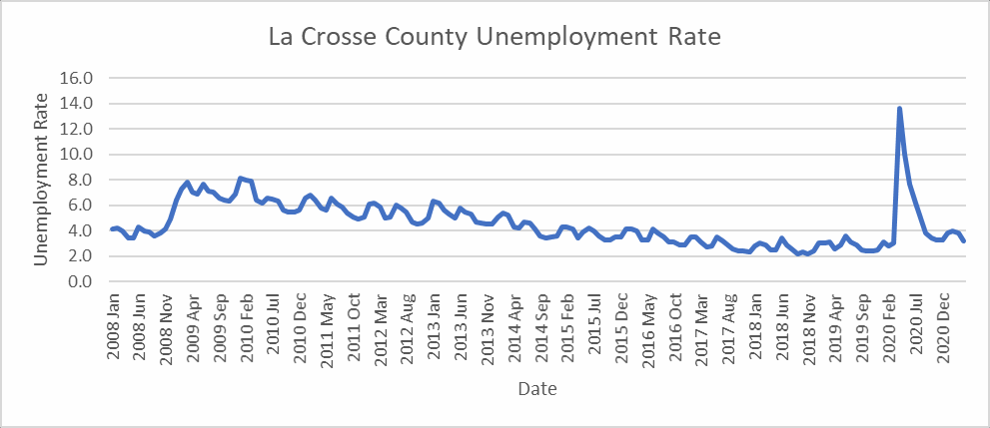
Figure 7.1 La Crosse County Unemployment Rates
Source: Bureau of Labor Statistics – Local Area Unemployment Statistics) Concerns have recently arisen regarding unemployment rates and the impact of COVID Pandemic unemployment programs on labor participation rates.

The COVID-19 pandemic caused an economic recession, as many businesses were forced to close their doors and people were forced to completely change their consumption patterns. This brought some immediate impacts such as business closures and increased unemployment rates, but it also brought significant uncertainty, and we will need to wait to see what shifts in consumption patterns will be more long-term. For example, many employees were forced to make a transition to working from home. Some have found that it works for them, and some have found that it is does not – but over the next year or two we will see how demand for commercial office space will be different based on that shift. This may also then have ripple effects on other industries that capitalized on the concentration of workers in central business districts. There are also predictions that mid-sized communities like La Crosse County, could have increased attractiveness for many who are not as comfortable living in large metropolitan areas anymore – especially as they may have more freedom to work remotely. So, this could present economic development opportunities for our region.
Potential individuals in the at-risk category for health and economic impacts of COVID-19 (based on Esri 2021 forecasts key indicators) include:
- 1,271 individuals based on age (65+)
- 70 household within the community are without a registered vehicle
- 347 households have an individual with a disability
- 145 (6.7%) households are below the poverty line
Various organizations have created grants and programs for Coronavirus Aid, Relief, and Economic Security (CARES Act Funding). These organizations include but are not limited to:
- Coulee Cap
- Hmong Wisconsin Chamber of Commerce
- U.S. Department of Agriculture – Rural Development
- U.S. Economic Development Organization
- U.S. Small Business Administration
- Wisconsin Economic Development Organization
- Wisconsin Small Business Development Center
- Wisconsin Women’s Business Initiative Corporation

Strengths and Weaknesses for Fostering Economic Growth
Fostering economic development is always challenging to rural towns due to lack of public sewer and water facilities and minimal institutional economic development resources. The Town of Shelby has these same deficiencies but is at an advantage as the Town is located near the regional business center (La Crosse).
Strengths: The Town enjoys local access to the regional highway system. USH 14/61 and STH 35 both traverse Town boundaries and provide access to other more regional transportation networks including freight, rail, and shipping facilities in nearby communities. Shelby also provides plenty of undeveloped land that could be utilized by both developing industries and residential contractors to provide corporate campus-type development. Close proximity to other industries within La Crosse County is also a local attribute.
Weaknesses: Meeting on the preparation of this Plan with the Planning Commission and residents of the community revealed the economic development outlook for the Town is less than it could be because of the lack of localized water or sewer system. Many noted that business owners, industries, and commercial uses require pressurized water systems to ensure sufficient product delivery and timely service provision. The Town is also located within a region that contains many other municipalities with more advanced service capacity, including the City of La Crosse that also provides direct access to Interstate 90.

County, Regional, and State Economic Development Programs
Numerous County, regional, and state economic development programs apply to the Town of Shelby. The following is a list of selected programs that could be beneficial to economic development in the Town of Shelby.
County Programs
- La Crosse Business Fund
Regional Programs
- Western Wisconsin Technology Zone
- Federal Economic Development Administration (EDA) programs administered through Mississippi River Regional Planning Commission (ex. Public Works and Economic Development Programs, Economic Adjustment Program, etc.)
State Programs
- Coronavirus Aid, Relief, and Economic Security Act (CARES) Funding
- Wisconsin Department of Transportation Local Transportation Enhancements Program (TE)
- Wisconsin Department of Transportation Local Transportation Economic Assistance Program (TEA)
- Value Added Dairy Initiative (Grow Wisconsin)
- Wisconsin Department of Commerce Enterprise Development Zone Program
- Wisconsin Department of Commerce Rural Economic Development Program
- Wisconsin Department of Commerce Entrepreneurial training Grant
- Wisconsin Economic Development Corporation (WEDC) Programs (Business Attraction, Export, Entrepreneur, Mainstreet Bounceback Grants, etc.)

Intergovernmental Cooperation
This element of the Comprehensive Plan analyzes the relationship of the Town of Shelby in terms of planning and decision making to adjacent local governmental units and quasi-public, regional, state, and federal governmental entities. It provides goals, objectives, and actions to increase intergovernmental cooperation and involvement. A description of the relationship between the Town of Shelby and other local, regional, and state entities resides in this section.
The Town of Shelby commenced the comprehensive planning process, deliberately, at a time when the County was undergoing a comprehensive planning update. The Town’s intent was to formally join the discussion already underway over directions for future land use and development in the region and ensure a fully coordinated planning process. Further, the Town wanted to ensure the planning process would consider the larger regional context and involve through communication neighboring governmental jurisdictions, planning organizations, agencies, stakeholders, and strong cross-boundary public participation.
GOAL 1
Boundary protection: Limit the further erosion of the Town’s land area, real property tax base, or population, from annexation.
Objective 1-1: Encourage development of areas adjacent to the City of La Crosse.
Objective 1-2: Encourage cooperative efforts between Shelby and neighboring municipalities to explore opportunities for shared services.
GOAL 2
The Town will maintain good relationships with governmental units in and around the region.
Objective 2-1: Establish and maintain excellent communication with other government officials (staff, elected and appointed officials) both formally (on committees, etc.) and informally (telephone calls, emails, etc.); and continue to build and establish new relationships.
GOAL 3
Participate in regional planning efforts and coordinate all planning activities with neighboring communities and La Crosse County.
Objective 3-1: Participate in regional planning efforts and coordinate planning efforts (e.g., comprehensive, land use, transportation, and natural resource protection), regulations, and specific land use decisions with neighboring communities, La Crosse County, Mississippi River Regional Planning Commission (MRRPC), and the La Crosse Area Planning Committee (LAPC).
GOAL 4
Coordinate with neighboring communities and La Crosse County to provide high quality services in the most cost-effective manner possible.
Objective 4-1: Continue to work cooperatively with neighboring communities to provide more effective and lower cost services provision.
ACTIONS
Action 1: Improve Shelby’s long-term land use planning and capital improvement programming efforts throughout the Town.
Action 2: Consider areas where Shelby can assist developments which will remain in the Town – such as financing, help for sewer/septic systems and water management.
Action 3: Continue efforts to increase the relationship with the City of La Crosse and surrounding municipalities. These efforts may include the development of a cooperative boundary agreement.
Action 4: Provide a copy of this Comprehensive Plan and any proposed updates or amendments to all governmental units required by State Statutes 66.1001.
Action 5: Inform other governmental units and agencies about changes in the local community and establish regular communication through newsletters or periodic visits and/or phone calls.
Action 6: Participate in regional or joint planning committees and commissions.
Action 7: Involve local school districts in long-range planning efforts and in reviewing current development proposals where appropriate.
Action 8: Support regional economic development efforts that are consistent with the Town’s vision and goals.
Action 9: Support regional efforts to expand transportation choices through such measures as expanding transit service and connecting multi-use trails to neighboring communities and regional trail networks.
Action 10: If necessary, when a development application is received, consult the appropriate government, agency, or staff in a timely manner, and consider their comments during the Town’s decision-making process. Request these entities respond in kind with their local development.
Action 11: Identify and possibly formalize a process for resolving conflicts in nonaggressive/non-confrontational manners.
Action 12: Work collectively with all other local governments and agencies to protect bluffs, water quality and prime farmland.
Action 13: Share information, equipment, resources, facilities, technology, services and possibly revenue streams that have cross-jurisdictional applications.
Action 14: Identify opportunities to jointly provide new or expanded services with other local communities. Ideas include adding recreational programs in local parks, increasing transit options, and installing multi-use trails.
Action 15: Jointly plan and pursue public utilities and services improvements with neighboring communities and willing partners.
Action 16: Identify opportunities to avoid duplication in the provision of public services with other governments including the school districts. This may include consolidation of services, building joint facilities, and equipment sharing for such things as road plows.

La Crosse County
La Crosse County encompasses 481 square miles and is located in western Wisconsin along the Mississippi River. The County’s 2019 population was estimated at 118,016. La Crosse County is approximately 150 miles southeast of Minneapolis/St. Paul, MN, 175 miles from Waterloo, Iowa, and 145 miles from Madison, WI. The County is comprised of 18 local units of government: 12 towns, 4 villages, and 2 cities. Interstate 90 and the La Crosse River bisect the County from east to west. Trempealeau and Jackson County border La Crosse County to the north, Monroe County lies to the east, Vernon County lies to the south, and the Mississippi River and Minnesota lie to the west. The County is currently working on an updated Comprehensive Plan, which is an update to the County’s existing plan, the La Crosse County Development Plan 2020. In addition, the County has adopted numerous other plans, studies, and ordinances that provide policy and direction to local communities, such as Shelby, including:
- La Crosse County, Wisconsin Farmland Preservation Plan, 1980 –Amended in 2014
- La Crosse County Comprehensive Outdoor Recreation Plan, 1998 – Amended in 2020
- La Crosse County Land & Water Resource Management Plan, 1999 – Amended in 2020
- Zoning Ordinance – Comprehensive Revision in 2012
- Land Division Ordinance
La Crosse County is also party to general cooperative agreements for fire, police, rescue, road maintenance, solid waste, recycling, and other services with several towns, villages, and cities in the County. The Town of Selby also is part of the Bluffland Coalition and Regional Stormwater Group.

Surrounding Municipalities
The Town of Shelby borders the Town of Barre, Greenfield, and Medary.
The following are existing contracts or agreements the Town of Shelby has with surrounding municipalities:
Town of Greenfield: Fire Services Contract
City of La Crosse: Sewer services, stormwater management, and drainage issues.

Regional Planning Jurisdiction
The Town of Shelby is located within the Mississippi River Regional Planning Commission’s (MRRPC) jurisdiction. The MRRPC prepares and adopts regional or county-wide plans and represents Buffalo, Crawford, Jackson, La Crosse, Monroe, Pierce, Pepin, Trempealeau, and Vernon Counties. The RPC was established to:
- Carry out comprehensive and intergovernmental planning;
- Have jurisdiction throughout the seven-county area, including incorporated and unincorporated areas;
- Meet area-wide requirements so local jurisdictions could receive federal grants;
- Provide an organization to receive federal grants.
Shelby is also located within the Western Wisconsin Technology Zone which allows up to $5M in state income tax credits and is administered by the MRRPC. The MRRPC also administers the La Crosse County Business Fund.
MRRPC recently completed the La Crosse County Outdoor Recreation Plan 2019-2024 and La Crosse County Multi-Hazards Mitigation Plan (HMP) 2020-2024. Included in the HMP are the following goals for the Town of Shelby:
- Elevate Hanifl Road to provide dry land access during high water events
- Purchase a boat to provide emergency services to areas not accessible by dry land during high water events
- Purchase a truck to haul water in the event lightning strikes a well
- Purchase communication equipment to coordinate water and sewer departments during storm events
- Purchase backup power generators for municipal wells
- Purchase communication system for sewer lift stations and water wells
- Purchase brush chipper to manage dead and excessively overgrown areas
- Install dry well (water points) locations on ponds and creeks for firefighting purposes

Important State and Federal Agency Jurisdiction
There are many state and federal agencies that affect planning in La Crosse County. The Wisconsin Department of Transportation (DOT) District 5 plays a critical role in many aspects of the County’s transportation system, from highway design and development to bicycle and pedestrian facilities and networks. The Town of Shelby is in Metropolitan Planning Organization (MPO) La Crosse Area Planning Committee (LAPC). As required by 23 CFR 450.300, the purpose of metropolitan transportation planning and programming is to:
- Carry out a continuing, cooperative, and comprehensive performance-based multimodal transportation planning process, including the development of a Metropolitan Transportation Plan (MTP) and a Transportation Improvement Program (TIP), that:
  - Encourages and promotes the safe and efficient development, management, and operation of surface transportation systems to serve the mobility needs of people and freight;
  - Fosters economic growth and development; and,
  - Takes into consideration resiliency needs, while minimizing transportation-related fuel consumption and air pollution.
- Encourage continued development and improvement of metropolitan transportation planning processes guided by the planning factors (23 CFR 450.306).
The Wisconsin Department of Natural Resources (DNR) also has a prominent role in the County because of the many DNR-owned land and facilities that are located here. The University of Wisconsin Extension office is in the City of La Crosse and serves as an educational resource for County residents. The U.S. Fish and Wildlife Service maintains a presence in the County because of the Upper Mississippi River National Wildlife and Fish Refuge. The U.S Army Corps of Engineers also maintains a presence in the County because of their ownership and management of locks and dams along the Mississippi River, which borders the western edge of the County. The Town works with FEMA for flooding and disaster events and the Public Service Commission for water rate setting.
The County and its local units of government recognize the importance of working with these state and federal agencies and are committed to continuing an ongoing dialogue with these agencies, both during and after the development of this Comprehensive Plan.
Shelby communicates with state and federal agencies on an as-needed basis. For the comprehensive planning process, state and federal agencies may be asked to review the plan documents as follows:
- WisDOT and LAPC: Review the Transportation Element and provide expertise and comments on development and planning goals.
- WDNR: Review the Agricultural, Natural Resources, and Cultural Resources Element regarding protection techniques for Shelby’s existing natural resources.

School Districts
The Town of Shelby is included within the boundaries of the La Crosse and West Salem School Districts. There are athletic field use agreements between the Town and school districts. The school districts help with maintenance on Township fields as needed.

Existing or Potential Conflicts and Processes to Resolve Conflicts
There is concern regarding annexation of Town lands because of Shelby’s inability to expand sanitary services as an ongoing issue. A long-term boundary agreement and negotiations with the City of La Crosse is one step being taken to resolve this conflict.

Land Use
This element of the Comprehensive Plan contains goals, objectives, and actions to guide the future development and redevelopment of public and private property. The element contains an analysis on opportunities for redevelopment and existing or potential land use conflicts. The element also explains future land use designations and delineates these uses on the Future Land Use Map found in Appendix C.
GOAL 1
Reduce impacts of floods, erosion, pollution, and stormwater.
Objective 1-1: Seek grants and funding for flood control projects.
Objective 1-2: Seek grants and funding for storm water study.
Objective 1-3: Develop a plan for storm water management.
GOAL 2
Ensure Development that will work to conserve and enhance the town’s community, rural character, and natural beauty.
Objective 2-1: Maintain the character of the Town of Shelby, included but not limited to:
Protecting and enhancing the unique character of the Town by establishing and enforcing maximum density standards for non-farm development as well as by enforcing design standards that require appropriate and quality designs for all new commercial, industrial, and institutional development in the community (including signage, lighting, and parking areas).
GOAL 3
Protect natural resources, air quality, groundwater, solar energy, and maintain greenspace responsibly.
Objective 3-1: Encourage the practice of conservation design of subdivisions.
Objective 3-2: Discourage the use of pesticides in the municipal and residential lawn care.
Objective 3-3: Allow access to multi-use trails for public use.
Objective 3-4: Encourage new development to include greenspace in design plans.
GOAL 4
Balance Farmland Preservation with development demand.
Objective 4-1: Use data to identify development demand.
Objective 4-2: Educate residents of the Town on the Farmland Preservation program.
Objective 4-3: Using data, identify areas for development and Farmland Preservation.
GOAL 5
Provide potential for all types of development and redevelopment allowing for growth in the tax base.
Objective 5-1: Allow for residents, developers, and entrepreneurs to enhance the growth of the Town.
GOAL 6
Pursue reasonable and responsible development and expand basic services to those areas when feasible.
Objective 6-1: Direct development to designated areas or to lands that have a substantial combination of the following characteristics:
- Are on slopes too steep to farm but do not intrude substantially on the bluffs;
- Are on or close to local roads that are regularly maintained;
- Have poor agricultural soils;
- Are currently served by public sewer and water services;
- Are not participating in the Farmland Preservation program
Objective 6-2: Consider development on lands only if absolutely necessary that:
- Are on roads that are not regularly maintained;
- Are on lands of extreme importance, such as bluffs and prairies;
- Are not easily accessible via roads and where substantial construction of access roads across prairies would be required.
Objective 6-3: Discourage development on lands that:
- Are wet, wetlands;
- Are prone to flooding, floodplains, and runoff;
- Offer poor structural support for buildings;
- Are good agricultural land; soil classes 1, 2, and 3 on Soil Map;
- Are on lands of historical or archeological importance.
Objective 6-4: Use the following tools in public and private land decision making:
- Zoning Map
- Soils Map
- Comprehensive Plan
- Environmental Features Map
- Town Survey
- Future Land Use Map
Objective 6-5: Promote responsible development in Shelby that does not annex more land than necessary to the City of La Crosse.
Objective 6-6: Utilize intergovernmental relations with surrounding municipalities and La Crosse County.
ACTIONS
Action 1: Brief members of the Planning Commission, Town Board, Sanitary District, Parks and Vacant Land Committee and Town Staff on the Comprehensive Plan document and other related planning documents. Ensure this plan is used to guide land use decisions and any planned expansions.
Action 2: Update this section as needed to allow for an influx in development demand and general changes and updates in the Town.
Action 3: Require greenspace for each development that can be utilized for park space.
Action 4: Maintain Land Use Districts to guide future decisions by the Planning Commission and Town Board. Update Land Use Districts as necessary.
Action 5: Encourage redevelopment of fully developed parcels to encourage growth in the tax base while being mindful of existing utilities and any impact on surrounding properties such as erosion and drainage.
Action 6: Work together with La Crosse County Zoning to create developer guidelines for the Town to clearly outline expectations, requirements, and rules that developers must follow to simplify the process and encourage development in the Town.
Action 7: Disallow any development on a slope of greater than 30%. Review development on slopes of 20% or greater on a case-by-case basis. Require that construction on slopes 20% or greater be accompanied by site plans that provide drainage on and off the site to protect all surrounding areas.
Action 8: Prioritize dense development in areas that have access to municipal sewer and water, plan for rural development in areas where sewer and water is not available.

Land Assessment

Table 9.1 Land Use Town of Shelby
Existing Land Use | Total Acres | Percent of Town Land (%)
Agricultural | 3,532 | 19.31
Commercial | 49 | 0.27
Industrial | 9 | 0.05
Park & Recreation | 733 | 4.01
Public | 649 | 3.55
Residential | 1,093 | 5.98
Woodland | 7,902 | 43.21
Water | 4,318 | 23.61
TOTAL | 18,287
Source: MRRPC 2021, La Crosse County Land Records 2014
Town estimates from 2021 indicate total acres to be 18,304. These calculations were derived from land use mapping from the County assessed in 2014. The most prevalent land use is woodlands at 43.21% (7,902 acres) followed by water at 23.61% (4,318 acres). As shown in Table 9.1, agriculture is prevalent throughout the local landscape with 19.31% (3,532 acres) of the total acres within the township. Map 9.1 Town of Shelby Existing Land Use can be found in Appendix C.

Development Density
The Town of Shelby has an average density of 190.8 people per square mile. Within the Town there are 76.7 housing units per square mile. Shelby’s density is a about two thirds of La Crosse County which has an average of 260.8 people in 66.3 housing units per square mile.

Table 9.2 Population and Household Density 2019
 |  |  | Area in Square Miles |  |  | Density (sq. miles of land area)
 | Population | Housing Units | Total Area | Water Area | Land Area | Population | Housing Units
Town of Shelby | 4,884 | 1,963 | 29.1 | 3.6 | 25.6 | 190.8 | 76.7
Town of Medary | 1,859 | 611 | 11.7 | 0.0 | 11.7 | 158.9 | 52.2
City of La Crosse | 51,666 | 9,772 | 23.8 | 2.1 | 21.7 | 2,380.9 | 450.3
La Crosse County | 117,894 | 29,949 | 480 | 28 | 452 | 260.8 | 66.3
Source: 2019 American Community Survey 5 Year Estimates, 2019 U.S. Gazetteer Files
*Housing Units: A house, an apartment, a mobile home or trailer, a group of rooms, or a single room occupied as separate living quarters, or if vacant, intended for occupancy as separate living quarters. Current estimates indicate the total number of housing units in Shelby is 1,970.

Intensity of Commercial and Light Industrial Districts
Intensity refers to height, bulk, and use associated with non-residential development. In the Town of Shelby, this is regulated through the County Zoning ordinance. Previously the County Zoning ordinance excluded residential use in Commercial and Industrial Districts. Current zoning offers additional options of authorized Residential Districts within Commercial and Industrial Districts. The following Commercial and Light Industrial Zoning Districts are located throughout the Town and are illustrated in the Town of Shelby Zoning Map 9.2.
The Commercial District authorizes Residential District “C” and commercial use. Commercial use includes retail, wholesale, offices, and service industry businesses. It also includes warehouses under 100,000 square feet (not to exceed 2), commercial animal establishments, bed and breakfast, and transient residential uses. Non-residential structures shall be a maximum height of 45 feet.
Authorized uses in the Light Industrial areas include any use authorized in the Commercial District: light manufacturing and assembly, distribution businesses, warehouses, and truck terminals and freight houses.
Map 9.2 Town of Shelby Zoning can be found in Appendix C.

Land Use Supply
The supply of land to support development is based on several factors including physical suitability, local and county regulations, and community goals. Intergovernmental agreements and annexations also become considerations when looking at the available land supply at the community level. Based on physical suitability, there is an available supply of land that could be used to support development in the Town. Local policy will more closely determine how this supply is defined and how it is used. Of particular interest are those parcels zoned “Transitional Agriculture,” as those acres can be converted to other non-agricultural uses. Policy will help determine whether these acres contribute to the supply for planned development in the short and long term.

Land Use Demand
Direct highway access and available land have made this an accessible location for suburban growth in the region. The southern part of the metropolitan region may become a growth focus as lot prices increase and build-out occurs to the north. Other factors, including proximity to the City of La Crosse may also fuel growth in and around Shelby. Additionally, when considering Town growth demand, it is important to look at annexation trends for land previously in the Town. Local-level data for all communities listed in Table 8.4 were not available after 1997. This information is included to demonstrate the different rates of growth or annexation experienced between the comparable listed.
In table 9.3, the number of housing units projected in 2040 which is approximately the same amount present in 1990. There was a decline in housing units from 1997 to 2020 likely due to annexations. The projected growth is 0.4% from 2020 to 2040. All towns in La Crosse County are projected to see an increase in housing by 10.9% from 2020 to 2040.

Table 9.3 Projected Housing Units 2015 to 2040
 | 2015 | 2020 | 2025 | 2030 | 2035 | 2040
Town of Shelby | 1,973 | 1,993 | 2,011 | 2,020 | 2,011 | 2,001
Town of Campbell | 1,994 | 2,014 | 2,035 | 2,046 | 2,037 | 2,030
Town of Medary | 587 | 605 | 622 | 638 | 646 | 655
All Towns in La Crosse County | 11,942 | 12,394 | 12,835 | 13,225 | 13,493 | 13,749
Source: DOA 2013, US Census Bureau 2010

The Town of Shelby and City of La Crosse are negotiating a boundary agreement. Preliminary plans have been discussed to determine areas of Shelby to be annexed into the City of La Crosse. Map 9.3 Draft Boundary Agreement Town of Shelby and City of La Crosse can be found in Appendix C. Area 1 as defined on the map has an estimated 266 acres of net developable area to be used as low, medium, and high-density residential area, commercial/retail office area, and open space/greenway. If Area 1a was added to this projection, it could add a 50% gain to the estimate. In Area 2 and 2a, there is an estimated 570 acres of net developable area for low density residential area and open/greenway space.
The 20-year development strategy scenario determined by the draft Town of Shelby and City of La Crosse Boundary Agreement considers an aggressive development strategy. It is similar to the incentivized development with low density subdivision growth similar to that occurring in the areas of Holmen. Under the given scenario under a 20-year period, growth would equate to approximately 72 homes per year. Population estimates by the DOA through 2035 are estimated at less than 0.5% annual growth (680 people annually) reflecting the needs in the region as high as 320 units annually. Some of this will be satisfied by urban housing, multi-family units and housing turnover (2%, 120 units in City of La Crosse) leaving a new net single family home demand of roughly 100 units annually in the MSA. If this 20-year scenario were to play out, the Town of Shelby would have to accommodate 72% of the housing growth in the region based on current figures. This is an aggressive estimate for the purposes of conservative estimating of the potential sewer needs over a 20-year period for Area 2 and 2a.

Table 9.4 Annexation, 2011-2021
 | Number of Housing Units* Annexed | Number of Properties Annexed | Population Annexed | Acreage Annexed
Town of Shelby | 0 | 1 | 0 | 53.00
Town of Campbell | 5 | 7 | 10 | 3.32
Town of Medary | 5 | 18 | 10 | 955.67
All Towns in La Crosse County | 31 | 78 | 77 | 3,069.54
Source: Municipal Boundary Review (MBR) team, Department of Administration, MRRPC 2022
* Housing Unit - A house, an apartment, a mobile home or trailer, a group of rooms, or a single room occupied as separate living quarters, or if vacant, intended for occupancy as separate living quarters.

Land Prices
One method to analyze comparative land prices is to look at the cost of farmland for Towns in the area. Table 9.5 shows average farmland sales for the Towns of Shelby and Onalaska and the average of all towns in La Crosse County from 2014 to 2018. The Town of Shelby averaged the highest agricultural land value per acre in 2018 compared to the Town of Onalaska and to the average of La Crosse County townships. Fourteen parcels of farmland were sold from 2014 to 2018 in the Town of Shelby with a change in land value increasing 60.6%. This was a greater increase in sales price compared to the average of all La Crosse County townships (26.2%) and the Town of Onalaska at 49.3%. According to Wisconsin Agricultural Land Sales, La Crosse County sold 19 parcels, 966 acres, with an average cost of $6,946 in 2019. UW Extension estimated farmland values to be at $4,767 per acre in Shelby in 2019 compared to the Town of Onalaska at $5,491 per acre.

Table 9.5 Average Farmland Sales for Selected Towns in La Crosse County, 2014-2018
 | Number of Parcels Sold | Total Acres | 2014 Average Land Value per Acre ($) | 2018 Average Land Value per Acre ($) | Change in Land Value per Acre 2014-2018 (%)
Town of Shelby | 14 | 1,113 | 3,525 | 5,660 | 60.6
Town of Onalaska | 13 | 669 | 3,500 | 5,225 | 49.3
All La Crosse County Towns | 121 | 3,696 | 3,845 | 4,852 | 26.2
Source: DOR 2014-2018

Future Land Use Projections
From 2000 to 2020, the Town of Shelby has, on average, increased housing units of less than 1% per year (US Census, Table 9.6). As discussed in the Housing Section, the Town of Shelby is projected to need approximately 28 housing units between 2015 and 2040. This will increase the current supply 1.4% between 2015 and 2040. To compare, the Town of Medary will see a 11.6% increase in households, the City of La Crosse will see a 0.14% increase, and La Crosse County will see an increase of 12.9%.
The table below outlines the number of households currently in the County as well as the projected growth in households that is expected from 2015 to 2040. The projections provided for the next twenty years have been provided by the State of Wisconsin Department of Administration (DOA). The projections have been reached by closely monitoring past growth trends within the Town, County, and surrounding areas.

Table 9.6 Projected Housing Units 2015 to 2040
 | 2015 | 2020 | 2025 | 2030 | 2035 | 2040
Town of Shelby | 1,973 | 1,993 | 2,011 | 2,020 | 2,011 | 2,001
Town of Medary | 587 | 605 | 622 | 638 | 646 | 655
City of La Crosse | 22,265 | 22,538 | 22,683 | 22,676 | 22,519 | 22,298
La Crosse County | 48,658 | 50,388 | 51,968 | 53,262 | 54,159 | 54,929
Source: DOA 2013, US Census Bureau 2010

Single Family, Multi-Family, and Mobile Home Residential land use accounts for 1,084 acres of land in the Town in 2020. In 2020, there were approximately 1,993 homes in the Town. On average, a residential unit is on 1.83 acres based on this data. The majority of land in the Town of Shelby is classified as Woodlands (55.8%), Transportation (20.1%), and Agriculture (5.94%) (Table 9.1). As the Town is projected to need more residential area, approximately 50 acres is needed from 2020 to 2030 to account for the projected housing increase while maintaining an average of 1.83 acres per housing unit.
La Crosse County made projections for residential area in acreage needed in the next 20 years. This is based on population density in 2020, projected population change from 2020-2030 (DOA), and proposed projections from the steering committee using core values of the La Crosse County Comprehensive Plan 2022. These values have been calculated to adjust for market changes in the next 20 years. The Town of Shelby is projected to need 1,286 acres for residential units in the next 20 years. This accounts for approximately 27% of the growth in all the town of La Crosse County.

Table 9.7 La Crosse County Acreage Projections for Residential Area
 | 2020 Population Density (pop./acre) | 2030 Population Projected Change | Acres of Residential Land Use Projected Need for 10 Years | 20 Year Acreage Projections
Town of Shelby | 4.489 | -5 | 322 | 1,286
Town of Medary | 3.434 | 60 | 51 | 206
City of La Crosse | 19.847 | 150 | 456 | 1,825
All Towns in La Crosse County | 3.366 | 1,755 | 1,809 | 4,648
Source: La Crosse County Planning Department 2021, La Crosse County Comprehensive Plan 2022

Opportunities for Redevelopment

Redevelopment opportunities exist in portions of the Town located along 14/61 & 35 and in areas of “town islands.”

Future Land Use Policies
Policies in this section are divided into two categories: 1) General policies; and 2) Area policies. The area policies relate to policies for specific geographic areas. General policies apply throughout the town unless specifically identified. These policies were developed through careful consideration by the Shelby Land Use Planning Committee.
General Policies
- No structure shall be built on a slope of greater than 30%. Structures may be built on slopes of greater than 20%; however, a site may have limited development due to the need for larger sites and difficulty in providing road to develop steeper slopes. Slopes less than 20% slope shall be allowed to develop more densely than greater slopes. Each development is to be reviewed for its slope characteristic to determine parcel size and developability. It is necessary to review each site on its own merit due to the many variables to be looked at, i.e., slope, wet land, green space, road access, size of development, proximity to developed areas and other similar type factors.
- Encourage development in the valleys and ridge tops. Discourage development on steeper hillsides. Slope and other environmental concerns, road access, parcel size and location have greater effect on future development than zoning. Much of Shelby is currently zoned Exclusive Agricultural and General Agricultural and these zonings discourage and restrict development as much of the land in these zoning districts is developable. Except in the more protected areas, as outlined in this plan. Areas zoned Exclusive Agricultural and General Agricultural should be rezoned to Residential to allow for more development options.
- Areas adjacent to developed areas and able to be serviced by a municipal sanitary sewer or similar type system shall be allowed to be developed up to four (4) homes per acre, to complement existing or proposed adjacent development.
- Areas with Sanitary Sewer shall be allowed to develop up to four (4) homes per acre.
- Areas without Sanitary Sewer are allowed to develop up to two (2) homes per acre, unless designated in the area polices as a more protected area or a conservation subdivision.
- Developments of higher density, condo projects or other types of community development may be allowed to be developed and will be reviewed on a case-by-case basis, based on the suitability of the area.
Future Land Use Districts
This section outlines the future land use districts for the Town of Shelby. Each category of land use contains an overall purpose statement that describes the intent of each district and allowable uses. Map 9.3 Future Land Use can be found in Appendix C.

Town of Shelby Planning Commission will review all requests for development using the following land use districts to determine how to responsibly develop land in Shelby pursuant to the goals, objectives and actions detailed in this plan.

1. Residential
This residential category identifies areas where a few existing residential parcels exist or are forecast to develop. Home occupations by conditional use permit will be considered on a case-by-case basis. Subdivisions should:
- Practice conservation design that allows development near or around open spaces. Especially for development on larger lots.
- Encourage open spaces that will provide for the continuation of existing or expanded agricultural operations, natural resource preservation, or recreation. Especially for development on larger lots.
- Observe appropriate design characteristics to create neighborhood identity. Such characteristics include consistent building materials and massing, setbacks, and access attributes. Signage that identifies new subdivisions should be placed on a permanent foundation and maintained by a homeowner’s association. Especially for development on smaller lots, with access to utilities.

2. Conditional Commercial
This area delineation was developed to provide for a compatible mix of uses that preserve and enhance the Town’s rural character and resources while also providing places to live, work, and recreate. Development within this area should maximize the locational attribute of the site while respecting existing land uses through appropriate design, access, and construction.
While the underlying future land use is the preferred land use for the district, this area overlay designation was added to allow for flexibility during the review process to provide for optimization of development along the primary transportation routes within the town. Plan commissioners may choose to grant “special exception” status to approved developments within this district based on compatibility of proposed uses, resident sentiment, and construction design.

3. Annexation Area
This area shows the land to be annexed to the City of La Crosse in the La Crosse/Shelby Boundary Agreement. This area also is considered as future residential area.
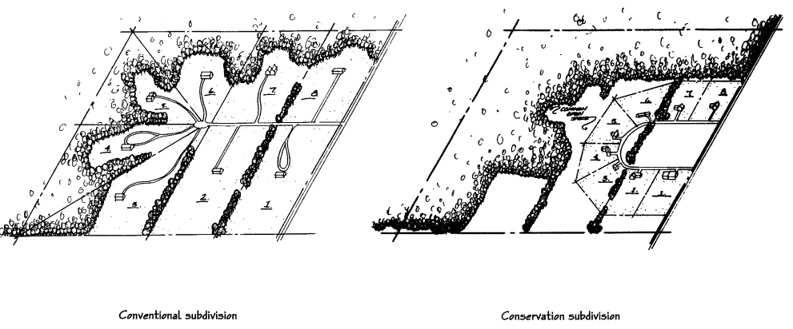

Implementation

The implementation of the Town of Shelby Comprehensive Plan involves decision-making by both public officials and the citizens of the community. These decisions will be measured by the concern for the welfare of the general community, the willingness to make substantial investments for improvement within the community, and the realization that certain procedures must be adhered to for the continued high-quality environment found within the Town. Suggested implementation measures include:
- The implementation and enforcement of regulatory ordinances and non- regulatory activities based on the goals and objectives identified in the Comprehensive Plan.
- The development of programs and support systems that further the goals and objectives set forth by the Town in this Plan.
- The establishment and support of a continued planning process providing for periodic review and updates to the Plan and land use control measures.
- The support of committees and local organizations to carry out specific community improvements as identified in the Comprehensive Plan.

10.1 Regulatory Measures
Regulatory measures used to guide development are an important means of implementing the recommendations of a comprehensive plan. Various examples, including the County zoning ordinance and Shelby subdivision regulations, comprise the principal regulatory devices used to protect existing development as well as help to guide future growth and development as identified in this Plan. The Town, County or State officially adopts these regulatory and land use control measures as ordinances (or as revisions to the existing ordinances).
10.1.1 Zoning Ordinance
Zoning is used to guide and control the use of land and structures on land. In addition, zoning establishes detailed regulations concerning the areas of lots that may be developed, including setbacks and separation for structures, the density of the development, and the height and bulk of building and other structures. The general purpose for zoning is to avoid undesirable side effects of development by segregating incompatible uses and by maintaining adequate standards for individual uses.
The establishment of zoning districts is generally conducted after careful consideration of the development patterns indicated in the Plan. Amending zoning district boundaries has the overall effect of changing the plan (unless amendments correspond to changes within the plan), therefore, it is reasonable to assume that indiscriminate changes may result in weakening of the plan. La Crosse County controls the content of the zoning ordinance and the Town of Shelby along with the County determine the local district map. These decisions are preceded by public hearings and Plan Commission recommendations.

Action: The existing La Crosse County ordinance is sufficient for current usage. However, amendments may become necessary to implement portions of this Plan. For example, there may be a need for a Planned Unit Development (PUD) ordinance to allow flexibility for development along major highway corridors in Shelby.
10.1.2 Official Maps
An official map shows the location of areas which the municipality has identified as necessary for future public streets, recreation areas, and other public grounds. By showing the area on the official map, the municipality puts the property owner on notice that the property has been reserved for future taking for a public facility or purpose. The municipality may refuse to issue a permit for any building or development on the designated parcel; however, the municipality has one year to purchase the property upon notice by the owner of the intended development.
There are no immediate plans for the Town to draft an official map. However, should local officials want to ensure consistency of the Future Land Use Plan with capital improvements, an official map should be drafted. For areas within the extraterritorial area outside the Village of Holmen, the official map must be developed jointly.
Action: Adopt an official map if, or at which time, changes in the rate of development require increased long-term infrastructure planning. Involve the Village of Holmen in locations within the extraterritorial area.
10.1.3 Sign Regulations
Local governments may adopt regulations, such as sign ordinances, to limit the height and other dimensional characteristics of advertising and identification signs. The purpose of these regulations is to promote the well-being of the community by establishing standards that assure the provision of signs adequate to meet essential communication needs while safeguarding the rights of the people in the community to a safe, healthful and attractive environment.
The County Zoning Ordinance includes provisions to regulate for type, bulk and setback. The development of local regulations is in place because the County regulations lack the specificity Shelby requires. This is especially true for subdivision signage.
10.1.4 Erosion/Stormwater Control Ordinances
The purpose of stormwater or erosion control ordinances is to set forth stormwater requirements and criteria which will prevent and control water pollution, diminish the threats to public health, safety, welfare, and aquatic life due to runoff of stormwater from development or redevelopment. Adoption of local ordinances for stormwater do not pre- empt more stringent stormwater management requirements that may be imposed by WPDES Stormwater Permits issued by the Department of Natural Resources under Section 147.021 Wis. Stats.
Stormwater runoff is a concern in areas with extreme topography. Where new development occurs, Shelby should require drainage plans as part of the development application.
Action: As part of the development application protocol, include a requirement for stormwater drainage plans to be completed that retain stormwater onsite. Continue to work with La Crosse Urban Stormwater Group to educate the community on stormwater management.
10.1.5 Historic Preservation Ordinances
An historic preservation ordinance is established to protect, enhance, and perpetuate buildings of special character or the special historic or aesthetic interest of districts that represent a community's cultural, social, economic, political, and architectural history. The jurisdiction’s governing body may create a landmarks commission to designate historic landmarks and establish historic districts.
In accordance with Wisconsin Statutes 101.121 and 44.44, a political subdivision (city, village, town or county) may request the State Historical Society of Wisconsin to certify a local historic preservation ordinance in order to establish a “certified municipal register of historic property” to qualify locally designated historic buildings for the Wisconsin Historic Building Code. The purpose of the Wisconsin Historic Building Code, which has been developed by the Department of Commerce, is to facilitate the preservation or restoration of designated historic buildings through the provision of alternative building standards. Owners of qualified historic buildings are permitted to elect to be subject to the Historic Building code in lieu of any other state or municipal building codes.
Locally, there is no historic preservation ordinance although preserving and enhancing historic structures and rural heritage has been identified as a community goal.
Action: Periodically review the need for development of a local historic buildings/structures reservation ordinance.
10.1.6 Site Plan Regulations
A site plan is a detailed plan of a lot indicating all proposed improvements. Some communities have regulations indicating that site plans may need to be prepared by an engineer, surveyor, or architect. Additionally, site plan regulations may require specific inclusions like general layout, drainage and grading, utilities, erosion control, landscaping and lighting, and building elevations.
Action: The current review process is sufficient for local needs, though increased requirements for the development of stormwater plans should be explored.
10.1.7 Design Review Ordinances
Overlay districts are typically developed in conjunction with the preparation of a comprehensive land use plan. They can provide significant improvements to delineated districts. Careful consideration of economic impacts, natural impacts, and private rights should be exercised when using overlay districts.
An overlay district is an additional zoning requirement that is placed on a geographic area but does not change the underlying zoning. Overlay districts have been used to impose development restrictions or special considerations on new development. For the Town of Shelby, these may include design specifications and parameters for mixed-use. An official overlay district must be adopted as part of the zoning code following appropriate public hearing procedures.
10.1.8 Building Codes / Housing Codes
The Uniform Dwelling Code (UDC) is the statewide building code for one- and two-family dwellings built since June 1, 1980. As of January 1, 2005, there is enforcement of the UDC in all Wisconsin municipalities. The UDC is primarily enforced by municipal or county building inspectors who must be state-certified. In lieu of local enforcement, municipalities have the option to have the state provide enforcement through state-certified inspection agencies for just new homes. Permit requirements for alterations and additions will vary by municipality. Regardless of permit requirements, state statutes require compliance with the UDC rules by owners and builders even if there is no enforcement.
10.1.9 Mechanical Codes
In the State of Wisconsin, the 2000 International Mechanical Code (IMC) and 2000 International Energy Conservation Code (IECC) have been adopted with Wisconsin amendments for application to commercial buildings. Shelby requires builders follow State mechanical codes for all structures built within the jurisdiction.
Action: State mechanical codes are sufficient. No action required.
10.1.10 Sanitary Codes
The Wisconsin Sanitary Code (WSC), which is usually enforced at the county-level, provides local regulation for communities that do not have municipal sanitary service. The WSC establishes rules for the proper siting, design, installation, inspection and management of private sewage systems and non-plumbing sanitation systems. The Town of Shelby requires new residential construction to follow La Crosse County standards.
Action: La Crosse County codes are sufficient. No action required.
10.1.11 Subdivision Ordinance
Subdivision regulations serve as an important function by ensuring the orderly growth and development of unplatted and undeveloped land. These regulations are intended to protect the community and occupants of the proposed subdivision by setting forth reasonable regulations for public utilities, storm water drainage, lot sizes, street design, open space, and other improvements necessary to ensure that new development will be an asset to the Town. The Town Board makes the final decisions on the content of the subdivision ordinance. These decisions are preceded by public hearings and recommendations of the Plan Commission.

10.2 Non-regulatory Measures
10.2.1 Capital Improvement Plan
This is an ongoing financial planning program intended to help implement planning proposals. The program allows local communities to plan for capital expenditures and minimize unplanned expenses. Capital improvements or expenditures are those projects that require the expenditure of public funds for the acquisition or construction of a needed physical facility.
Capital improvement plans list proposed projects according to a schedule of priorities over the next few years. It identifies needed public improvements, estimates their costs, discusses financing options, and establishes priorities over a 3-to-5-year programming period. Improvements or acquisitions considered a capital improvement include:
- Public buildings
- Park acquisition and development
- Roads and highways
- Utility construction
- Joint school and other community development projects
- Fire protection equipment
A capital improvement plan or program is simply a method of financial planning for these types of improvements and scheduling the expenditures over a period of several years in order to maximize the utility of public funds. Each year the capital improvement program should be extended one year to compensate for the previous year that was completed. This keeps the improvement program current and can be modified to the community’s changing needs.
Preparation of a Capital Improvement Program
The preparation of a Capital Improvement Program is normally the joint responsibility between the community administrator or plan commission, municipal staff, governing body, and citizen commissions. The preparation of a capital improvement program may vary from community to community depending on local preferences, the local form of government and available staff. In communities that have a community development plan or comprehensive plan, a planning agency review of the proposed capital improvement program is desirable.
Action: When formalization of multiple infrastructure projects is forecast, amend existing CIP to plan and earmark funding for public facilities development and spending.

10.3 Consistency Among Plan Elements
The State of Wisconsin planning legislation requires that the implementation element describe how each of the nine elements will be integrated and made consistent with the other elements of the plan. Since the Town of Shelby completed all planning elements simultaneously, no known inconsistencies exist. Further, the Action Plan at the end of this chapter consolidates actions and policies from throughout the plan reducing overlap and ensuring consistency.
This Comprehensive Plan references previous planning efforts, and details future planning needs. To keep consistency with the Comprehensive Plan the Town should incorporate existing plans as components to the Comprehensive Plan and adopt all future plans as detailed elements of this Plan.
The Town of Shelby will continue to make educated decisions based upon available information and public opinion. Planning will occur consistent with the 20-Year Planning Vision and decisions will incorporate a comprehensive outlook based on all nine elements in this plan.

10.4 Plan Adoption, Monitoring, Amendments and Update
10.4.1 Plan Adoption
In order to implement this Plan, it must be adopted by the Town Plan Commission. After the Commission adopts the Plan by resolution, the Town Board must adopt the Plan by ordinance. This action formalizes the Plan document as a frame of reference for general development decisions over the next 20 years. Once formally adopted, the Plan becomes a tool for communicating the community’s land use policy and for coordinating legislative decisions.
10.4.2 Plan Use and Evaluation
The Town of Shelby will base all of its land use decisions against this Plan’s goals, objectives, actions, and recommendations including decisions on private development proposals, public investments, regulations, incentives, and other actions.
The Town of Shelby can expect gradual change in the years to come. Although this Plan has described policies and actions for future implementation, it is impossible to predict the exact future condition of the Town. As such, the goals, objectives, and actions should be monitored on a regular basis to maintain concurrence with changing conditions.
The Plan should be evaluated at least every 5 years and updated at least every 10 years. It is recommended that the Plan be evaluated more frequently, either on an annual or biennial basis. Members of the Town Board, Plan Commission, and any other decision-making body should periodically review the Plan and identify areas that might need to be updated. The evaluation should consist of reviewing actions taken to the implement the Plan visions and actions. The evaluation should also include an updated timetable of actions to help realize priority goals and address new issues as they emerge. Any changes would be added to the Plan through the amendment procedure in 9.4.3 below.
10.4.3 Plan Amendments
The Town of Shelby Comprehensive Plan may be amended at any time by the Town Board following the same process to amend the plan as it originally followed when it was initially adopted (regardless of how minor the amendment or change is).
Amendments may be appropriate throughout the lifecycle of the Plan, particularly if new issues emerge or trends change. These amendments will typically be minor changes to the Plan’s maps or text. Large-scale changes or frequent amendments to meet individual development proposals should be avoided or the Plan loses integrity. Any proposed amendments should be submitted to the Plan Commission for their review and recommendations prior to consideration by the Town Board for final action.
10.4.4 Plan Update
According to the State comprehensive planning law the Comprehensive Plan must be updated at least once every ten years. As opposed to an amendment, the plan update is a major re-write of the plan document and supporting maps. The State planning law also requires that by January 1, 2010, all programs and/or actions that affect land use must be consistent with the locally adopted Plan.

10.5 5-Year Action Plan
The plan implementation table on the following pages provides a detailed list of major actions that the Town should complete as part of the implementation of the Comprehensive Plan over the next 5-year period. It should be noted that many of the actions require considerable cooperation with others, including the citizens of Shelby, Town staff, and local/state governments.
The 5-Year Action Plan was designed to provide direction to the Plan Commission, Town Board, and interested parties to start implementing this Plan. To do this, certain actions were selected from each of the nine comprehensive planning elements based on the perceived necessity of timely implementation. Many are ordinance or planning-related updates that will better prepare Shelby for development in coming years. In five years, when this plan is reviewed, the 5-Year Action Plan should be updated to reflect new priorities and accomplishments. At that time, some actions listed in Table 10.5 may carry over into the next 5-year planning period, while those that were accomplished should be replaced with other actions prioritized by the Plan Commission through a public process.

Table 10.5: 5 Year Action Plan
Action by Planning Element | Who is Responsible?
Housing
Transportation
Utilities and Community Facilities
Agricultural, Natural, and Cultural Resources
Economic Development
Intergovernmental Cooperation
Land Use
Implementation

Appendix A:
Public Participation Plan
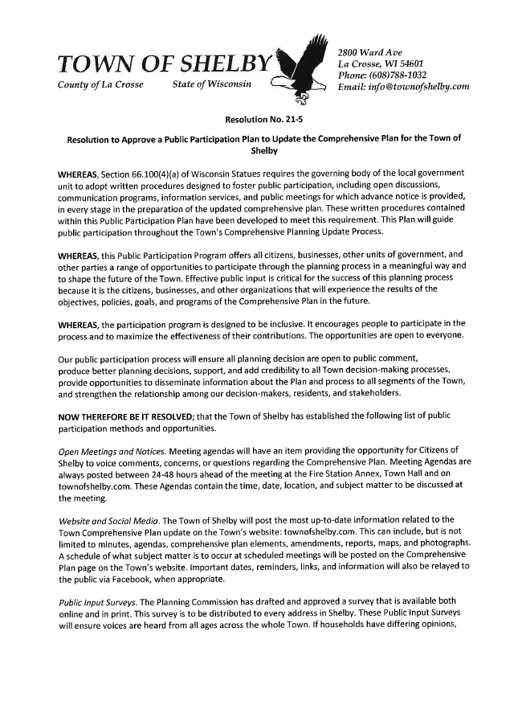
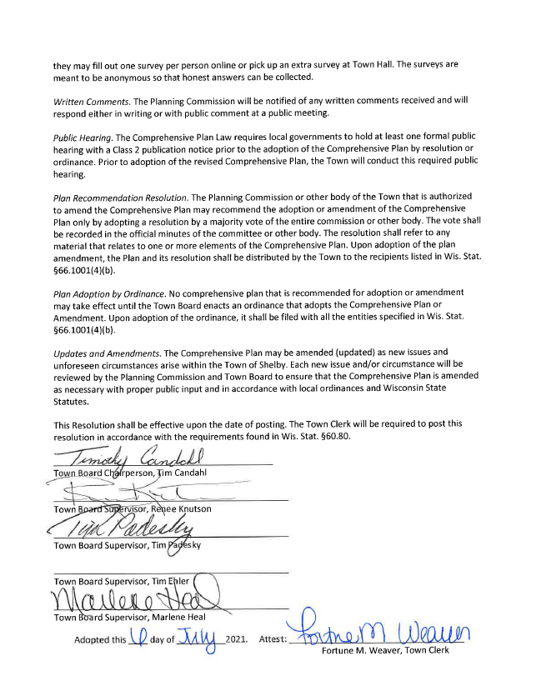

Appendix B:
Land Use Considerations and Plans
B-1: LAPC Goal Analysis
LAPC - Land Use Goals | Not Applicable, Agree, Disagree (state concerns)*
Housing and neighborhoods in the City of La Crosse will attract new investment and more residents, especially through renovation and enhancement of existing housing stock. | Not Applicable
Senior housing options will continue to expand, and new housing intended for residents who remain mobile and active should be located within a 10-minute walk of retail and services. | Agree
New housing will continue to include a range of housing types and lot sizes, including a priority on single family lots smaller than 1/2-acre. | Agree
The region places a high priority on infill development to enhance the utilization of existing urban infrastructure and enhance the concentration of uses so that more residents are within a 10-minute walk of their daily retail needs. | Agree
New buildings and development areas will often include a mix of uses. | Agree
Towns, villages and cities will pursue and approve boundary agreements that allow some growth in unincorporated areas. | Agree
LAPC – Transportation Goals
New roads for the primary purpose of facilitating regional commuter traffic will generally be avoided – community preference is for expansion of existing roads and transit enhancements instead. | Agree
Road projects will be designed to improve the safety and mobility of all users, with emphasis placed on maintaining neighborhood connections and cohesiveness. | Agree
The region will have a flexible and fully interconnected grid of streets and highways. | Agree
A Regional Transportation Authority (RTA) will be created to fund and maintain transportation systems. | Agree
Transit use will increase among all age groups. | Disagree
Fixed-route regional transit, such as Bus Rapid Transit, should be actively studied and pursued. Routes should be identified, and necessary right-of-way protected (or gradually acquired) until implementation becomes feasible. | Agree
Intelligent transportation systems and mass data gathering technologies will be utilized to the extent practicable to improve the safety and mobility of our transportation networks. | Agree
Growth will be accommodated without a significant increase in congestion through the use of many strategies, including road and highway improvements, traffic signal timing improvements, new/enhanced transit services, enhanced and expanded bike and pedestrian facilities, scheduling adjustments by major employers, and other approaches. | Agree
Truck routes in the region will be efficient and clearly identified, especially including those through the City of La Crosse. | Agree
Mississippi River locks and dams will be upgraded to accommodate modern shipping requirements. | Agree
Interstate passenger rail service to Minneapolis and Milwaukee/Chicago will increase in frequency and reliability. | Agree
Public and private landowners will reduce their subsidy of automobile use through a mix of strategies. | Agree
Bike and pedestrian facilities will be present everywhere. | Agree

Appendix C: Maps

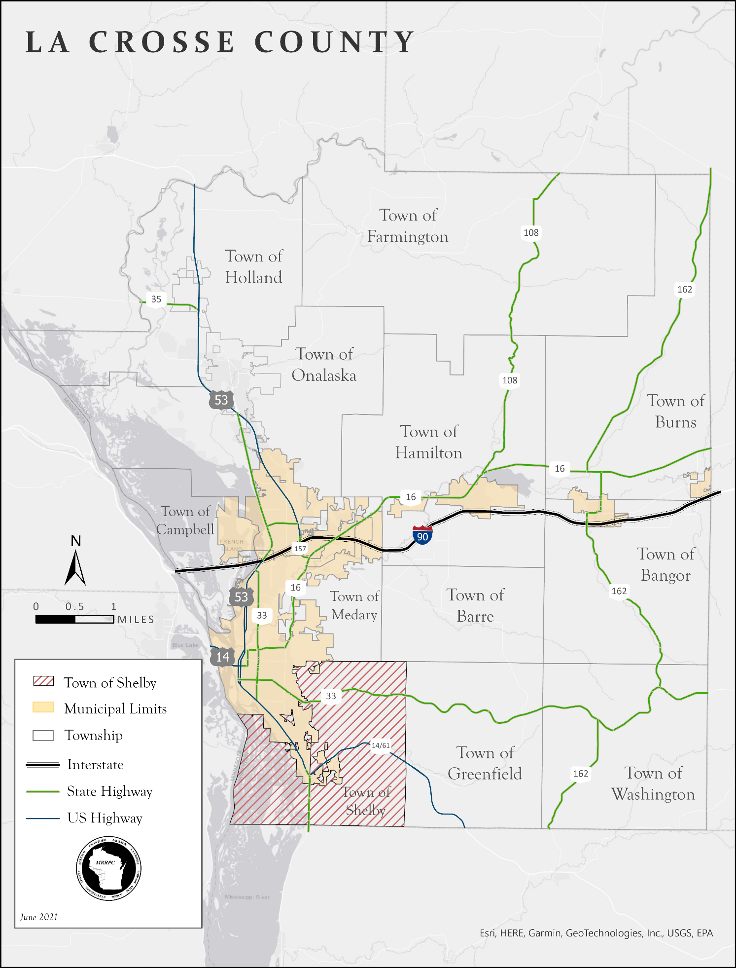

Map 1.1 Regional Context
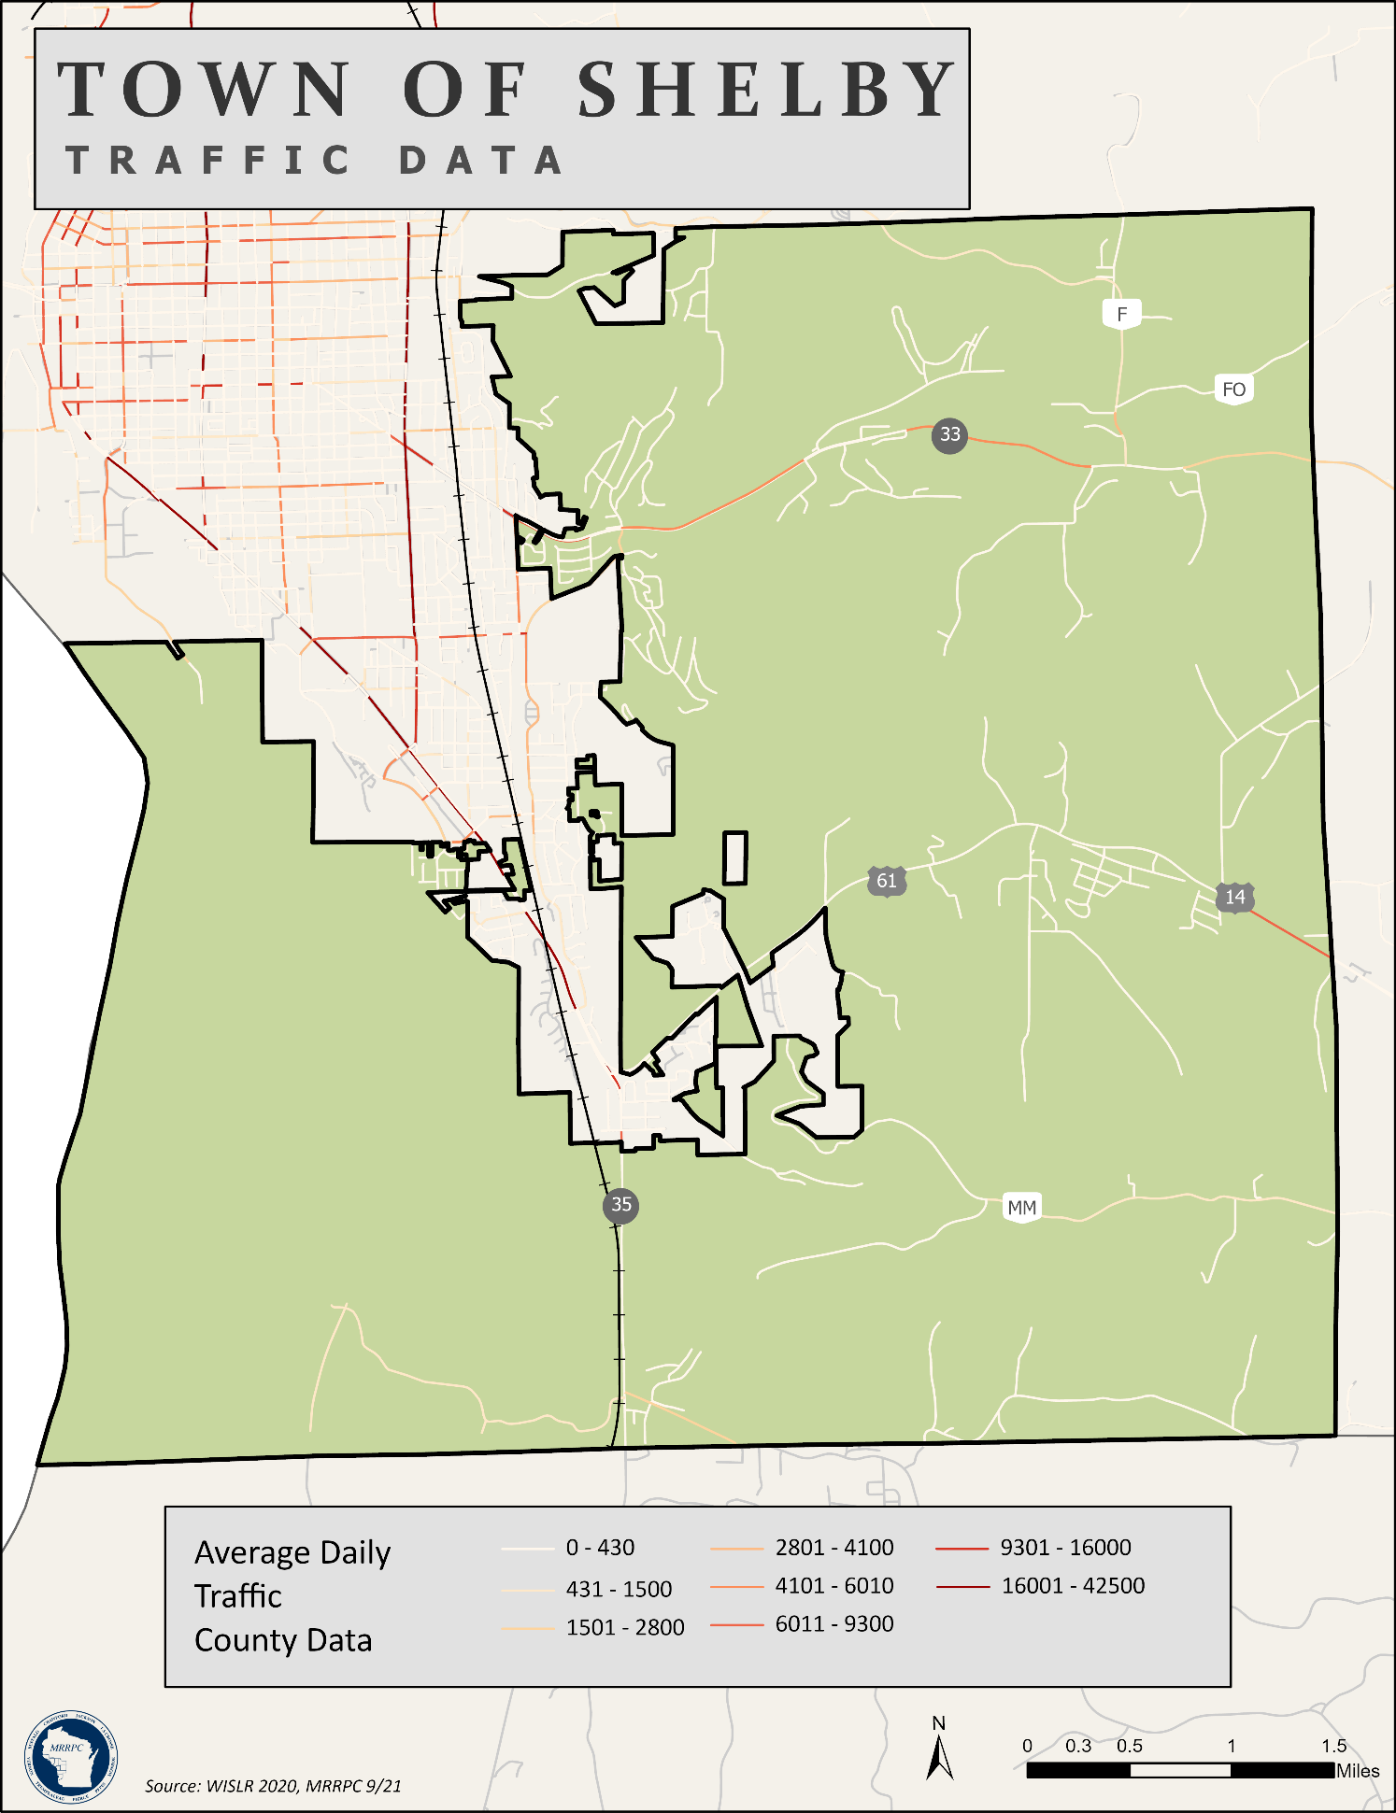

Map 3.1 Average Daily Traffic
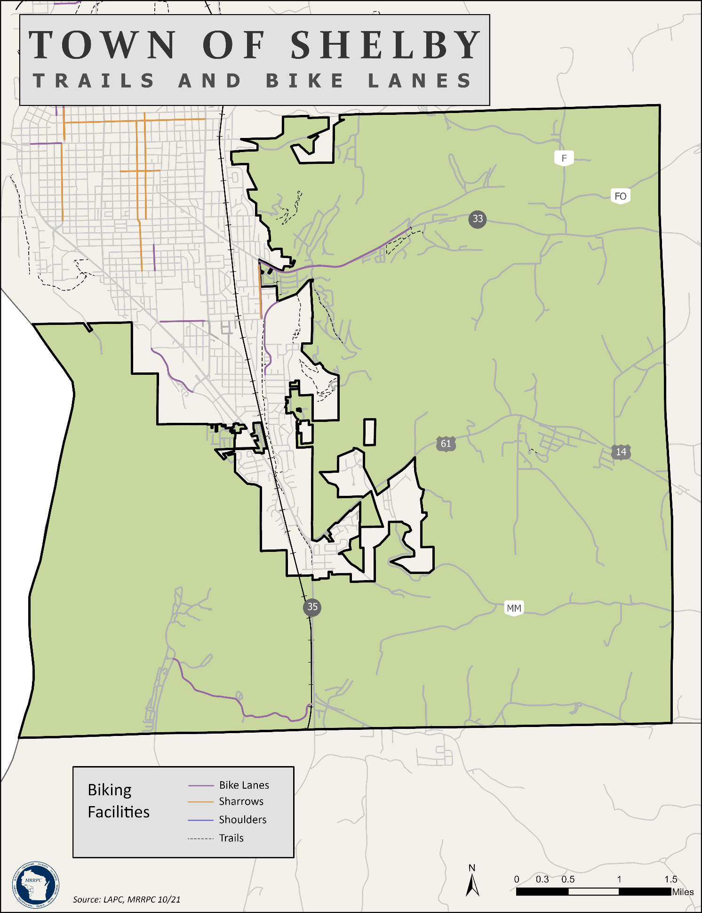

Map 3.2 Trails and Bike Lanes
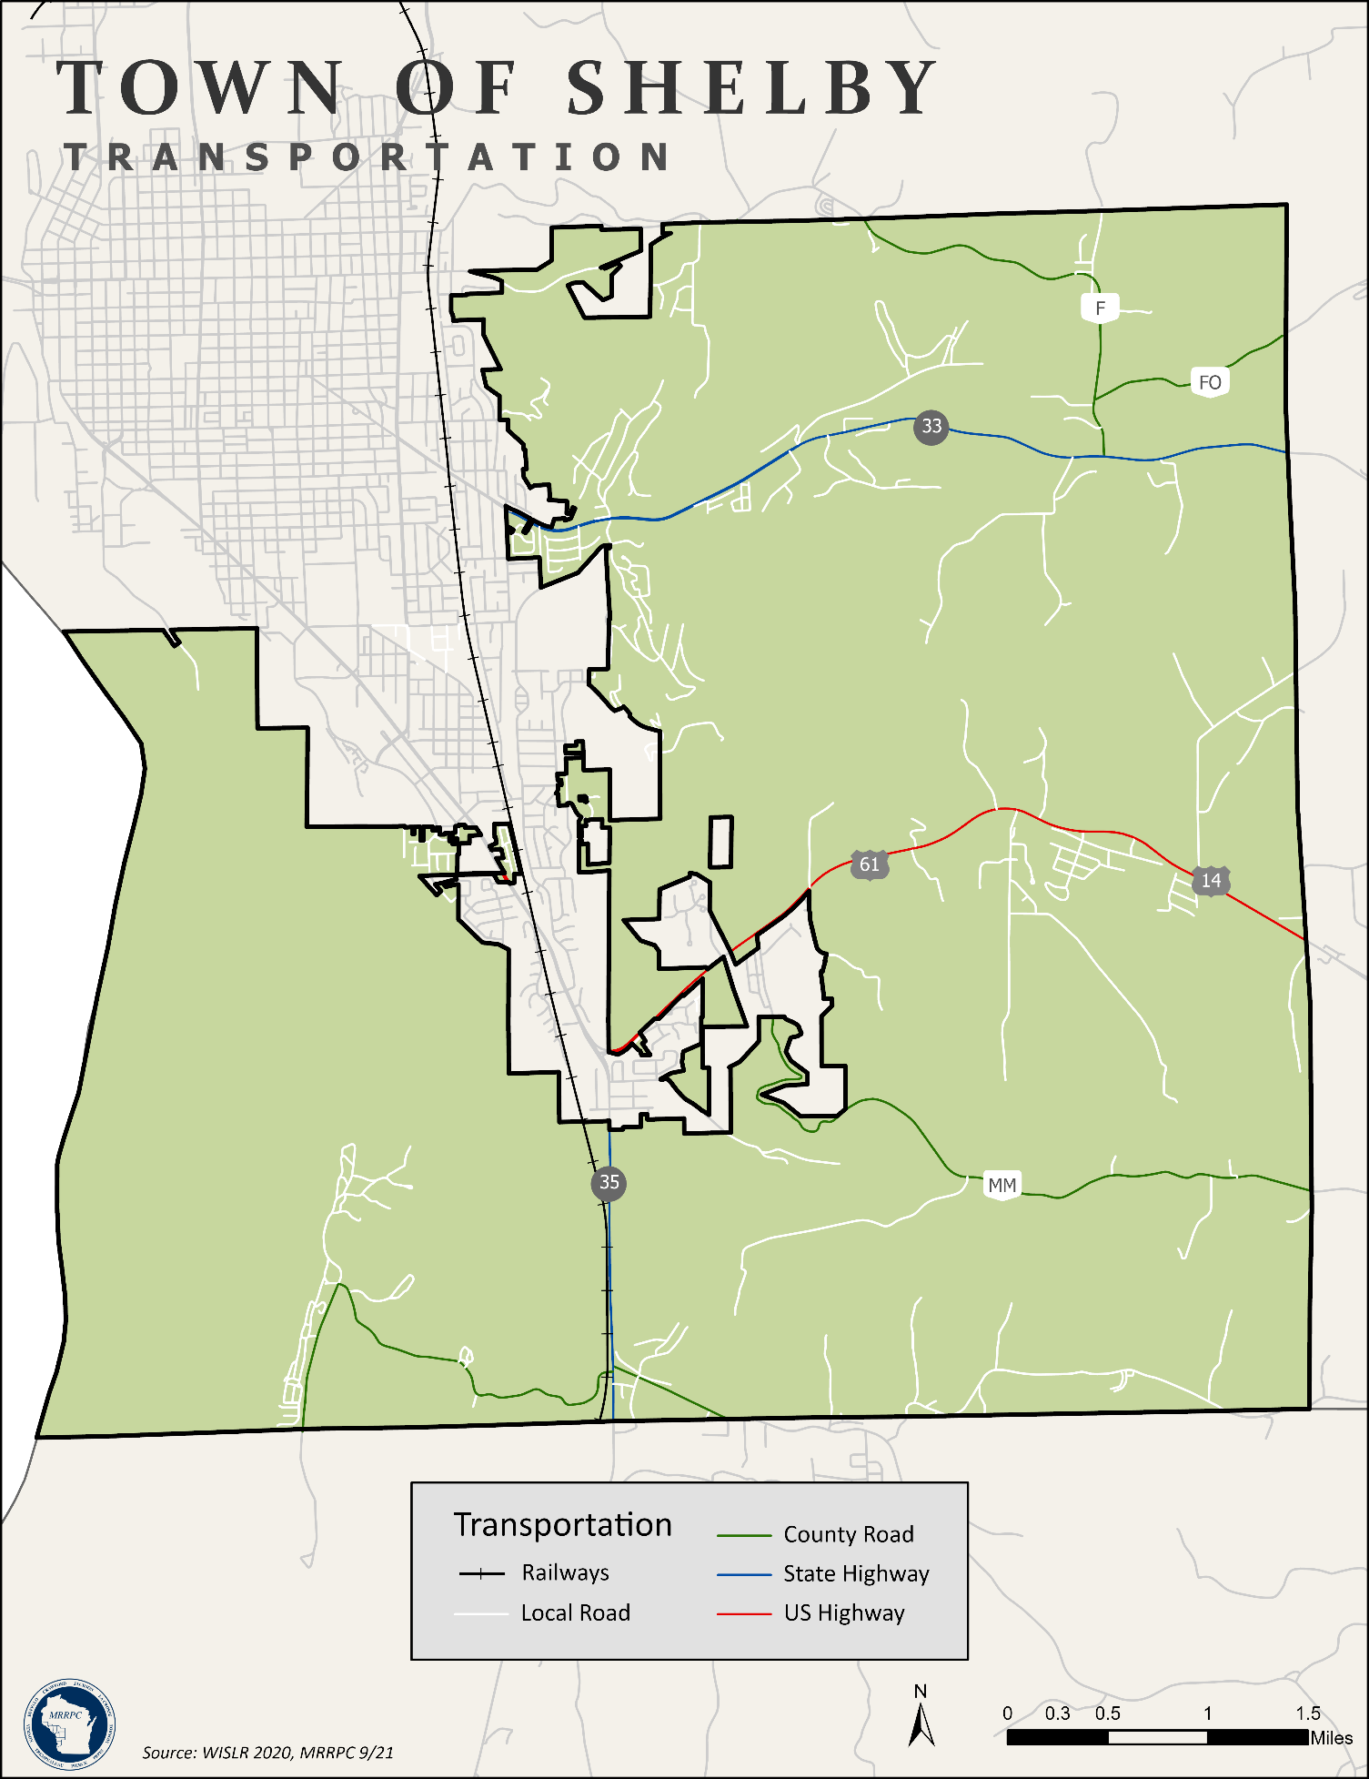

Map 3.3 Transportation
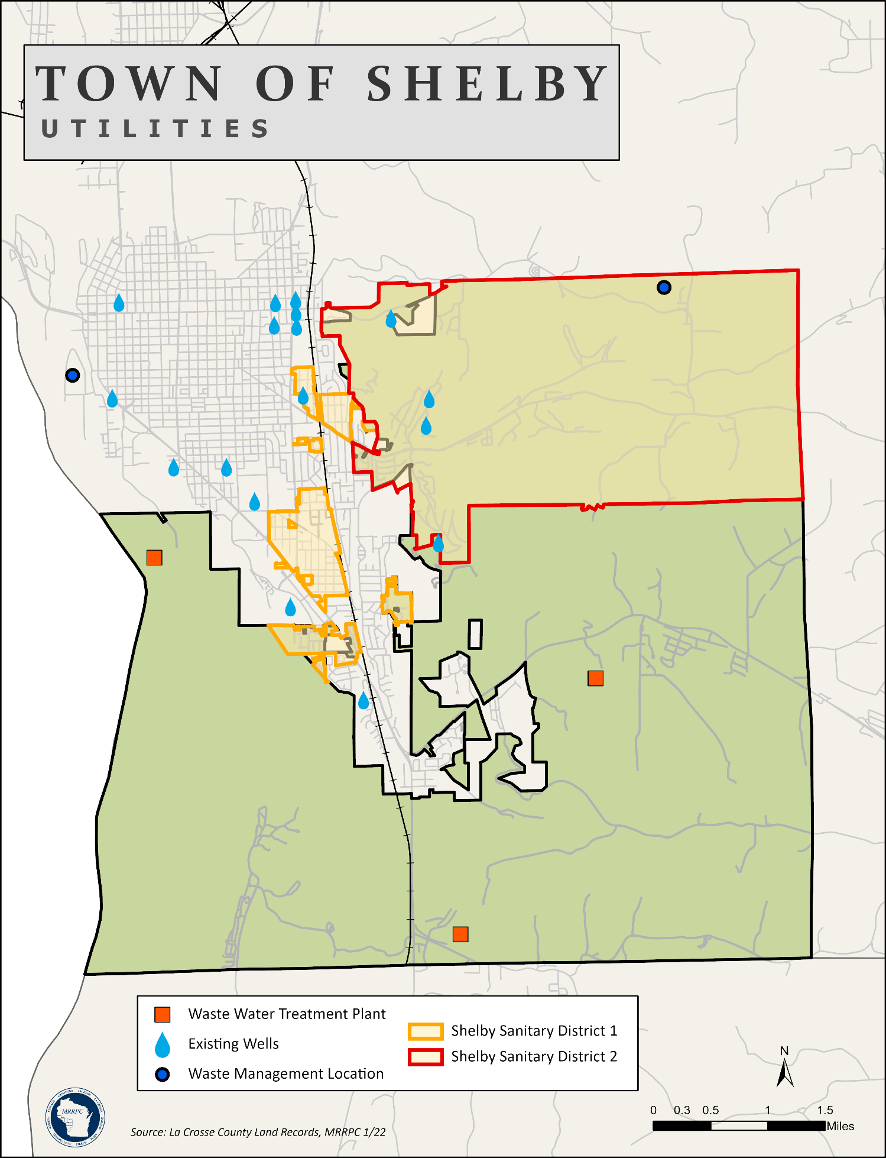

Map 4.1 Utilities
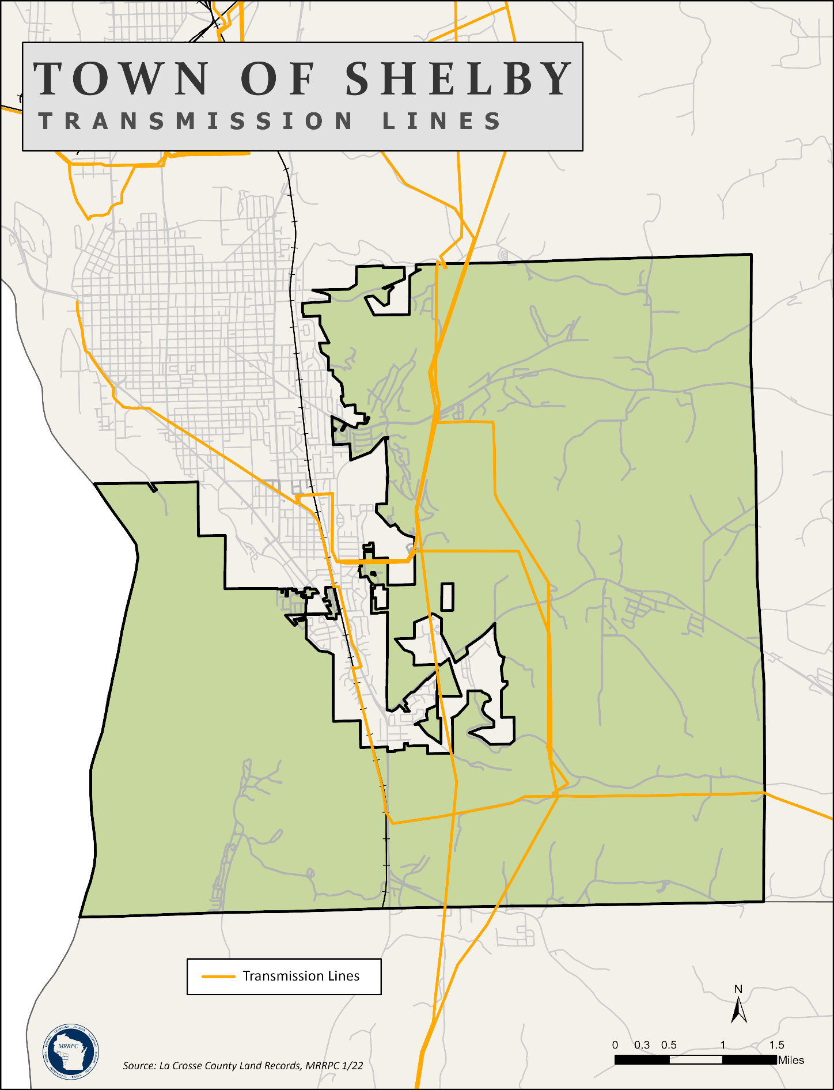

Map 4.2 Transmission Lines
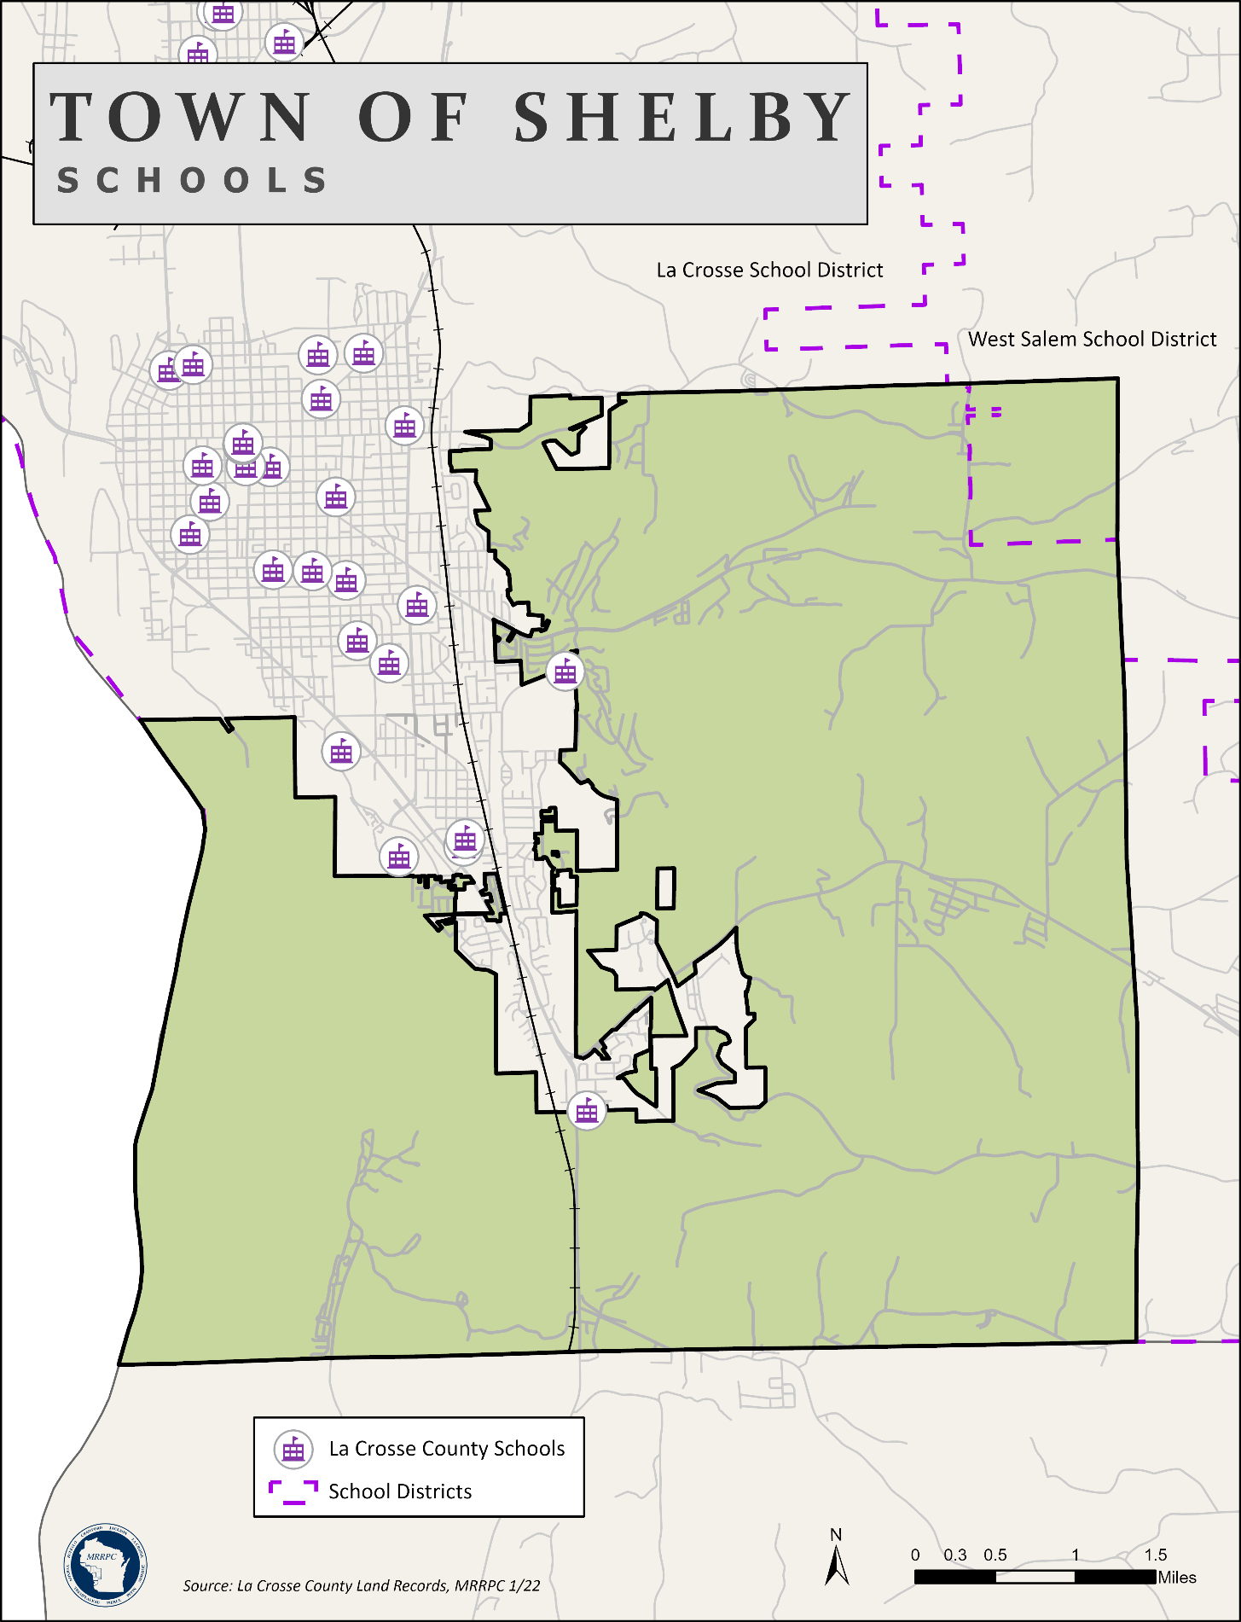

Map 4.3 Schools
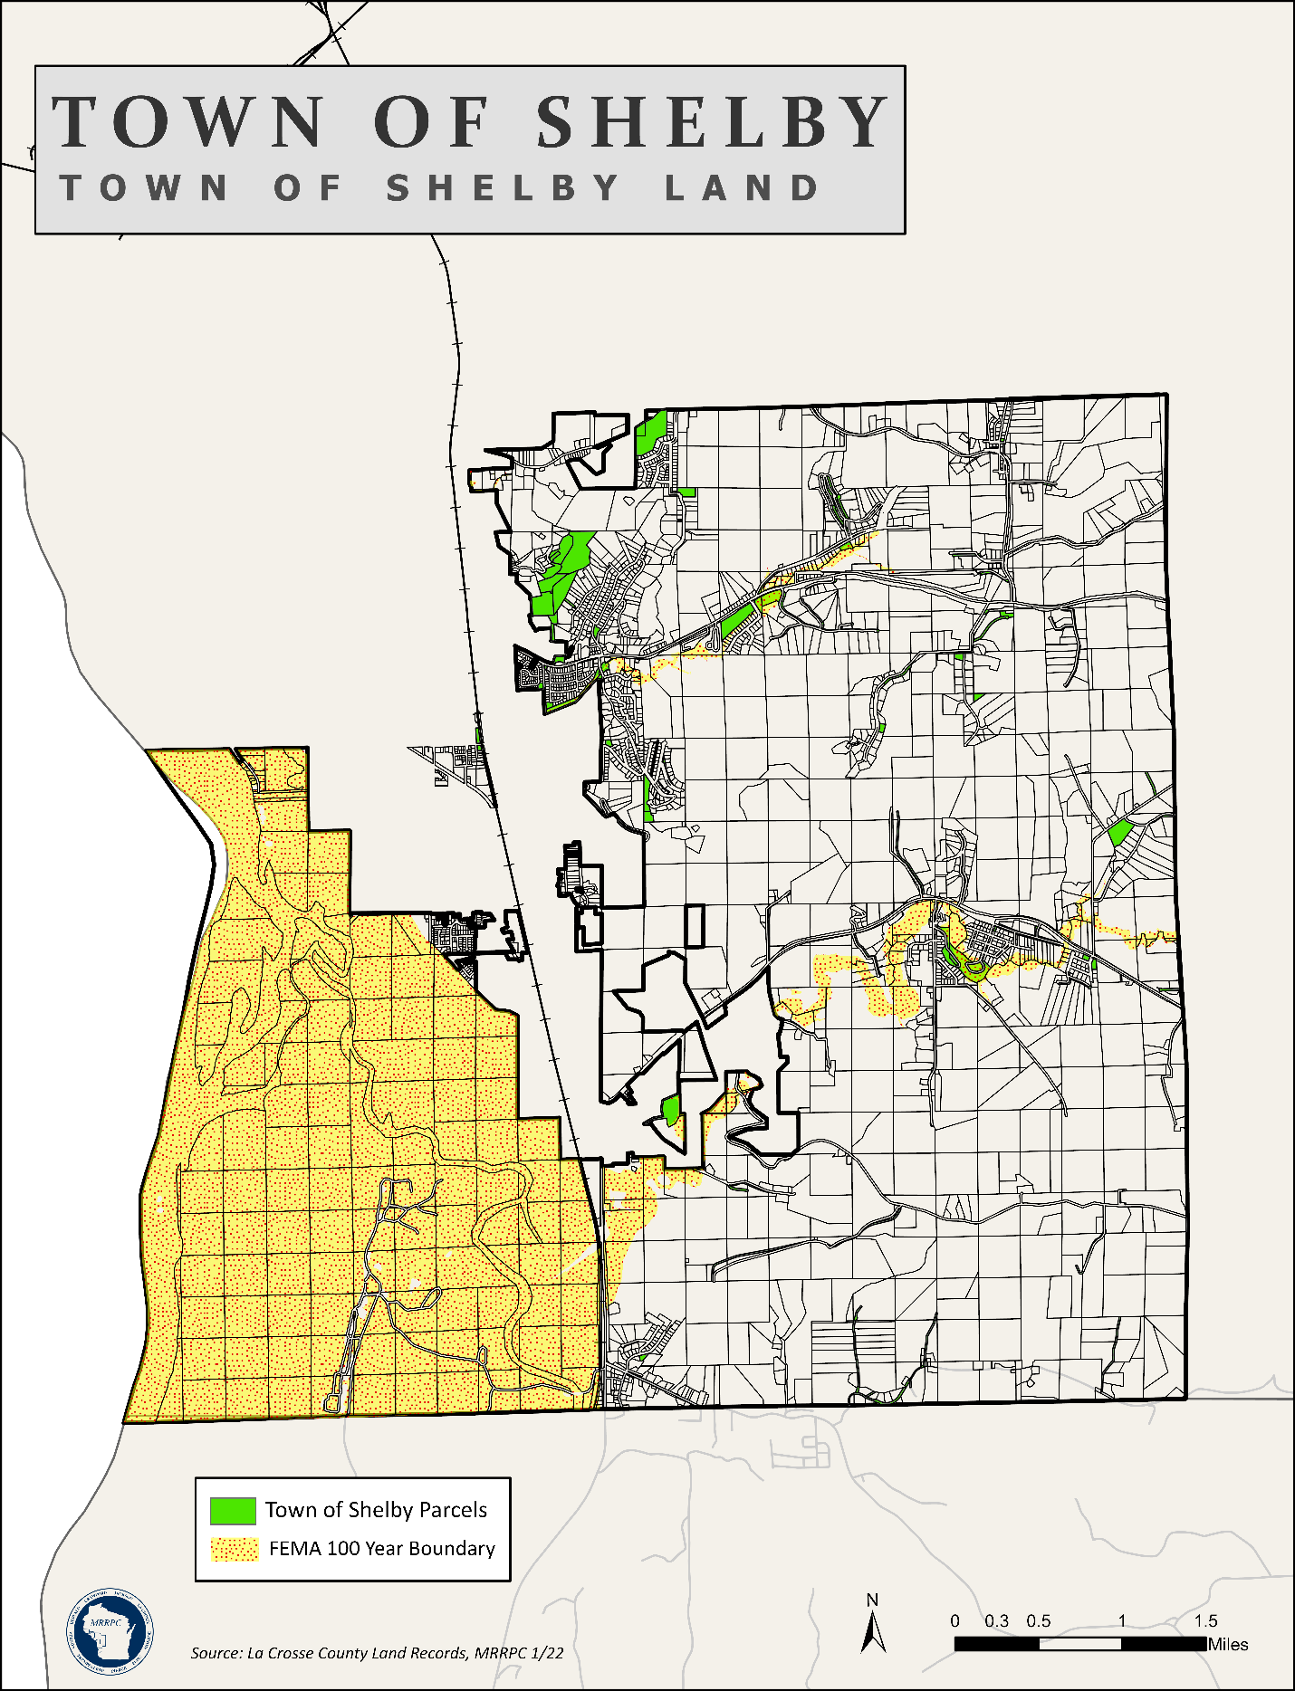

Map 5.1 Shelby Owned Parcels
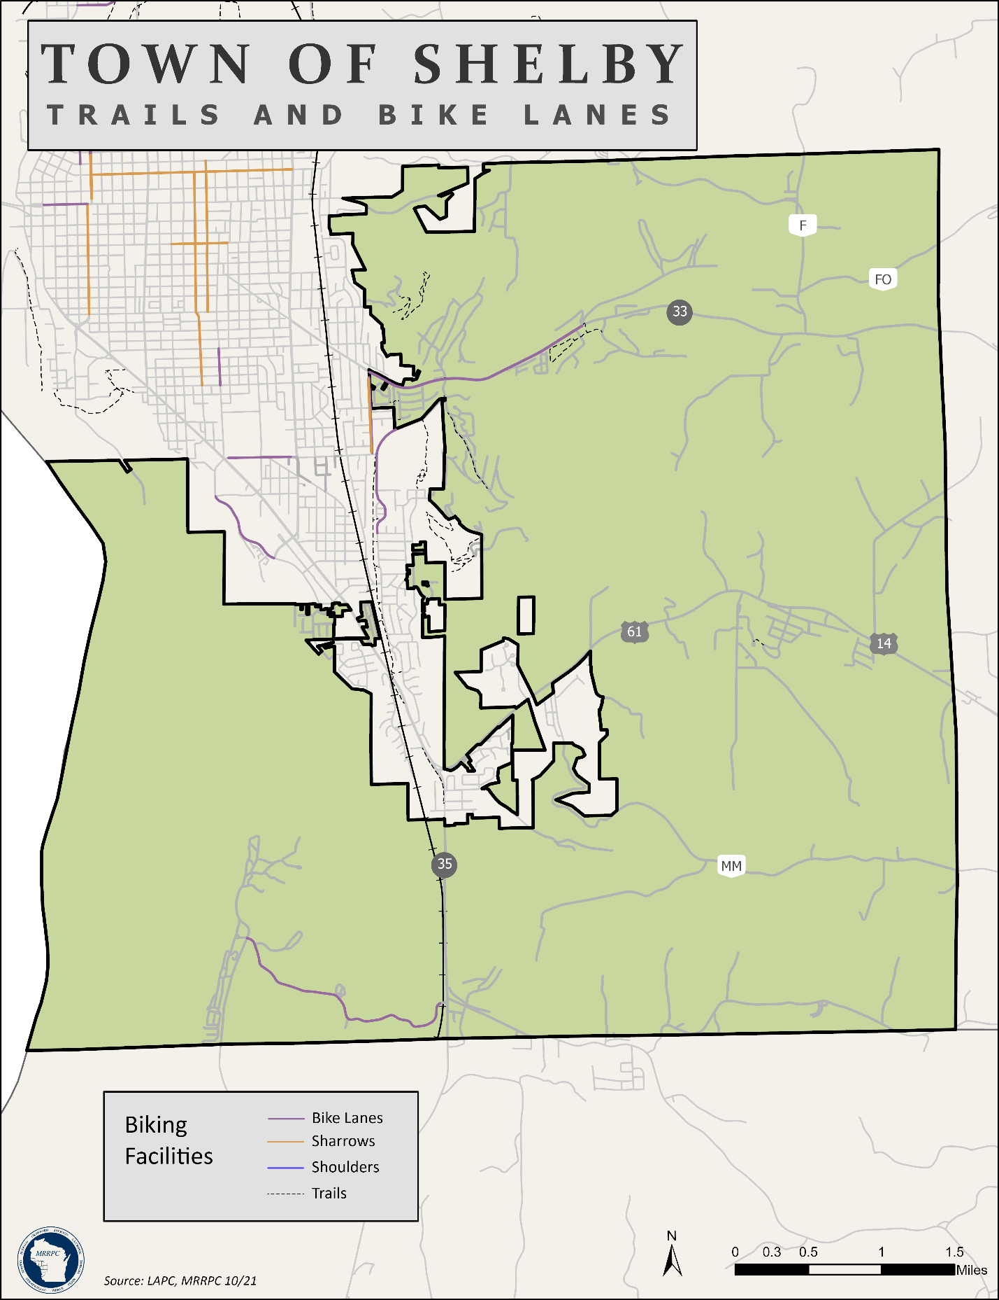

Map 5.2 Trail Systems
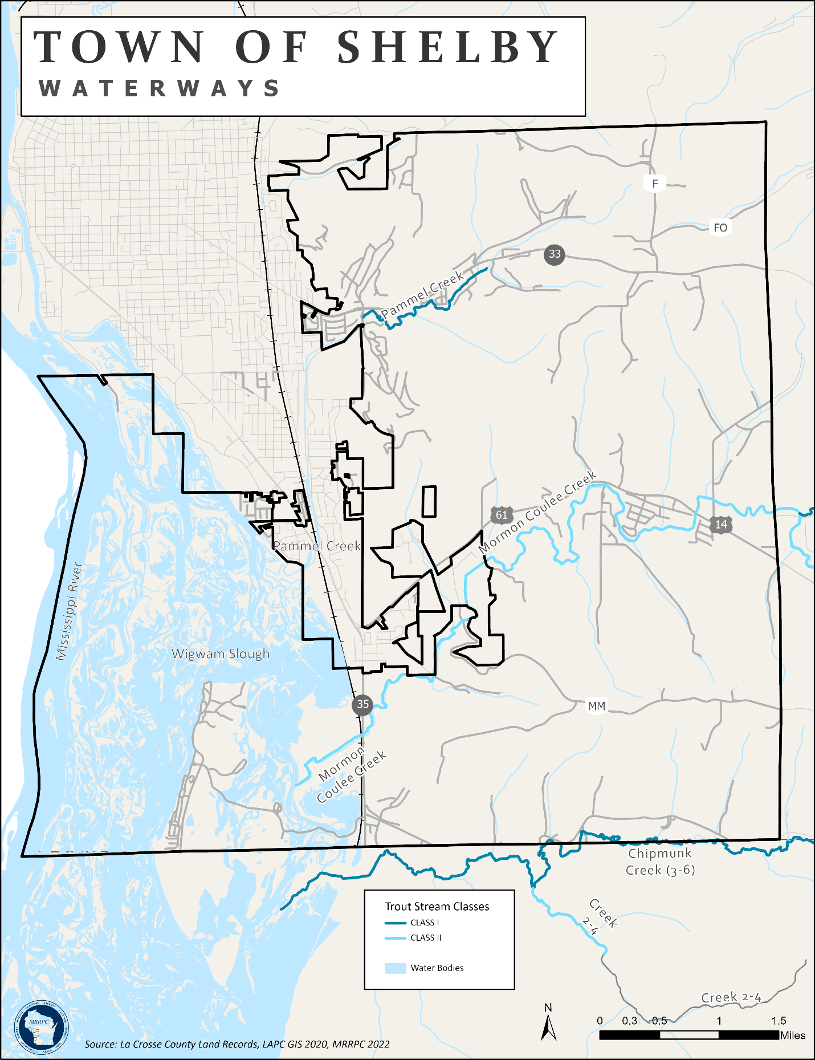

Map 5.3 Waterways
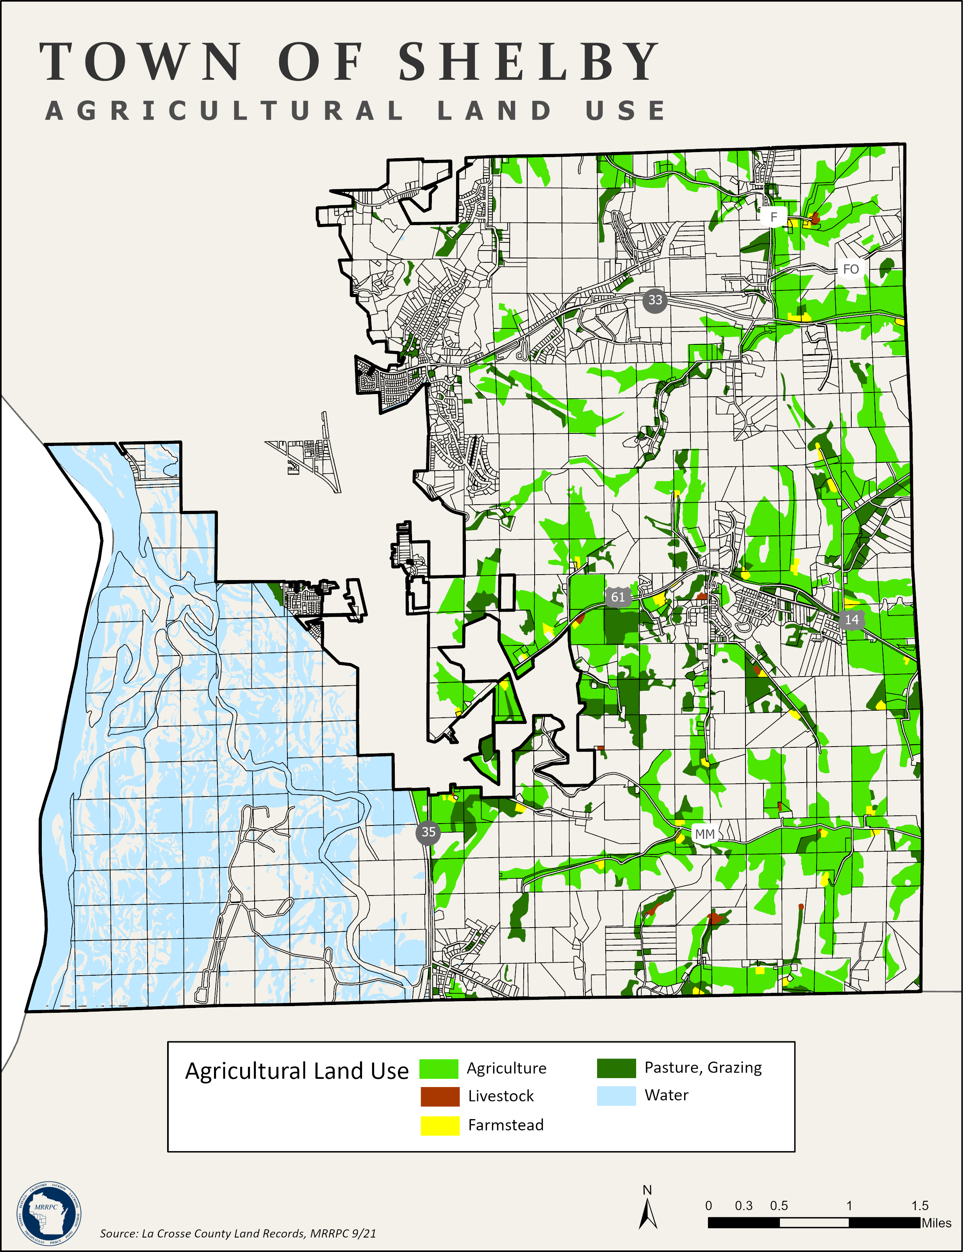

Map 6.1 Agricultural Land Use
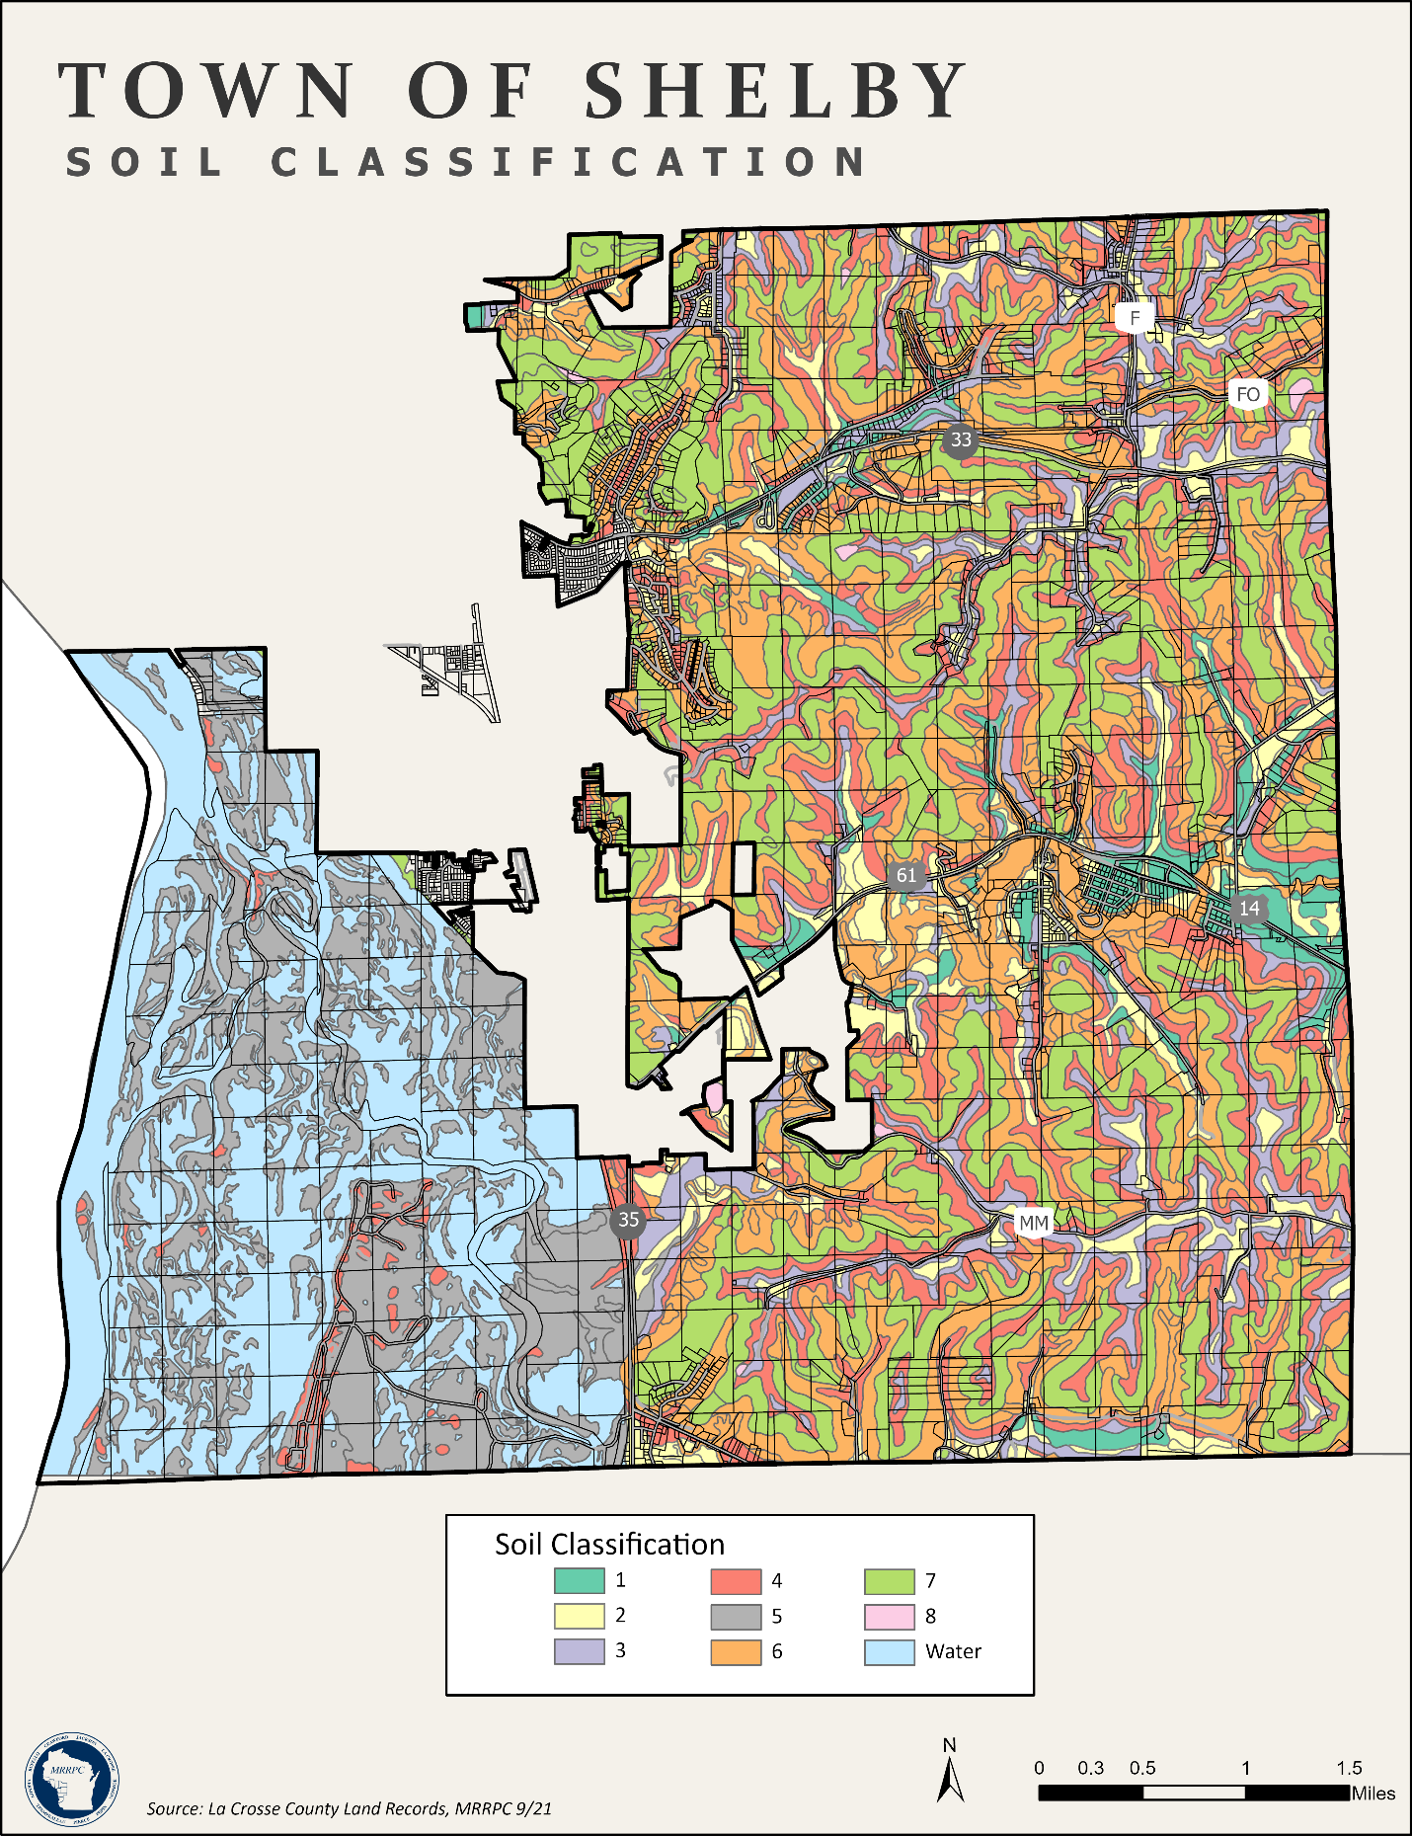

Map 6.2 Soil Classification
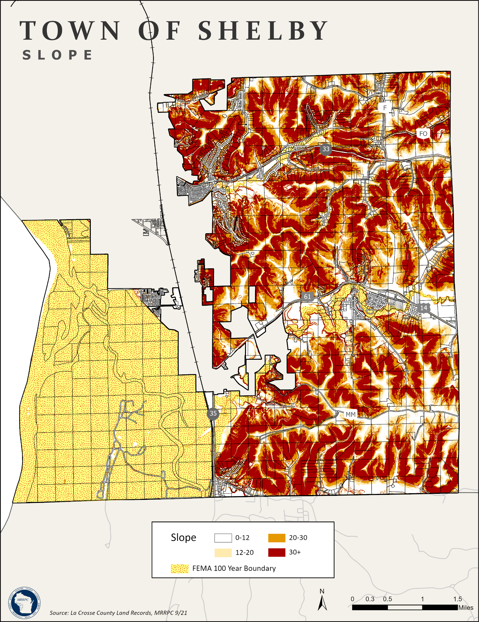

Map 6.3 Slope

Map 6.4 Archeological Sites

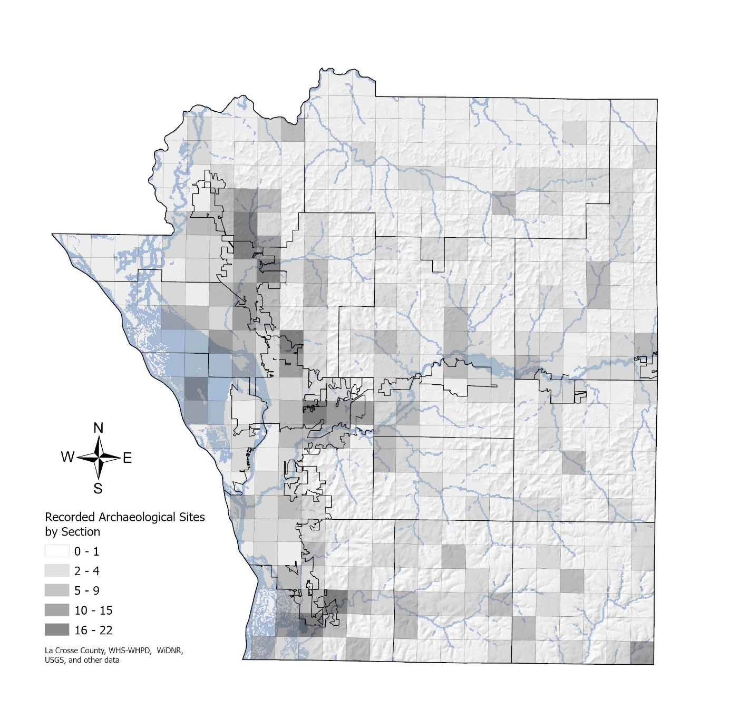
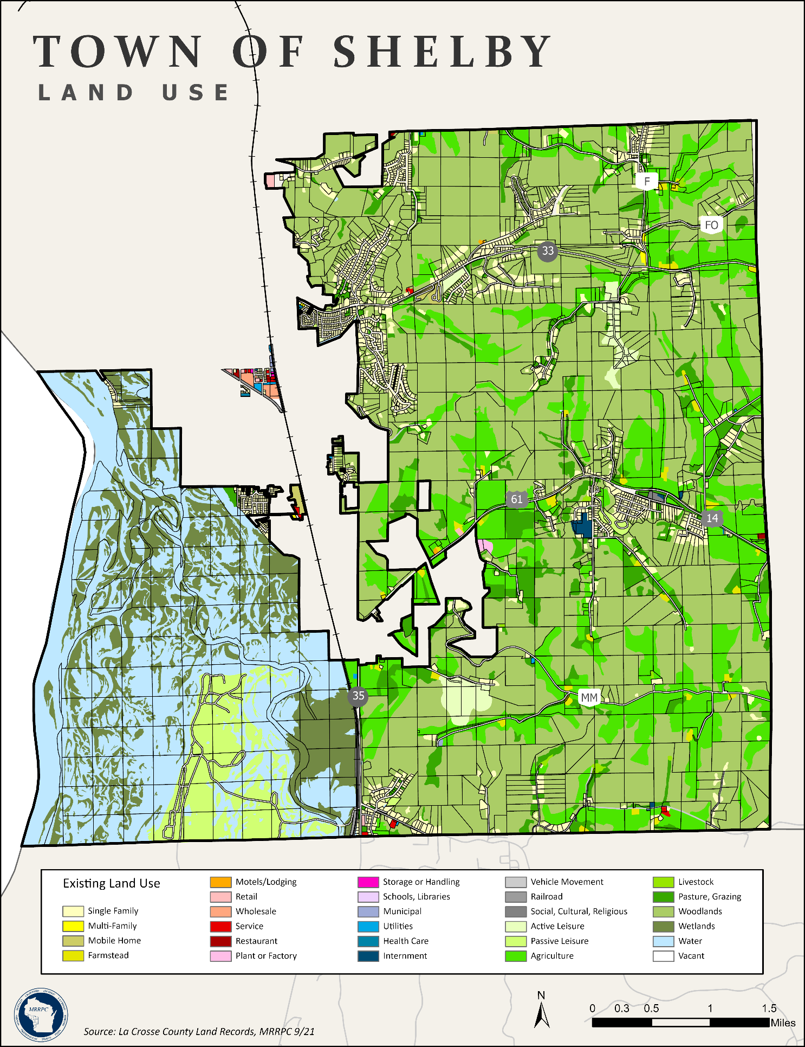

Map 9.1 Existing Land Use
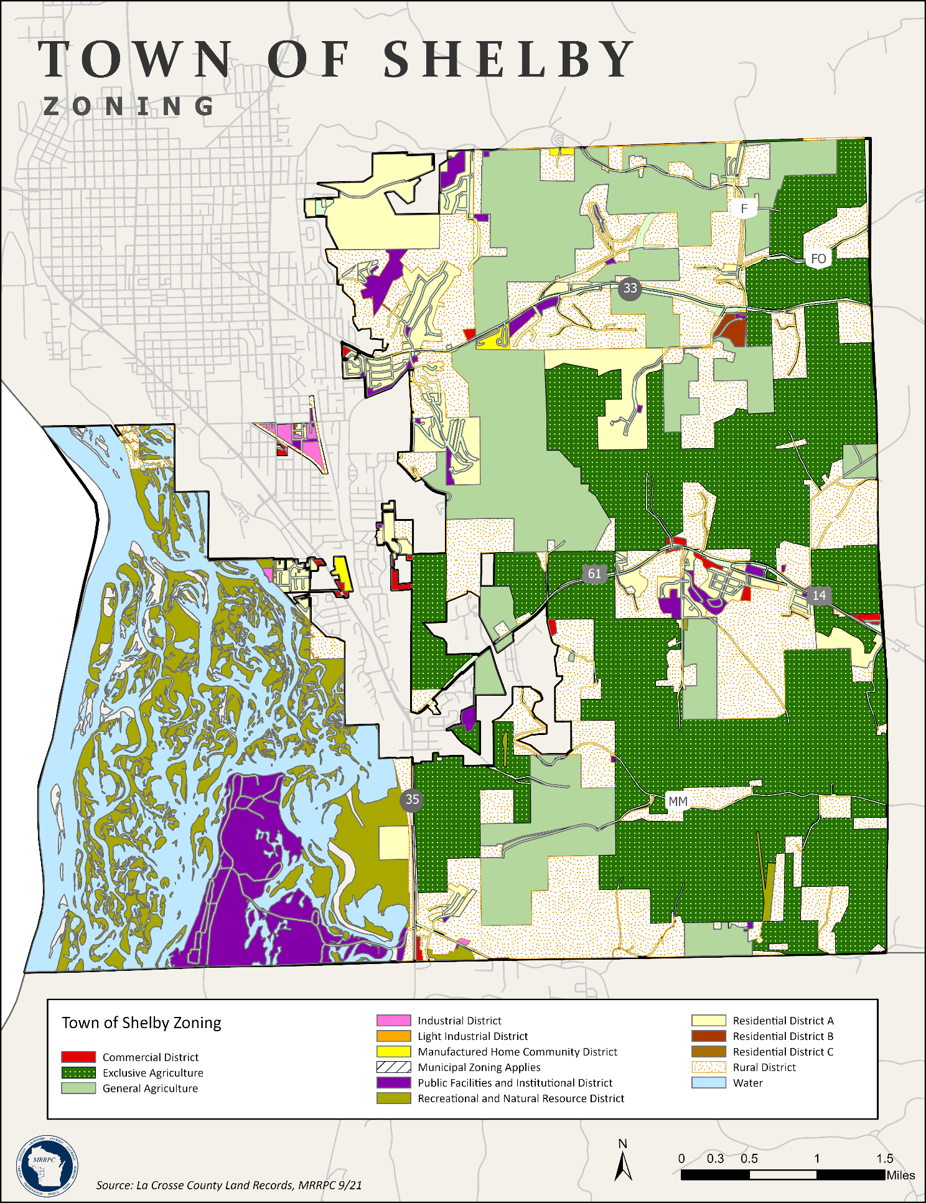

Map 9.2 Zoning
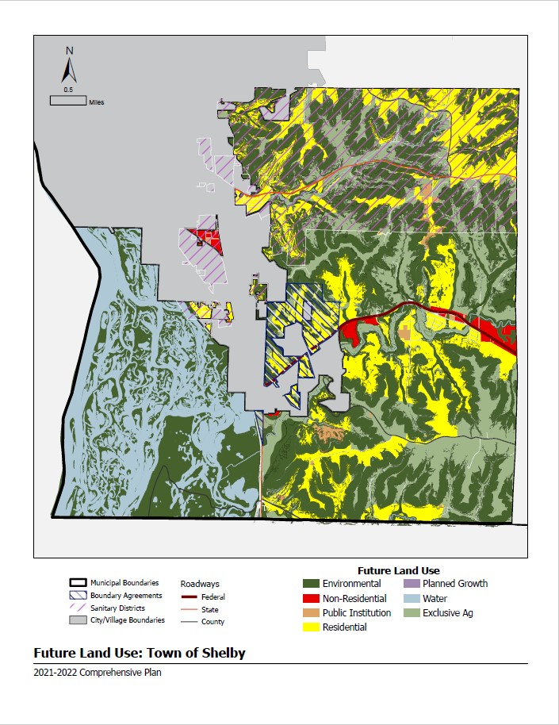

Map 9.3 Future Land Use

Appendix D

Survey Responses
1. Please tell us how satisfied you are with the following:

2. What is your opinion of sharing the following services? The Town of Shelby should…

3. Why do you choose to live in the Town of Shelby? (Choose all that apply)

4. Please tell us the priority level of each of the following (select all that apply). Shelby should:

5. What type of development should the Town promote? (Check all that apply)

6. What municipal water and sewer services do you have?

7. Do you believe the Town of Shelby should work to extend municipal water and sewer to new development areas to encourage higher density development?

8. Do you believe the Town of Shelby should work to provide municipal water and/or sewer to already developed areas which are not currently served by water/sewer?

DEMOGRAPHICS
12. What best describes your connection to Town of Shelby? (Choose one) I live in the Town of Shelby (see map):

13. What best describes the amount of time you have resided in Shelby? (If applicable, choose one)

14. What best describes your age group? (Choose one)

15. What best describes your employment status? (Choose one)

Appendix E

Public Hearing Affidavit

Resolution to Adopt Plan

Ordinance to Adopt Plan

